

**Amrita Viswa Vidyapeetham**

Centre for Excellence in Computational Engineering Networking Coimbatore - 641-112 (India)

**Implementation of String Library & Hack CPU in Jack**

**Prepared By:**

P.S.S.Sai Keerthana (CB.EN.U4AIE21038)

P.Komal Sai Anurag (CB.EN.U4AIE21039) Udaygiri Varun (CB.EN.U4AIE21071) Sejal Singh (CB.EN.U4AIE21061)

**Supervised By:**

Prof.Sreelakshmi K Asst. Professor

A 2nd Semester Project submitted to the Department of Centre for Excellence in Computational and Networking partial fulfillment of the requirements for final project of Elements of Computing Systems-2

July, 2022

**Amrita School of Engineering**

**Amrita Viswa Vidyapeetham**

Coimbatore - 641-112 (India)

**Declaration**

We declare that the submitted report is our original work and no values and context of it has been copy pasted from anywhere else. We take full responsibility, that if in future, the report is found invalid or copied, the final decision will be of concerned faculty. Any form of plagiarism will lead to disqualification of the report.

Place: Ettimadai

Date: 13.07.2022

**Acknowledgement**

We would like to express our special thanks of gratitude to our professor (Prof. Sreelakshmi K) who gave this golden opportunity to do this wonderful project to implement the String library and Hack CPU in Jack Language. Her teaching skills gave us the path and driving force to complete this Project.

Also, we would to thank Dr. Jyothish Lal G for providing all the basics of this Nand2tetris Part-1 course. Through your teaching we could understand all the basics clearly and it helped us a lot in doing the project.

We would also thank Prof. Noam Nisan and Prof. Shimon Schocken for providing this wonderful subject and tools which is very interesting to work on.

**Abstract**

In this project we will implement some string libraries in jack, test them using the VM Emulator and see the results. Also, we will implement the Hack CPU in Jack.

**Table of Contents**

|  |  |
| --- | --- |
| **Declaration** | **I** |
| **Acknowledgement** | **II** |
| **Abstract** | **IV** |
| **Table** **of Content** | **V** |
| **Bibliography** | **57** |

**1 String Libraries 1**

AIM …………………………………………………………. 4

Steps of action in Jack ………………………………………… 4

* 1. SetcharAt …………………………………………….. 5
  2. appendLastchar ………………………………………. 6
  3. eraseLastchar ………………………………………… 7
  4. intValue ……………………………………………… 8
  5. toUppercase ………………………………………….. 9
  6. toLowercase …………………………………………. 10
  7. startwith …………………………………………….. 11
  8. endswith …………………………………………….... 12
  9. subString …………………………………………….. 13
  10. compareTo ………………………………………….… 14
  11. count ………………………………………………….. 15

**2 Hack CPU 2**

AIM ………………………………………………………….. 17

Steps of action in Jack …………………………………………. 17

Block Schematic diagram of CPU ………………………………. 18

2.1 Primary chips

2.1.1 Nand gate ……………………………………………………19

2.1.2 Or gate ……………………………………………………....19

2.1.3 And gate …………………………………………………….. 20

2.1.4 Not gate ………………………………………………………20

2.1.5 Xor gate ………………………………………………………21

2.1.6 Mux gate ……………………………………………………...21

2.2 Secondary chips

2.2.1 Half Adder ………………………………………………… 22

2.2.2 Full Adder ………………………………………………… 22

2.2.3 16-bit Adder ……………………………………………… 23

2.2.4 16-bit And gate …………………………………………… 24

2.2.5 16-bit Mux gate …………………………………………… 24

2.2.6 16-bit Not gate ……………………………………………. 25

2.2.7 16-bit incrementor ……………………………………….. 25

2.2.8 Or-8-Way ………………………………………………… 26

2.2.9 Or-3-input ………………………………………………… 26

2.3 Important conversion

2.3.1 toBinary …………………………………………………… 27

2.2.2 toBinaryall ……………………………………………….. 28

2.2.3 toBinary8 ………………………………………………… 29

2.2.4 toDecimal …………………………………………………. 30

2.2.5 toDeciamal8 ……………………………………………… 31

2.4 Important chips

2.4.1 Data Flip-Flop……………………………………… 32

2.4.2 16-bit Data Flip-Flop ……………………………… 32

2.4.3 Register …………………………………………… 33

2.4.4 16-bit Register …………………………………….. 33

2.4.5 Hack ALU…………………………………………. 34

2.4.6 Program Counter ………………………………….. 38

2.5 The Hack CPU ………………………………………………… 40

**3 Sudoku Solver 3**

AIM ………………………………………………………….. 47

Steps of action in Jack …………………………………………. 47

3.1 Rules of Sudoku …………….......………...…………………. 48

3.2 Implementation Logic……….......…………………………… 49

3.3 Multi-Array………….……….......…………………………… 50

3.2 Sudoku Solver……….……….......…………………………… 53

**Chapter - 1**

**AIM:**

Our aim is to implement String Libraries (setCharAt, appendLastchar, eraseLastchar, intValue, toUppercase, toLowercase, startswith, endswith, count, substring, Compareto).

**Steps of action in Jack:**

1. Here to implement these libraries, first we will create a class and declare an array and a variable length of type field.
2. And then we will create a constructor with a string ‘str’ and in it we will create an array of the string length and all character of the string are taken in to that array.
3. Next, we will use a get method to print the string in which a string is created with the length of the array and all the elements of array are appended into the string.
4. Next, we will create a method to implement the above-mentioned libraries.

**1. SetcharAt**

The “setCharAt” will replace the character of string at given index location to the given character. The logic used here is, we will iterate array using a variable and check when the iteration value and required index location are equal, the given character to assigned to that particular index of array.

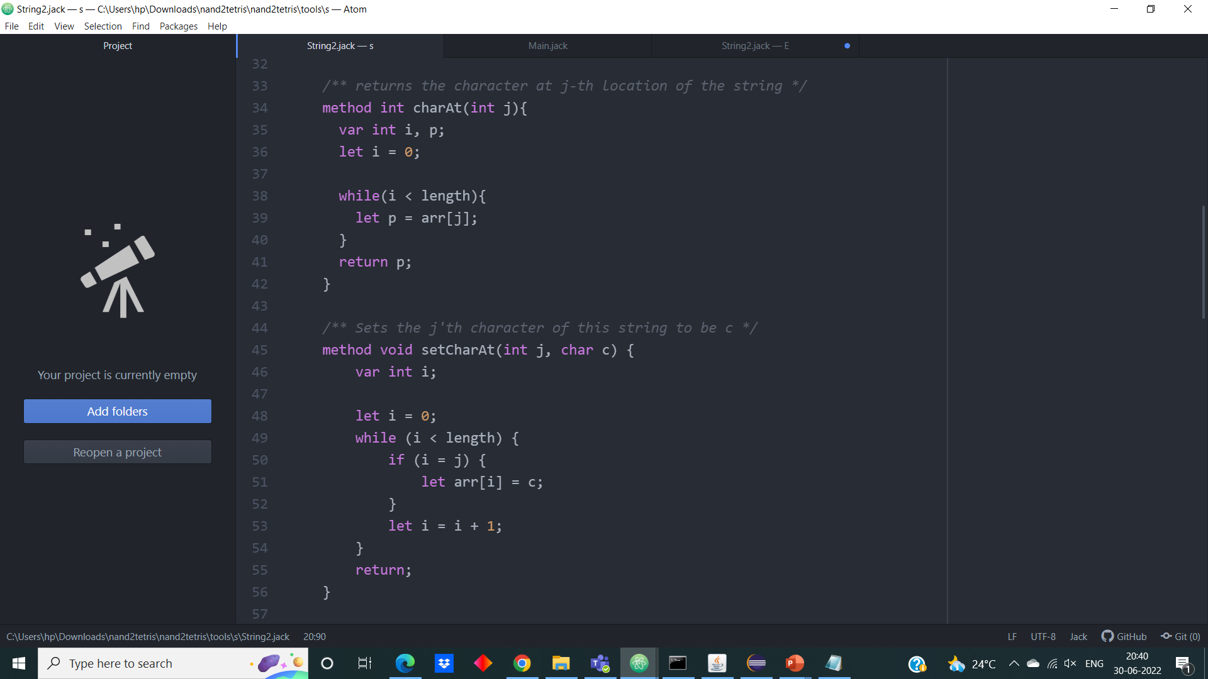**Jack Code:**

**Output:**

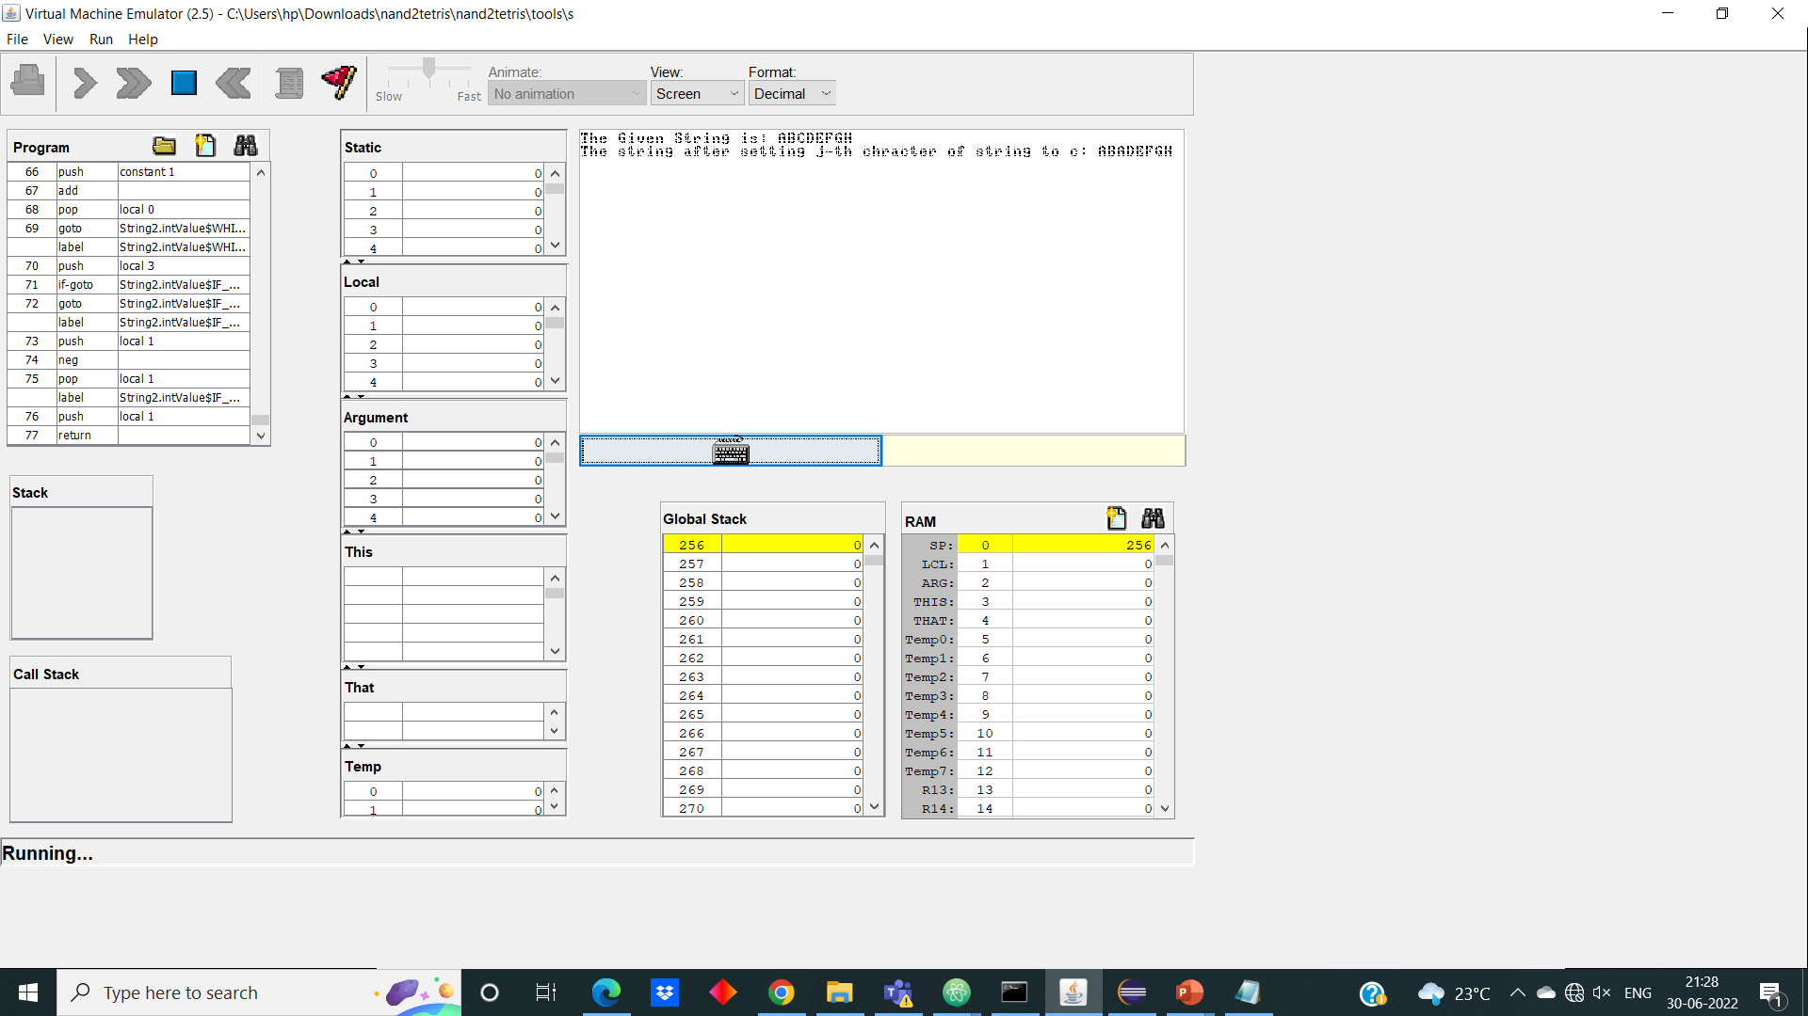 Here in this output, we are setting the character at 2nd location of given string to ‘A’.

**2. appendLastchar**

The implementation of appendLastchar will append the given character to end of the string. The logic used here is we created a new array with length ‘(length+1)’ and in the iteration all elements in the array ‘arr’ is added to it and finally the character we need to append is assigned to the last index.

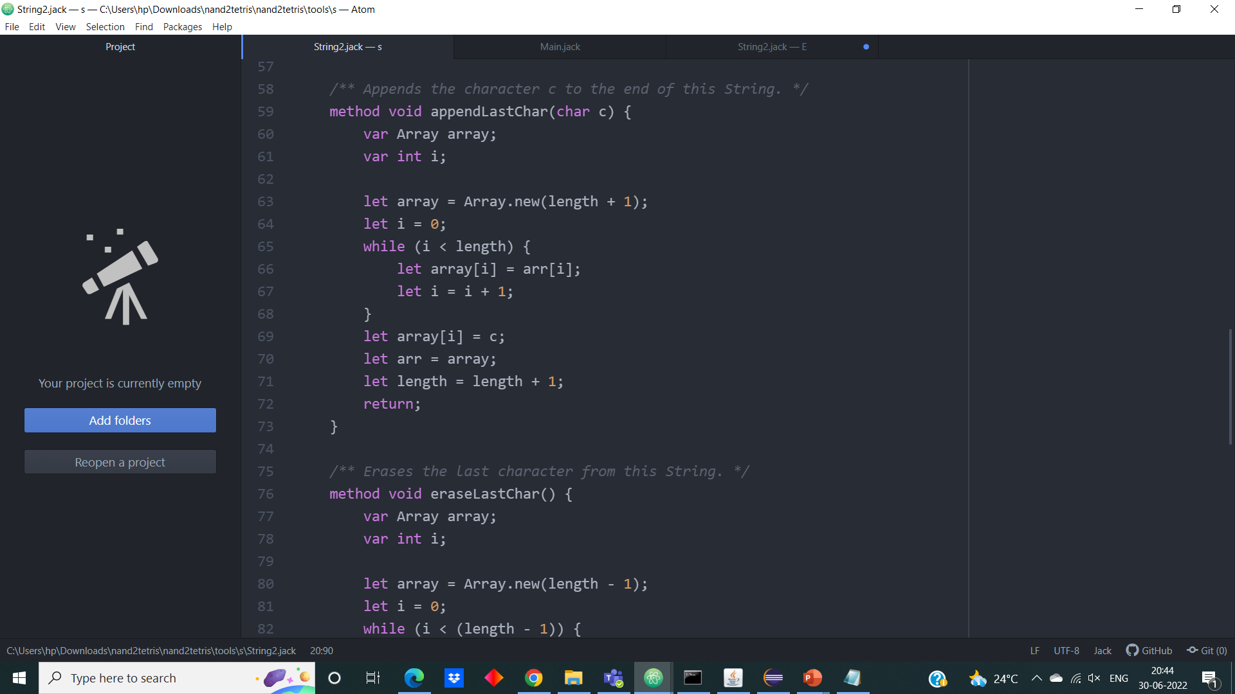**Jack Code:**

**Output:**

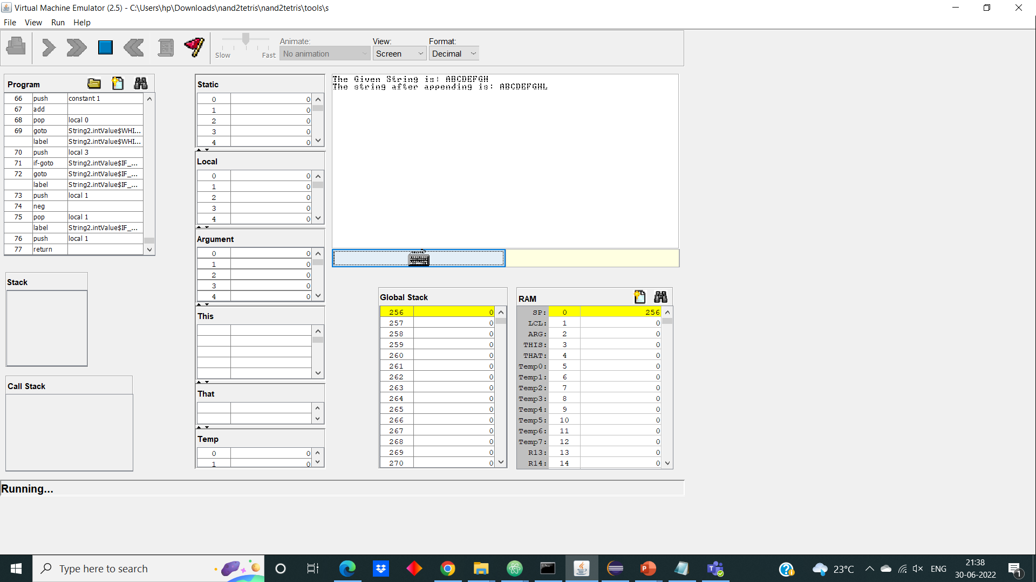 Here in the Output, we appending the character ‘L’ to the end of the string.

**3. eraseLastchar**

The “earseLastchar” will erase the last from the given string and return the string. The logic used here is, we will create an array with length one less than the length of array ‘arr’ and in while iteration we will add the elements into the new array. As length is ‘length-1’ only element up to last before index we store in new array. So, the last element got erased.

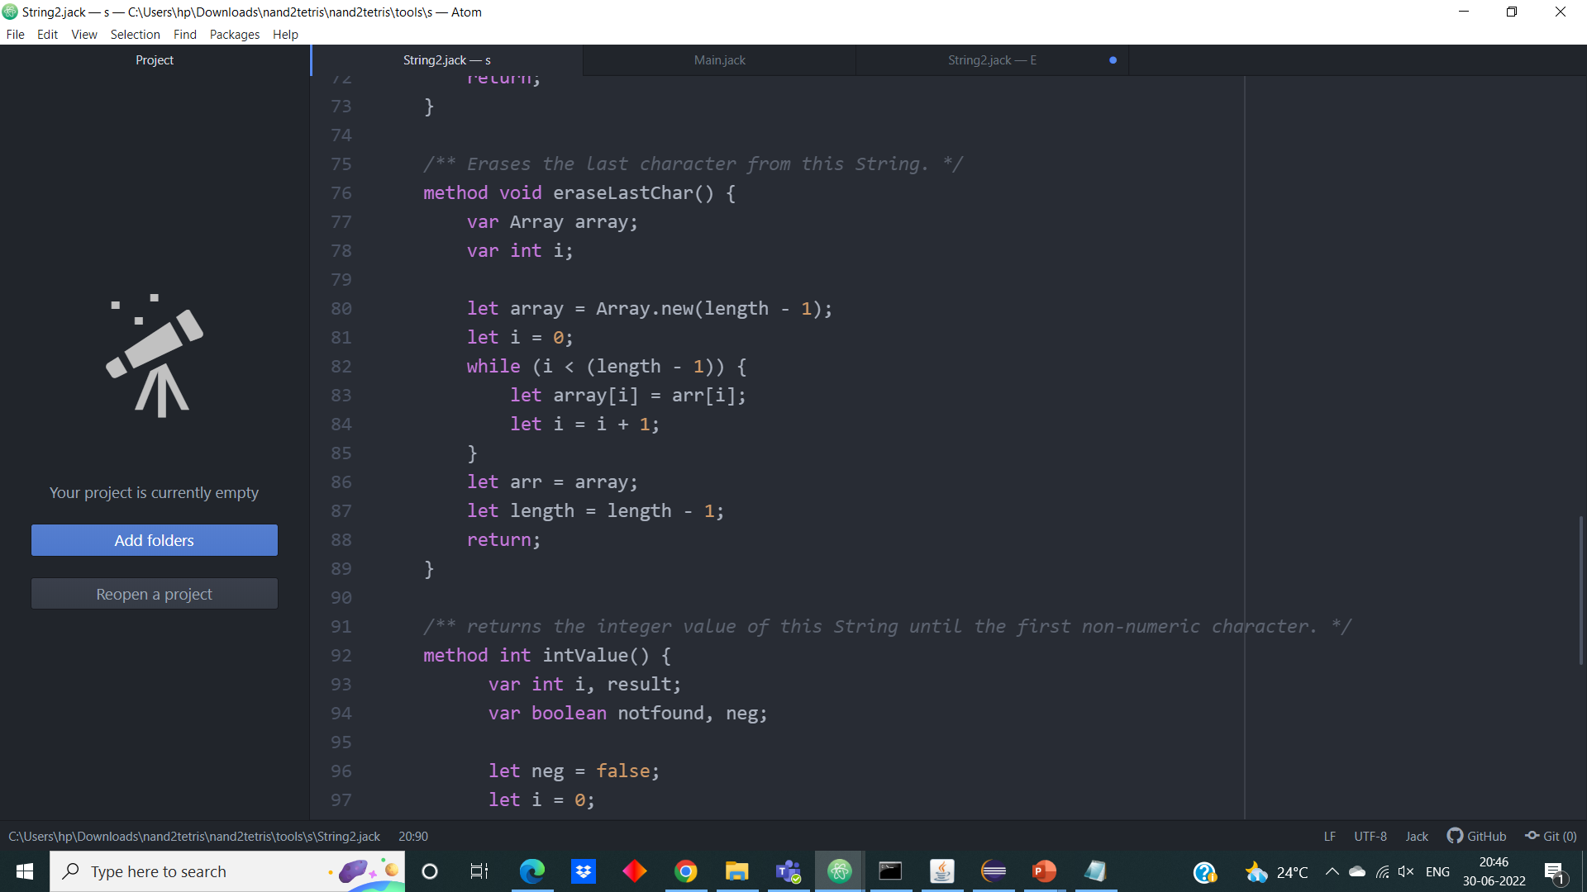**Jack Code:**

**Output:**

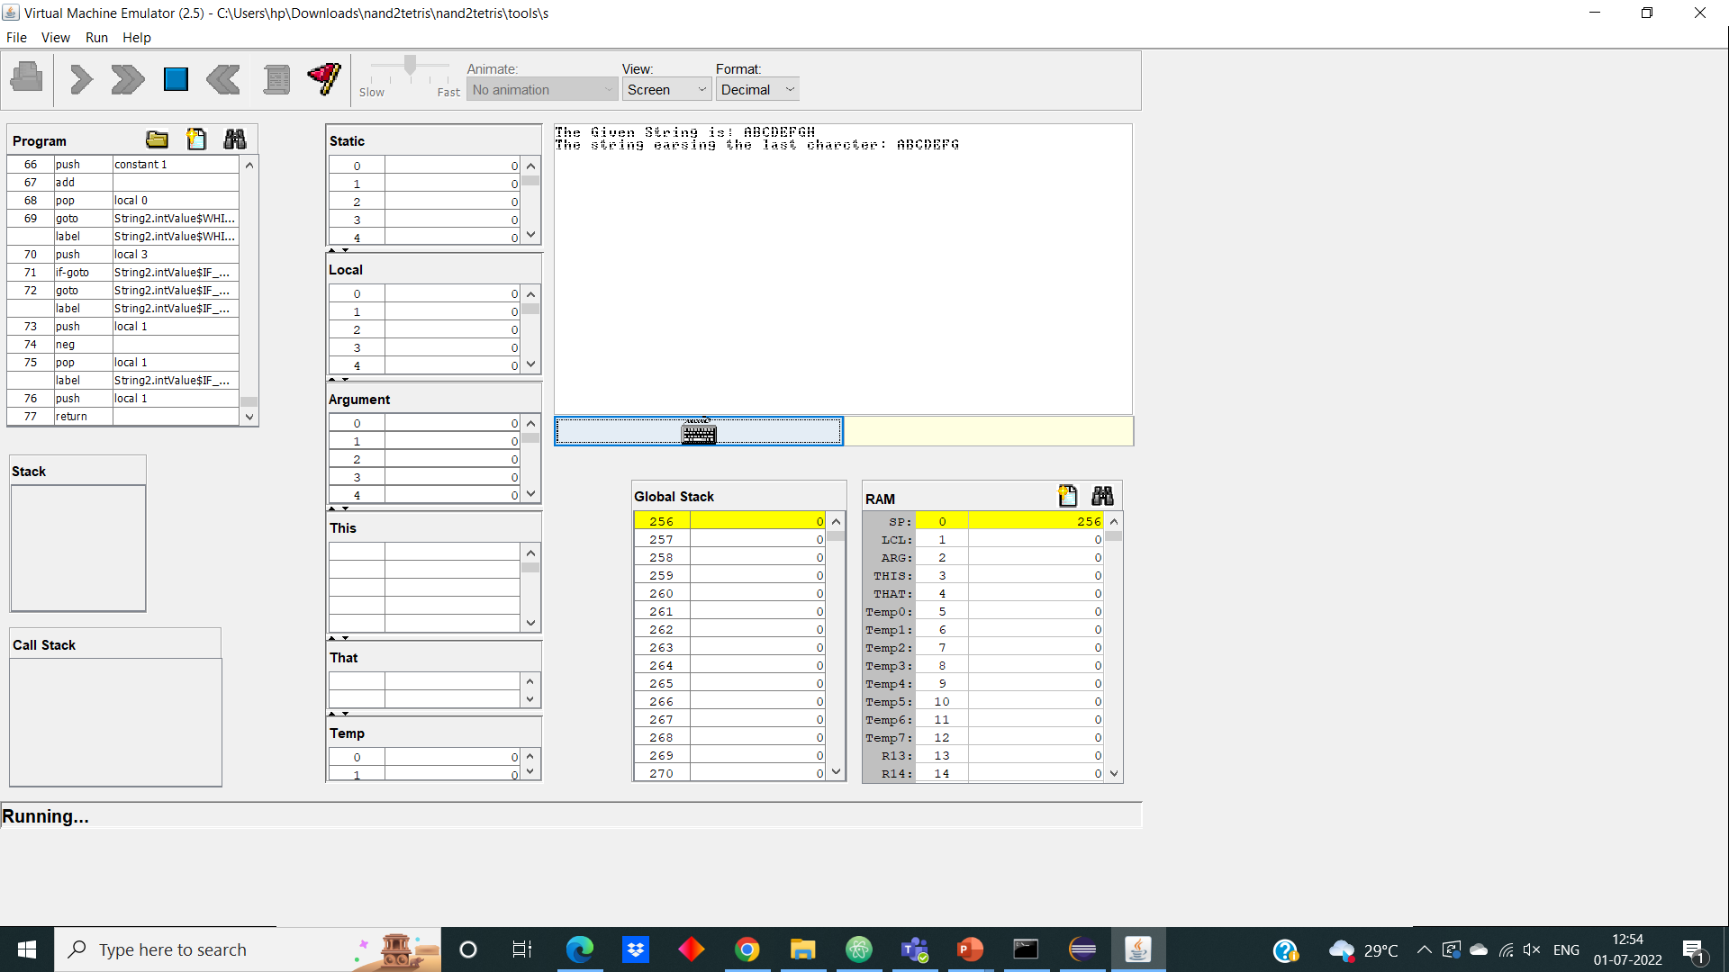 Here in this output, the last character ‘H’ got erased from the given string “ABCDEFGH”.

**4. intValue**

The “intValue” will returns you the integer value of the given string until the first non-numeric character. For that, first we will check the 0th index of string, if it is minus, we will multiply our final answer by minus. Next, we will whether remaining are integer using ASCII codes. When we found the ASCII code of non-numeric character, the iteration will be stopped.

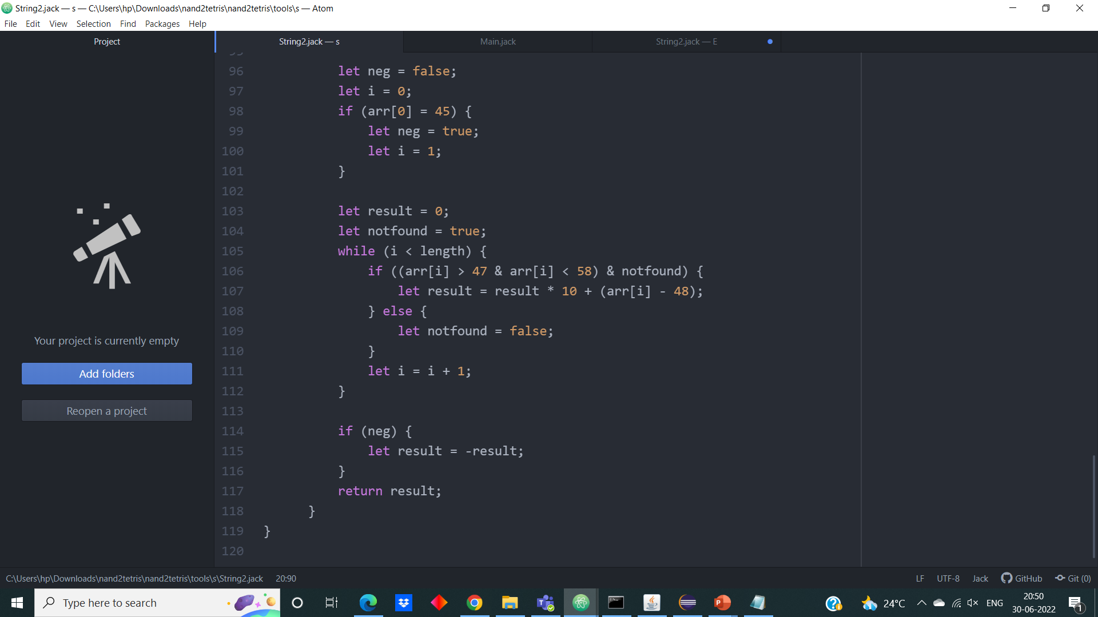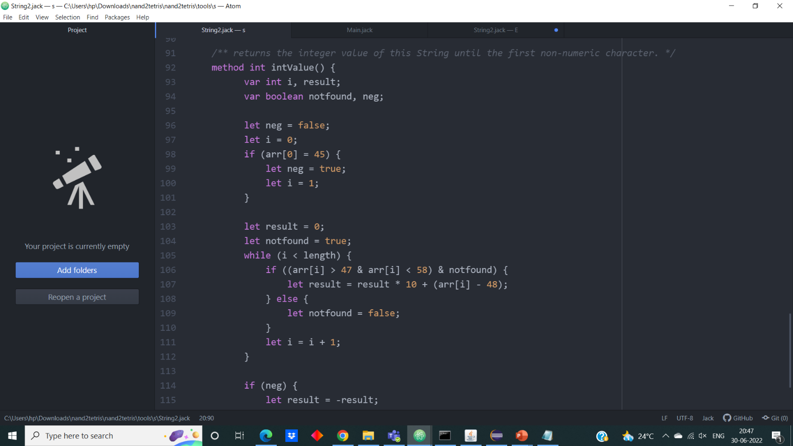**Jack Code:**

**Output:**

Here in this output, we are getting only the integer value upto first numeric value i.e., -1296 in “=1296ABC”.

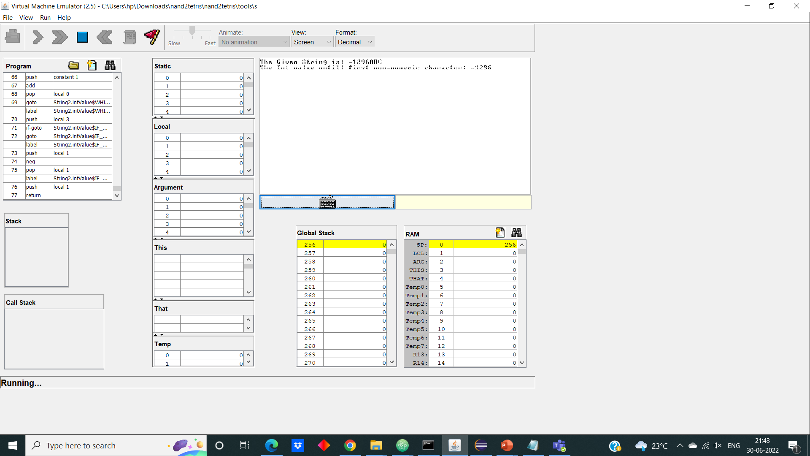

**5. toUppercase**

The “toUppercase” will change all the lowercase letters in the given string to upper case and returns the string. The logic used here is, first we will check the given character’s ASCII code of is in the range of 97 to 122 which indicates lower case letters and if it satisfies it’s ASCII code is subtracted by 32 which gives ASCII code of its Uppercase of its respective character.

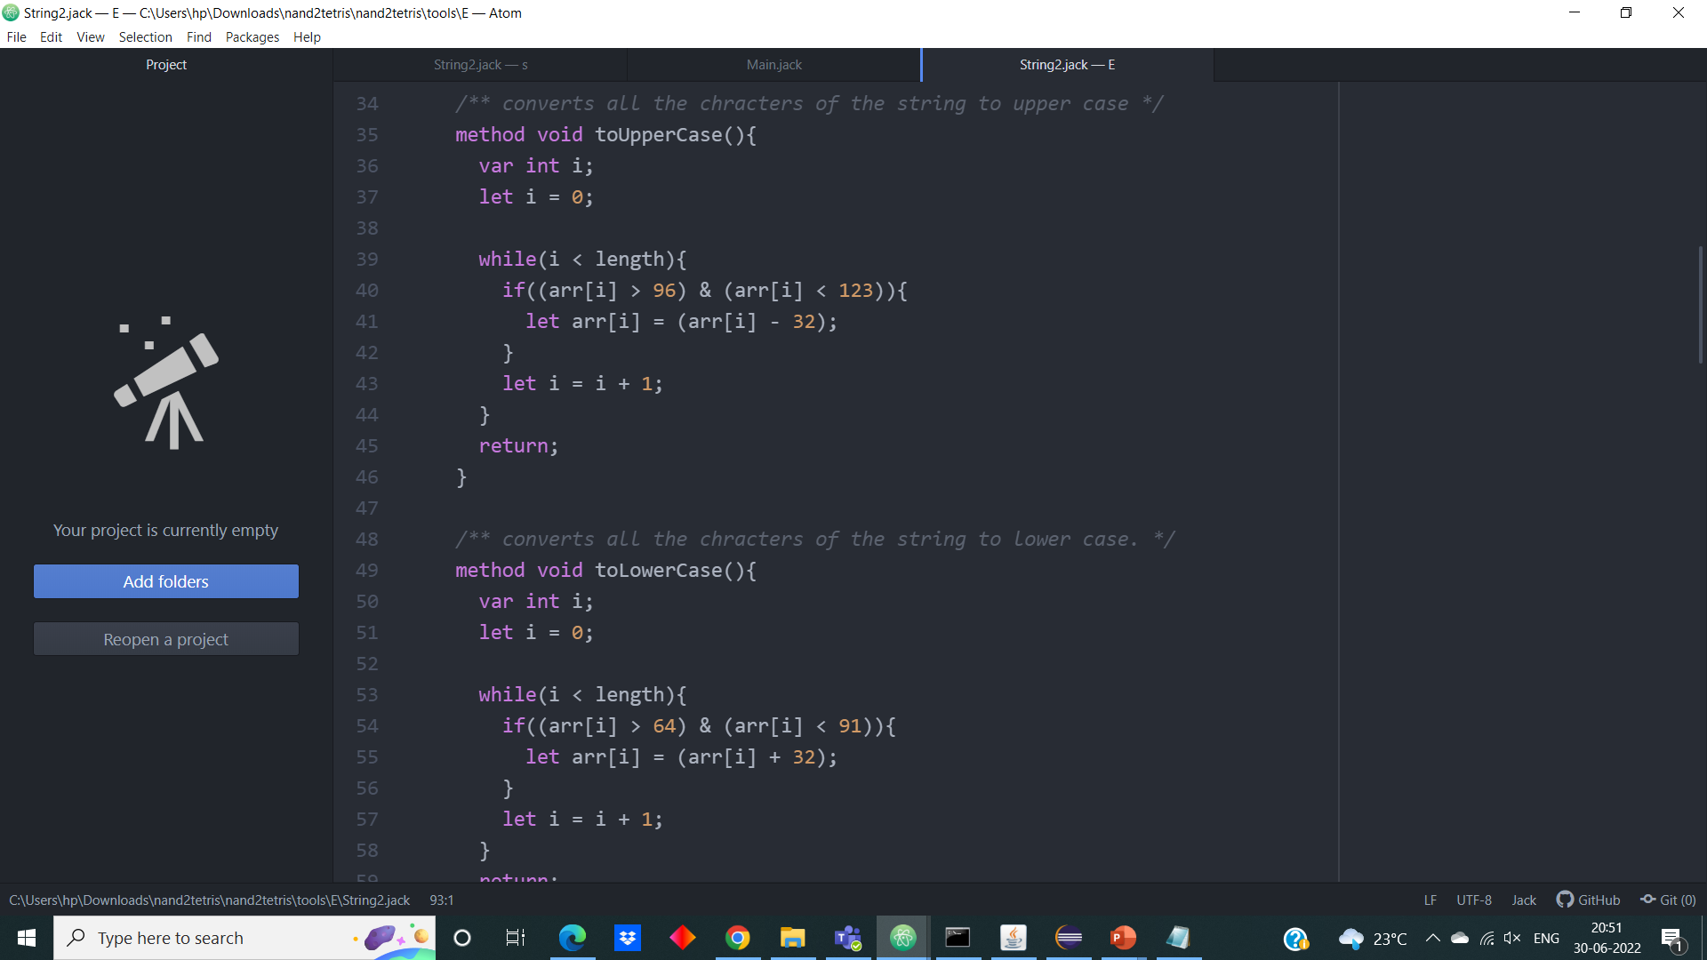**Jack Code:**

**Output:**

Here in this output, the given string in lowercases is converted to string

in uppercases.

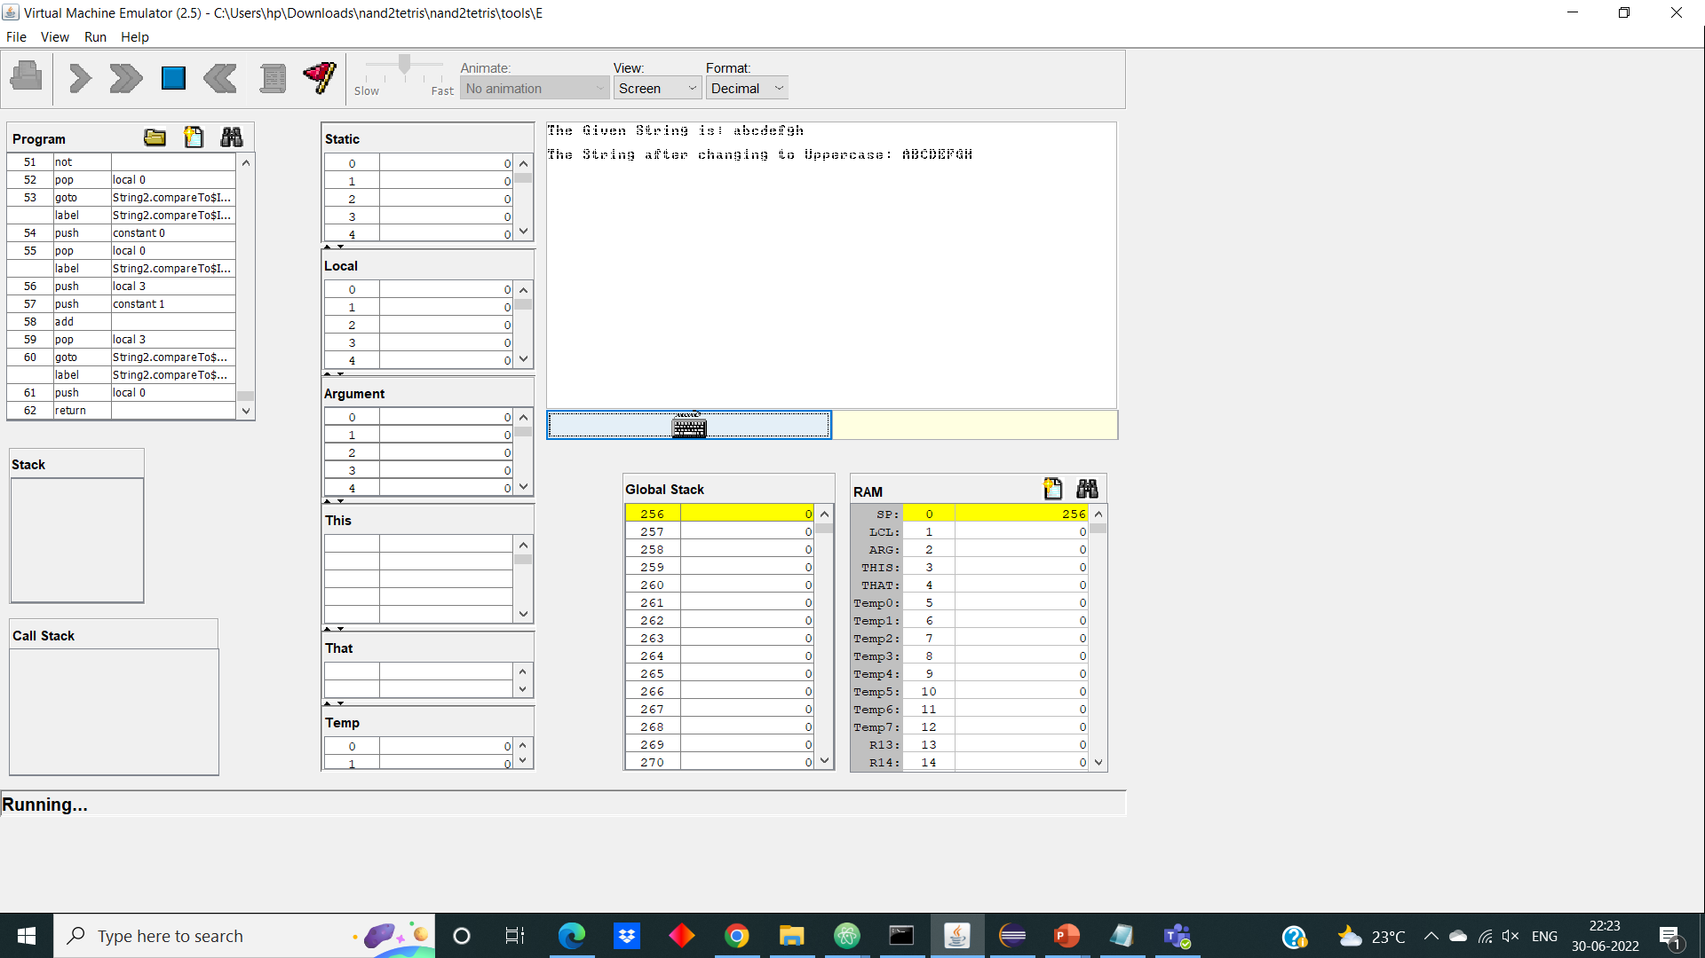

**6. toLowercase**

The “toLowercase” will change all the Uppercase letters in the given string to lower case and returns the string. The logic used here is, first we will check the given character’s ASCII code of is in the range of 65 to 90 which indicates upper case letters and if it satisfies it’s ASCII code is added by 32 which gives ASCII code of its Uppercase of its respective character.

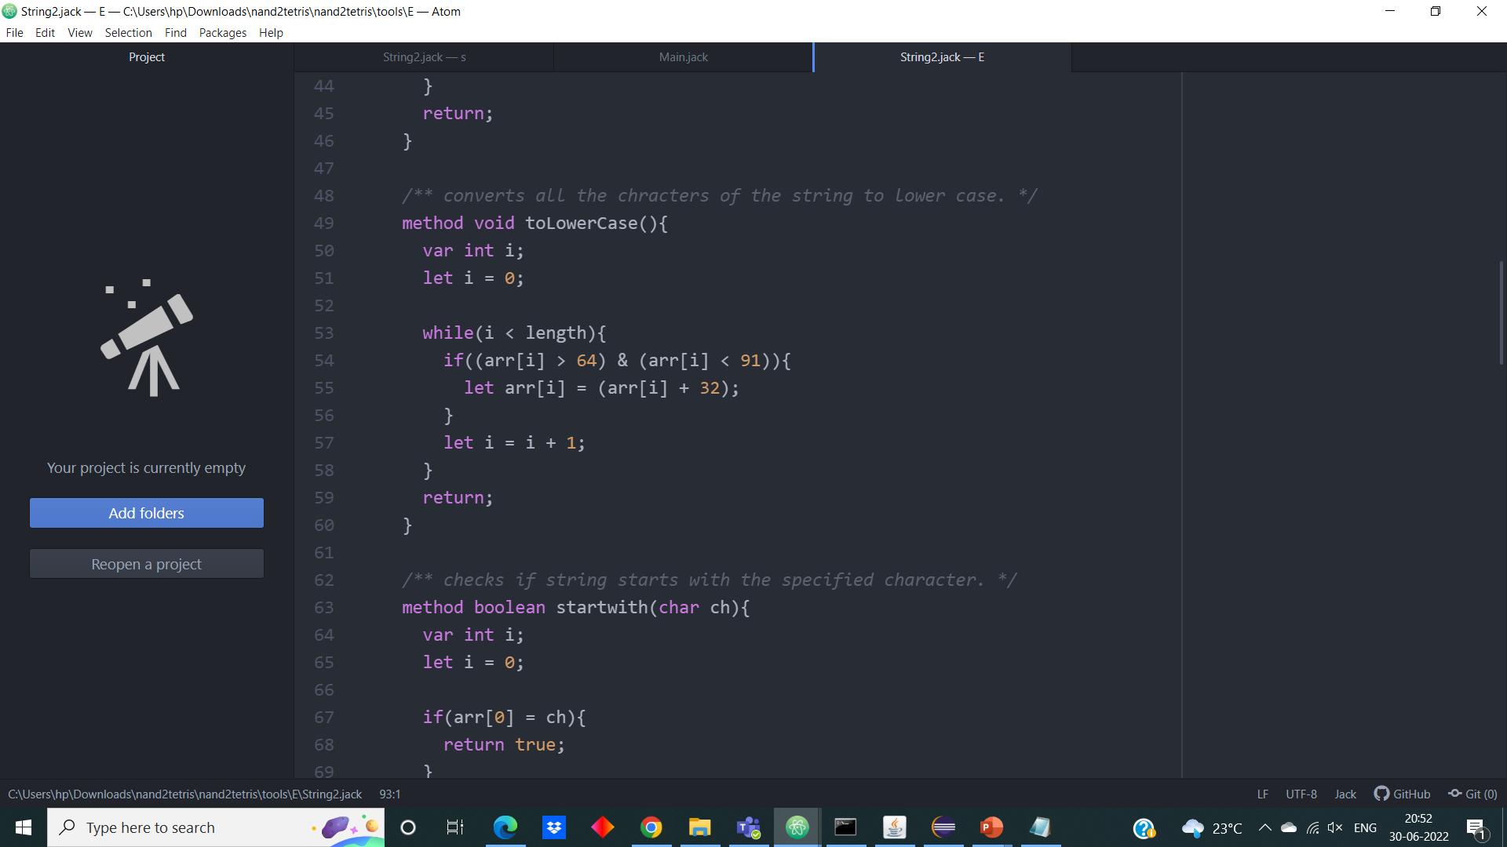**Jack Code:**

**Output:**

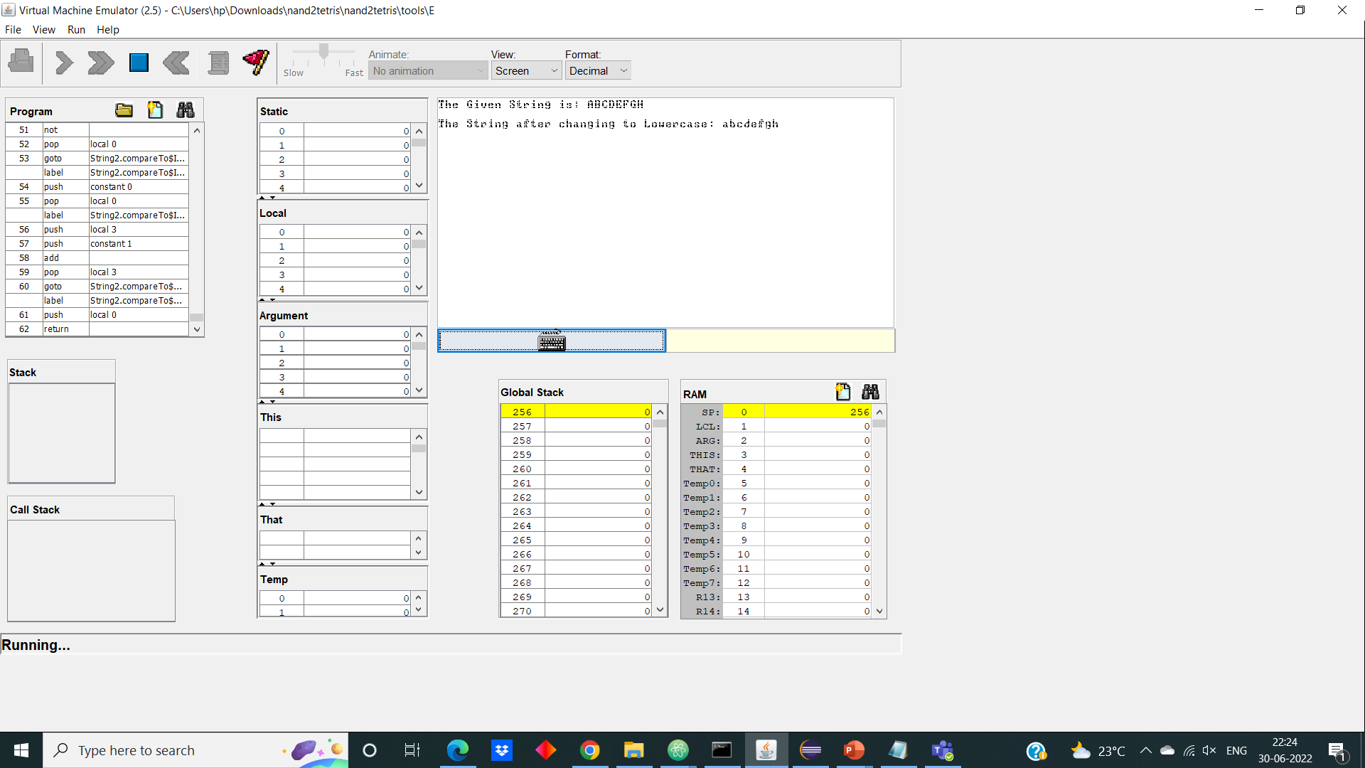 Here in this output, the given string in Uppercases is converted to string in lowercases.

**7. startswith**

The “startswith” will check if the given string starts with the given specified character. The logic used here is, we will check whether the 0th index of the array is equal to the given character.

**Jack Code:**

**Output:**

Here in this output, we are checking whether the given string starts with the character ‘A’.

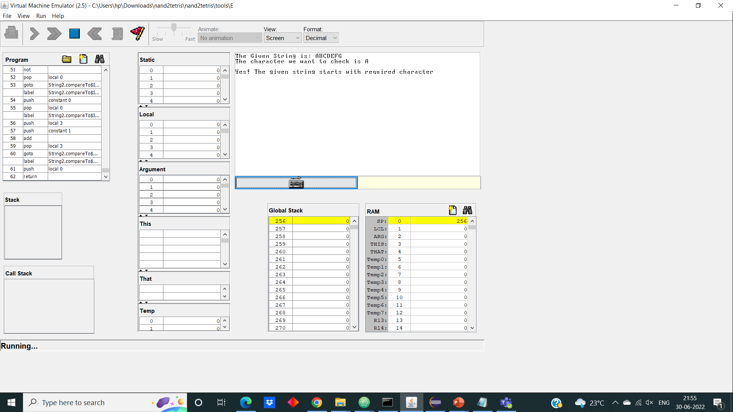

**8. endswith**

The “endswith” will check if the given string starts with the given specified character. The logic used here is, we will check whether the (length-1) th index of the array is equal to the given character.

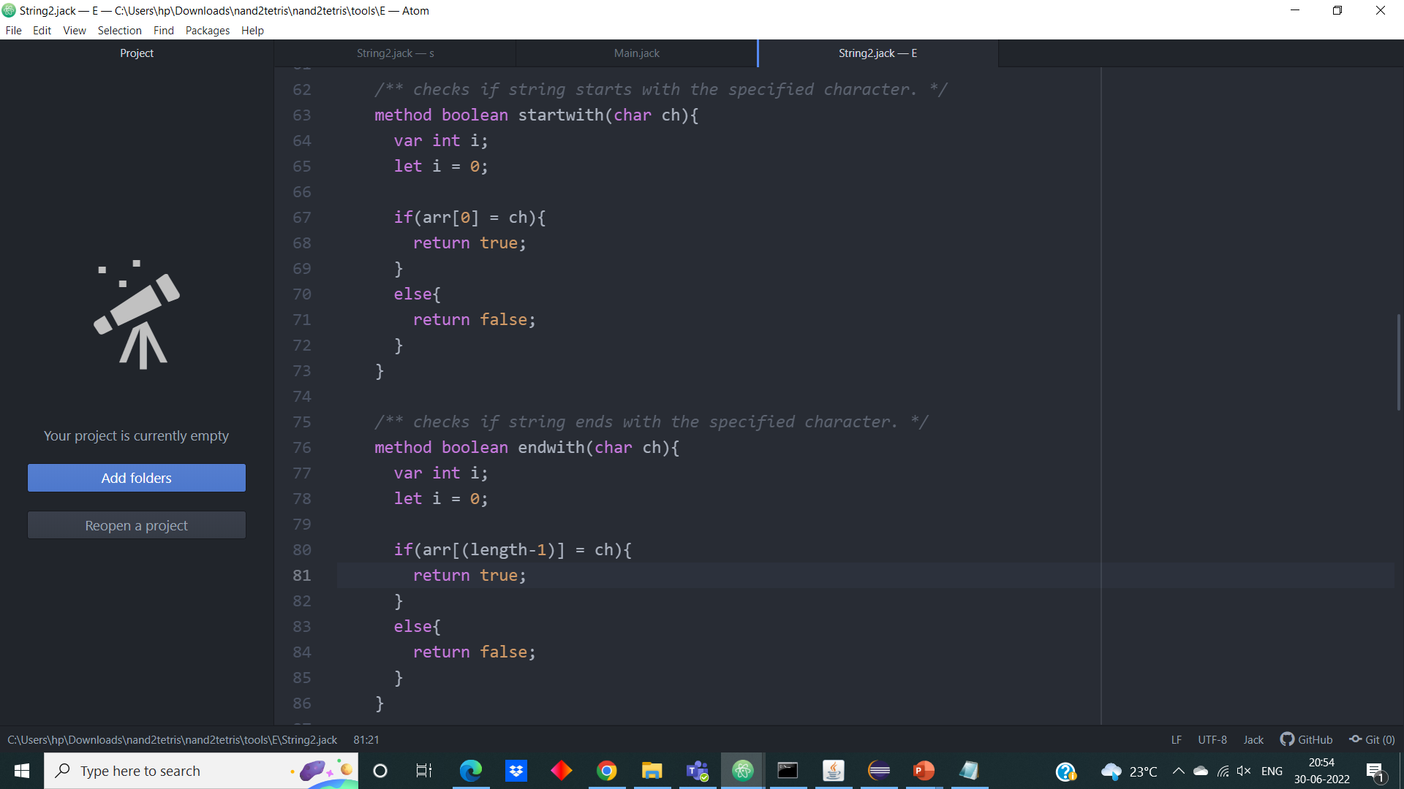**Jack Code:**

**Output:**

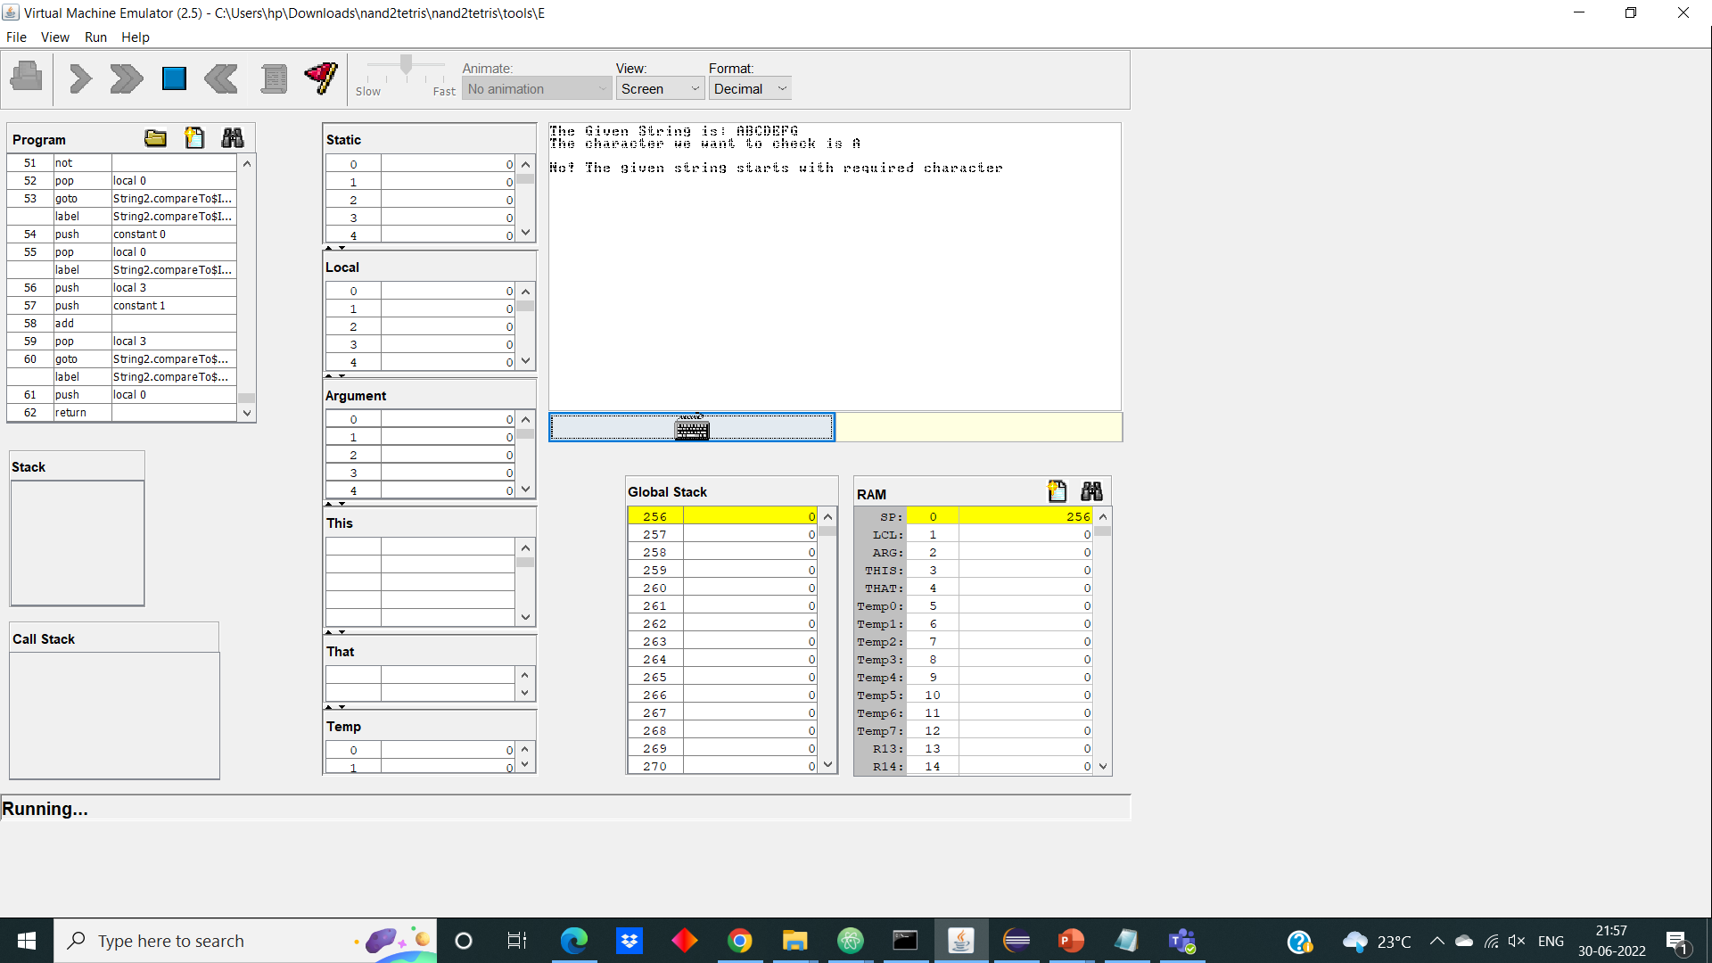 Here in this output, we are checking whether the given string end with the character.

**9. subString**

The “subString” will give the substring of the given string. The substring begins at specified beginIndex and extend to character at index endIndex-1.

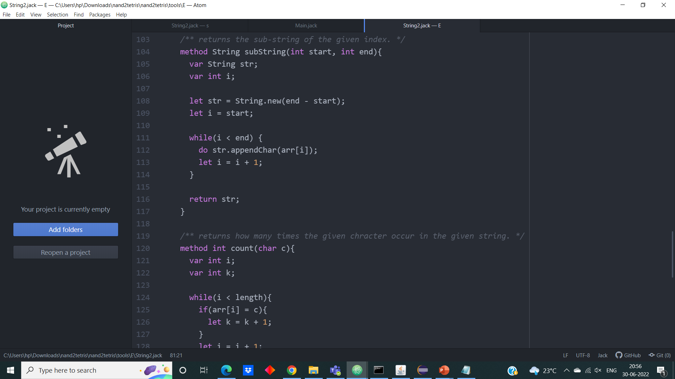**Jack Code:**

**Output:**

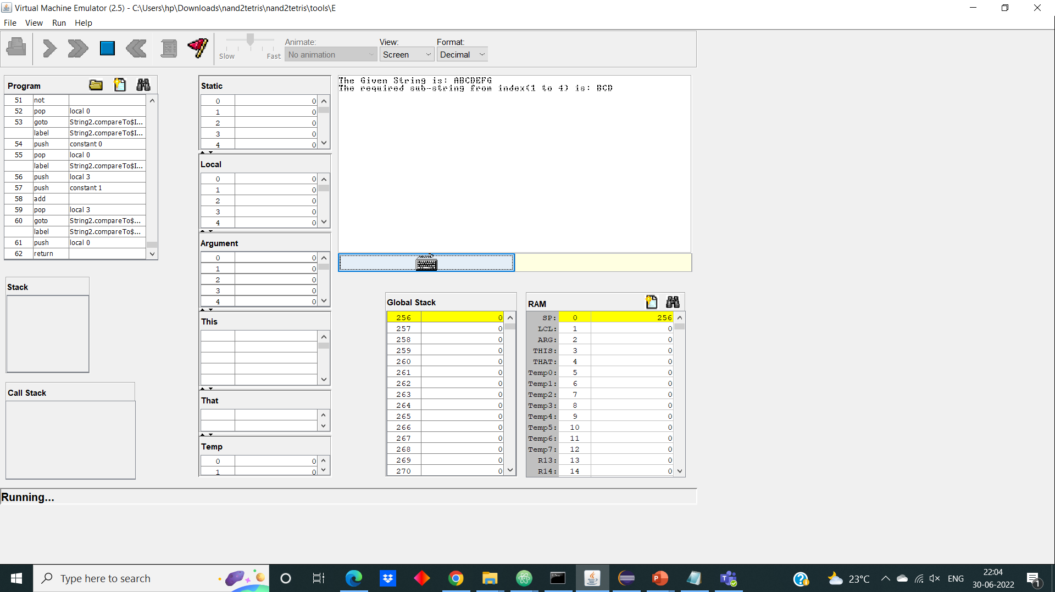 Here in this output, we are getting the substring of our string “ABCDEFGH” from index 1 to 4 i.e., “BCD”.

**10. compareTo**

The “compareTo” will check whether the two given strings are equal or not.

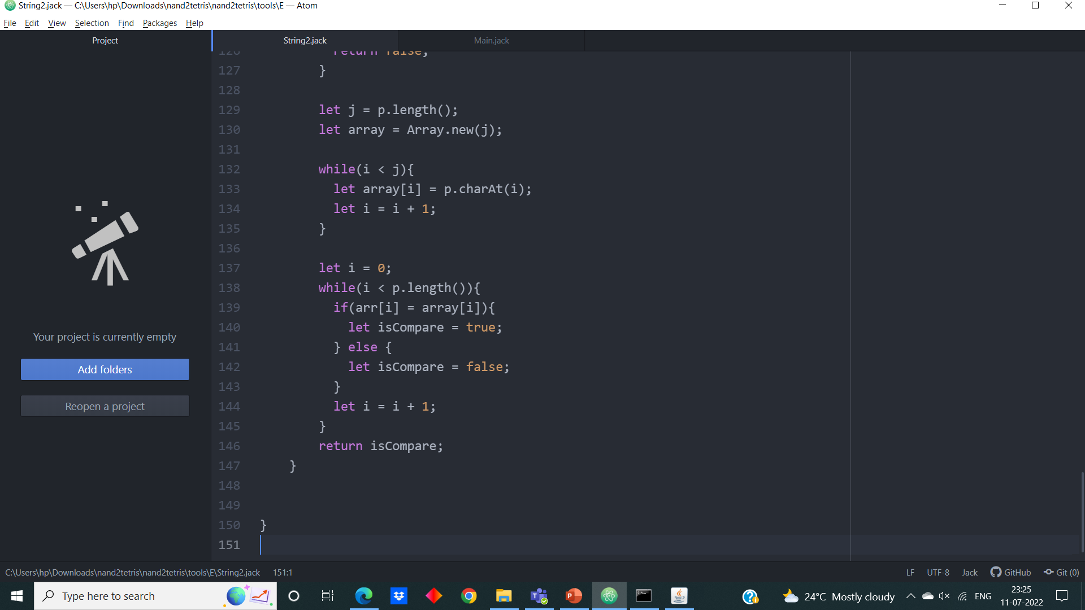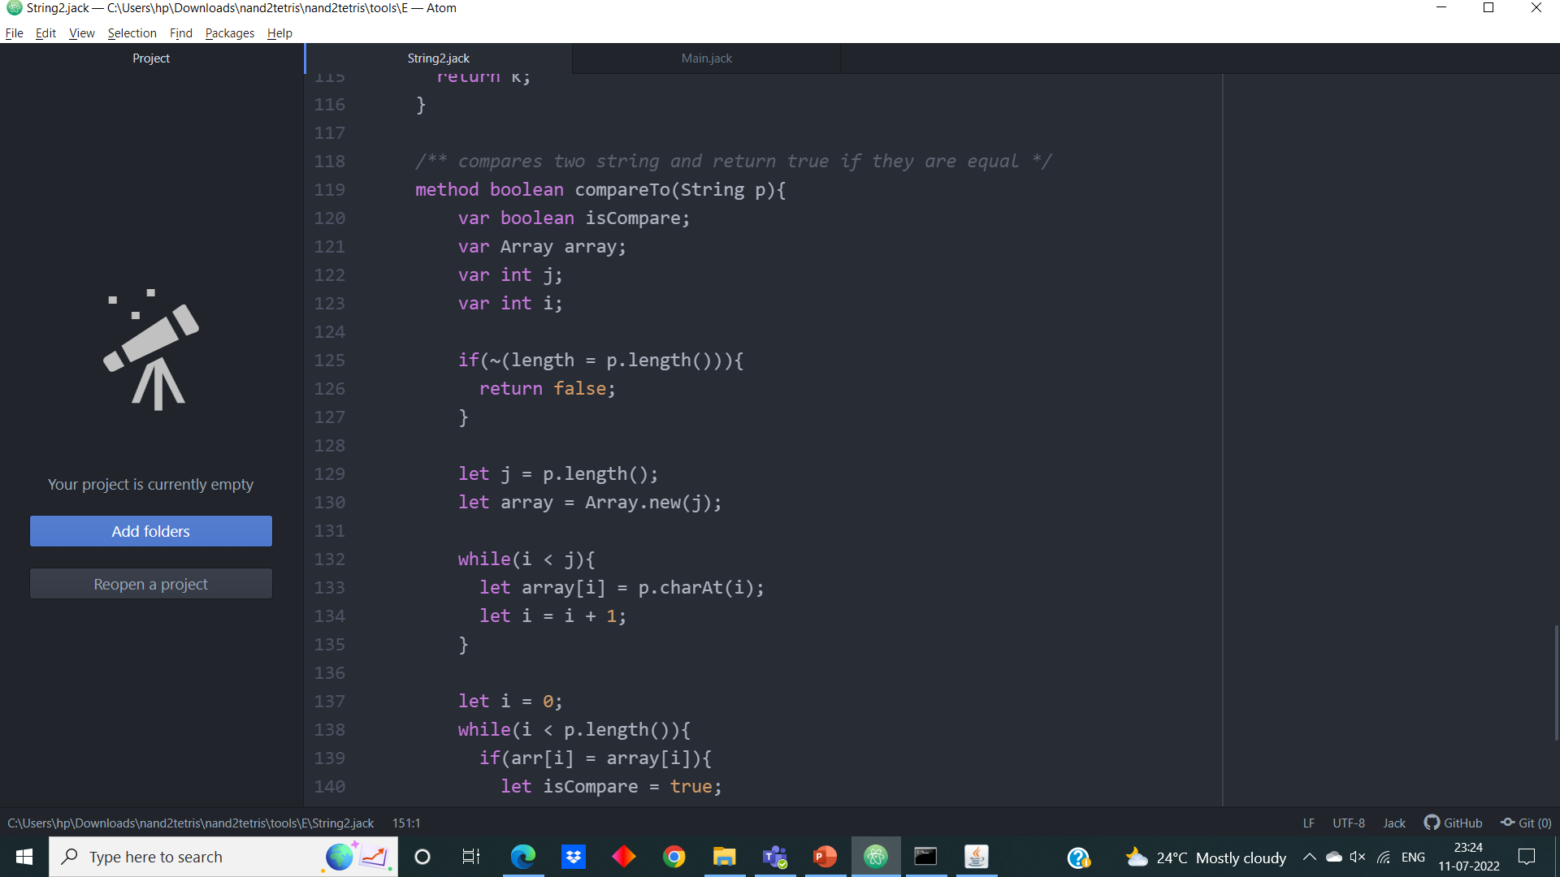**Jack Code:**

**Output:**

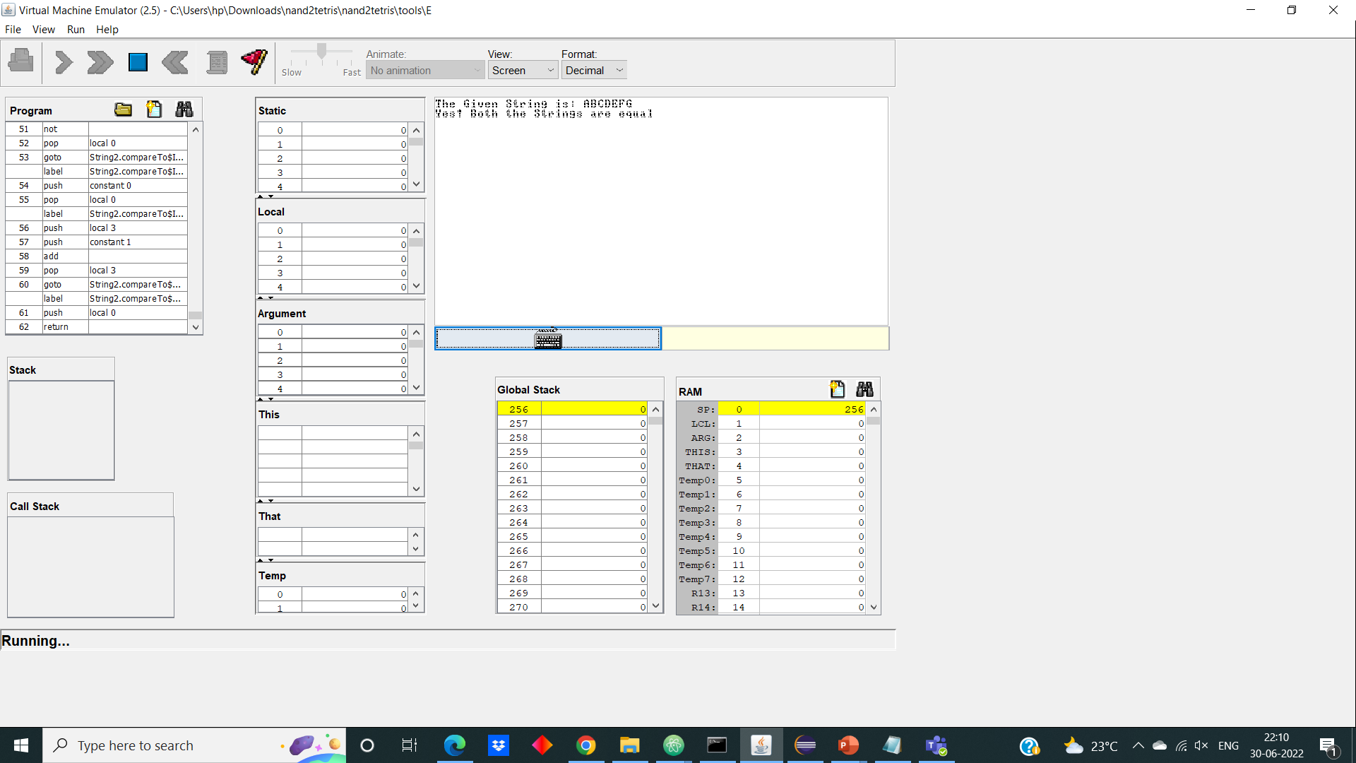 Here in this output, the input string is ‘ABCDEFG’ and it is compared with another string ‘ABCDEFG’.

**11. count**

The “count” will check how many times the given character appeared in the given string. The logic used here is, while iterating the given array if we find the required character in it count variable is incremented by 1 and finally after iteration completed, we get how many times it appeared in the string.

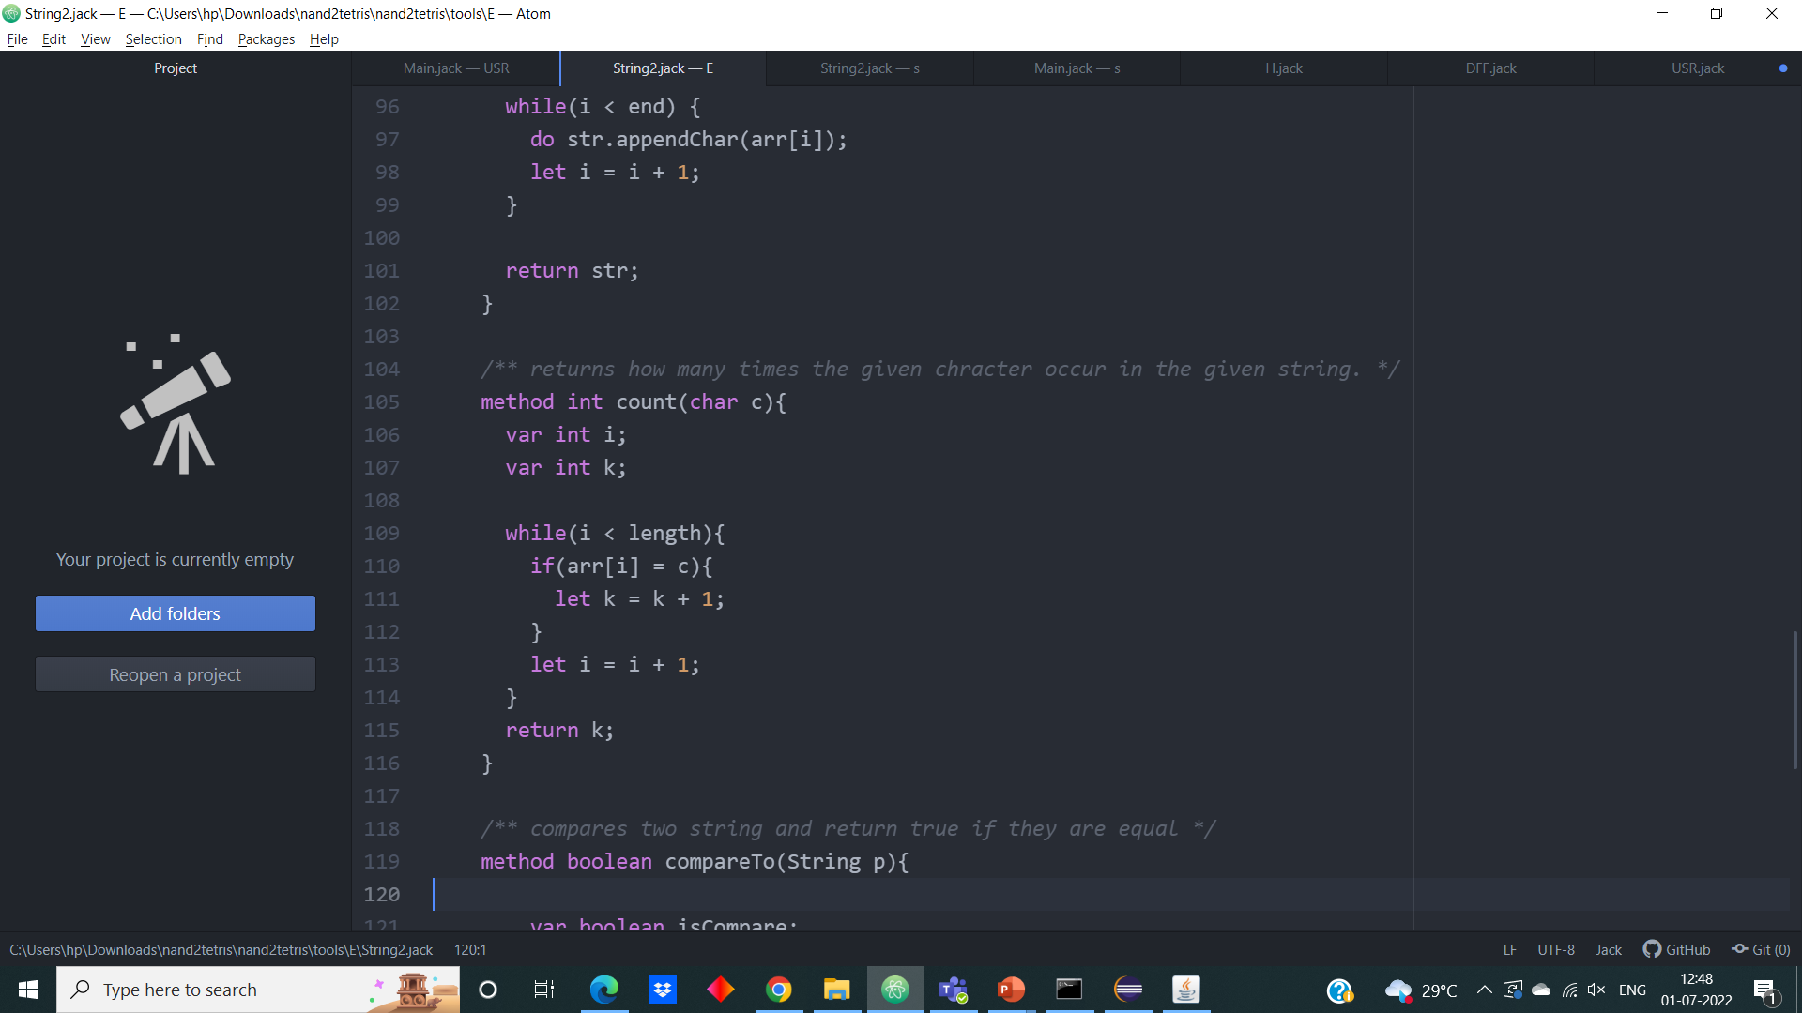**Jack Code:**

**Output:**

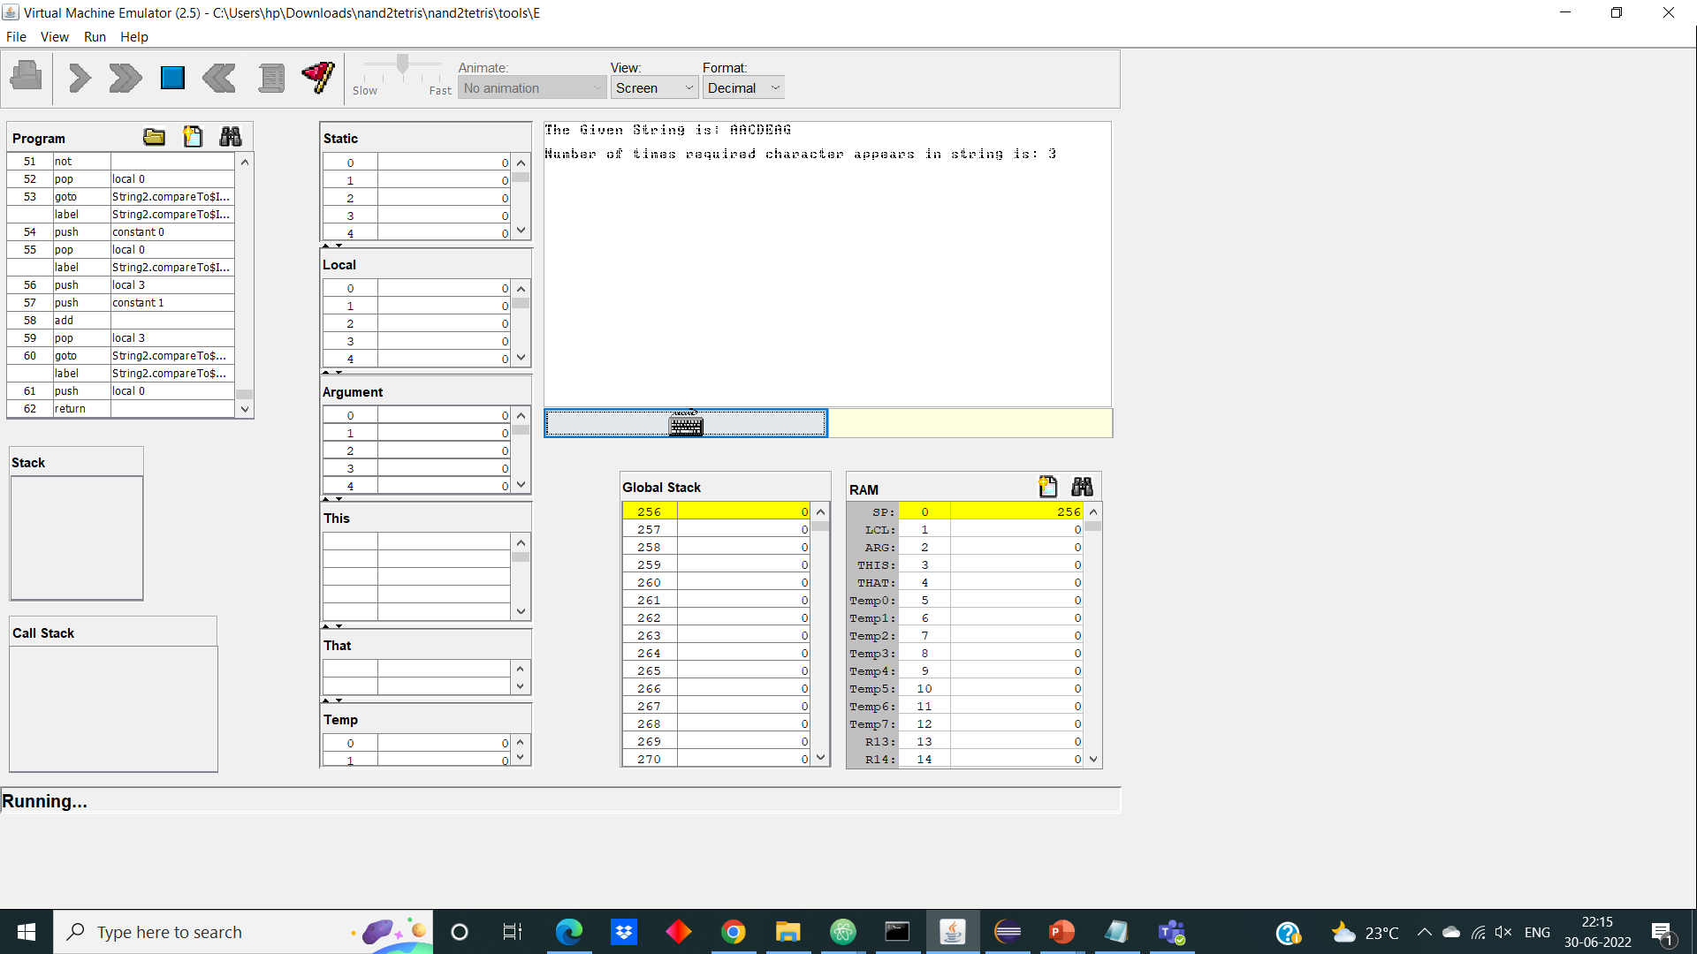 Here in this output, we will count how many times the character ‘A’ appeared in the string “AACDEAG”

Now in the Part-2 of this question we will covert this vm file into the asm file by using VM translator we build in python and asm file to hack file using the Assembler.

Next, we will compare the hack file generated by Assembler in the Nand2tetris and the Assembler we built on our own in python.

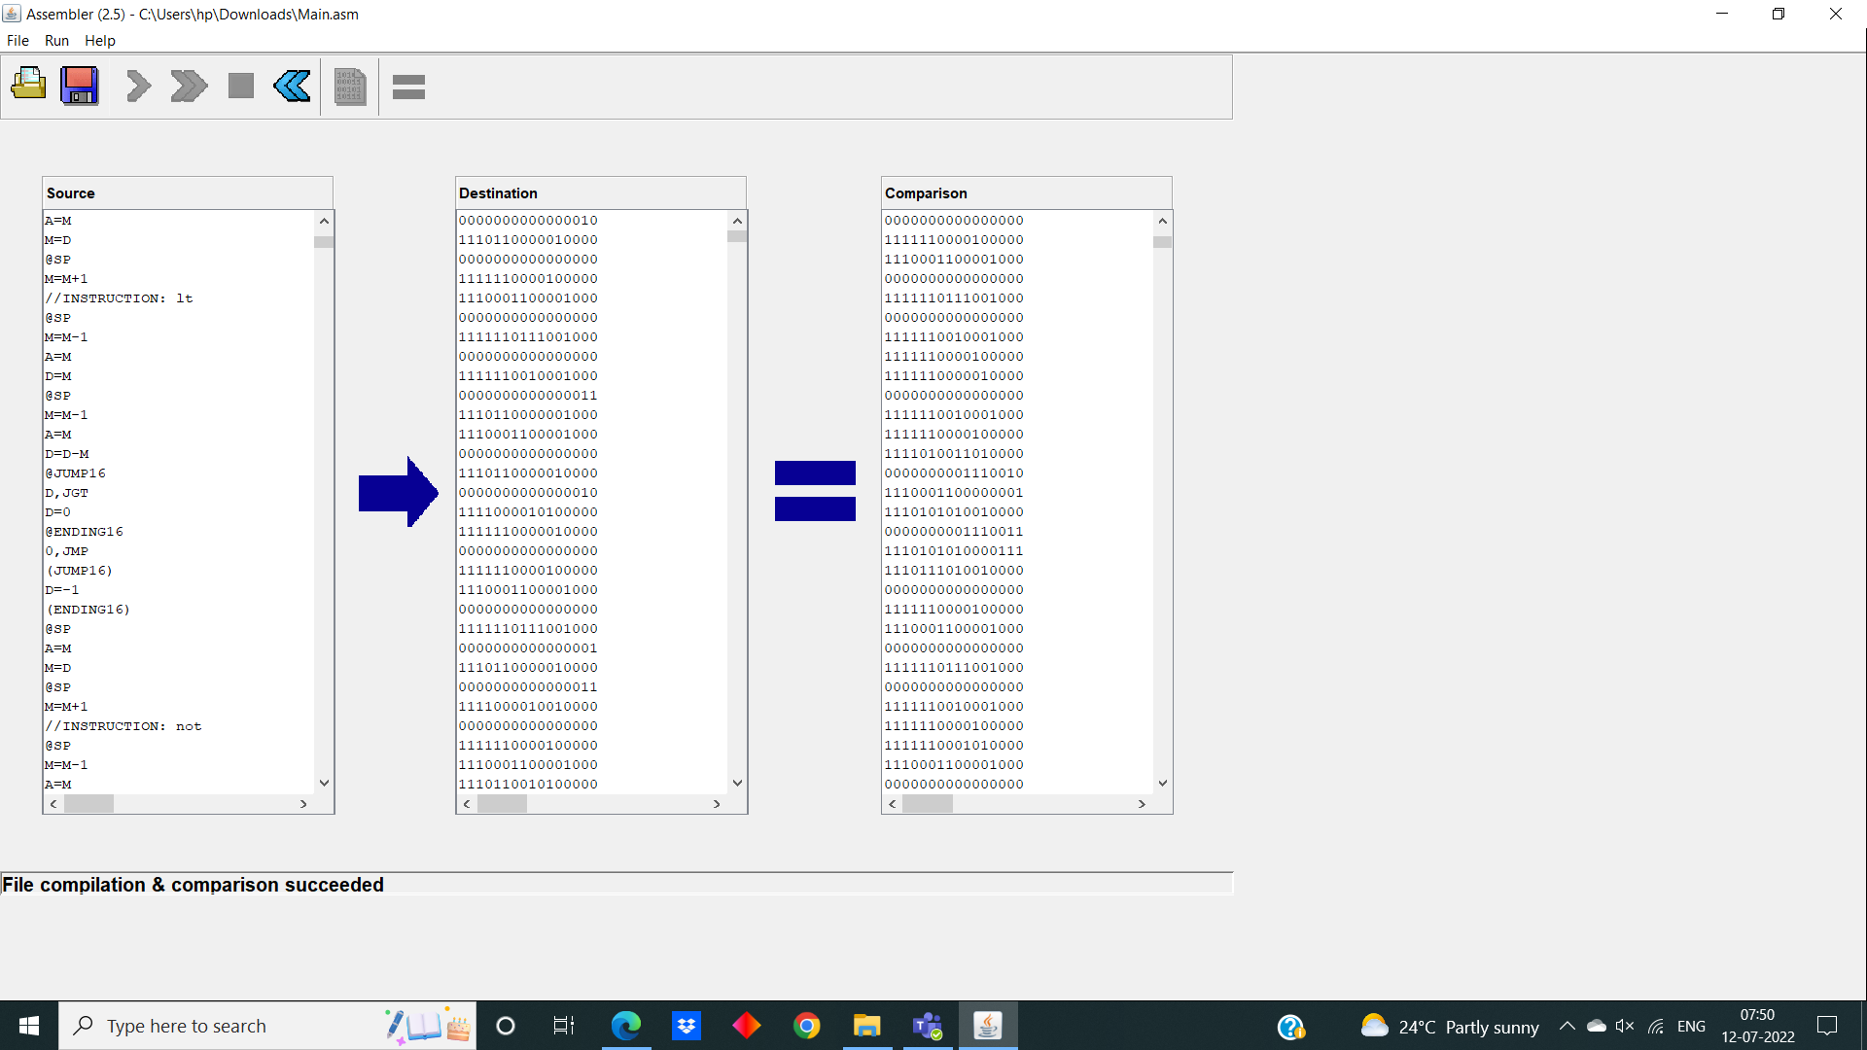

**Chapter - 2**

**AIM:**

Our aim is to build a Hack CPU and all the required gates used in the implementation of it in the Jack Language.

**Steps of action of Jack:**

1. Here the implementation of the CPU is done from the scratch.
2. All the basic gates implemented is done from the Nand gate.
3. These basics gates implemented using Nand gate is further implemented in Secondary and important chips.
4. But here the implementation of 16-bit gate is done differently. Normally, 16-bit array should be the input for it but giving a 16-bit array as input is somewhat difficult. So, what we do is we give input as integer and in that method (or) function is converted to its respective 16-bit binary representation. Finally, the return value will also be the 16-bit array.

**Block schematic design Hack CPU**

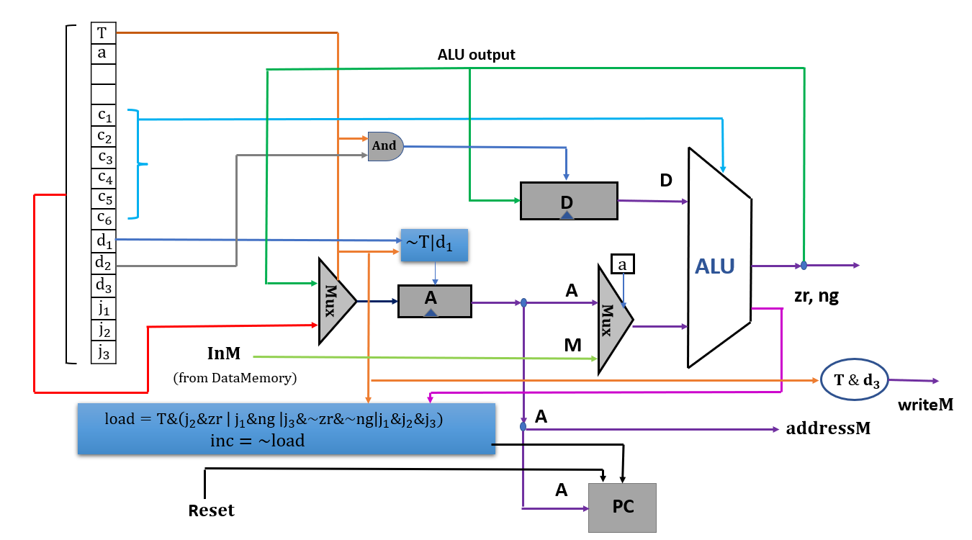

**A) Primary Chips**

**1.Nand gate**

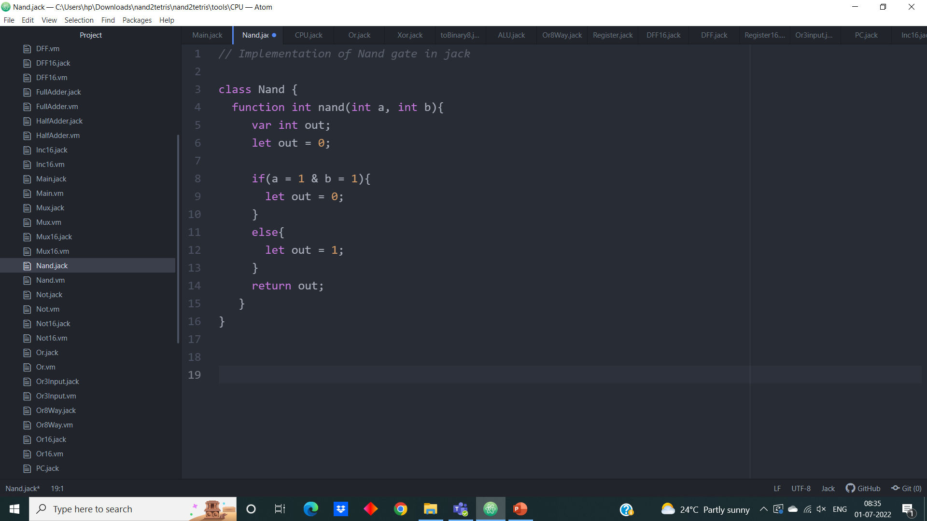 **Jack Code:**

**2.Or gate**

**Jack Code:**

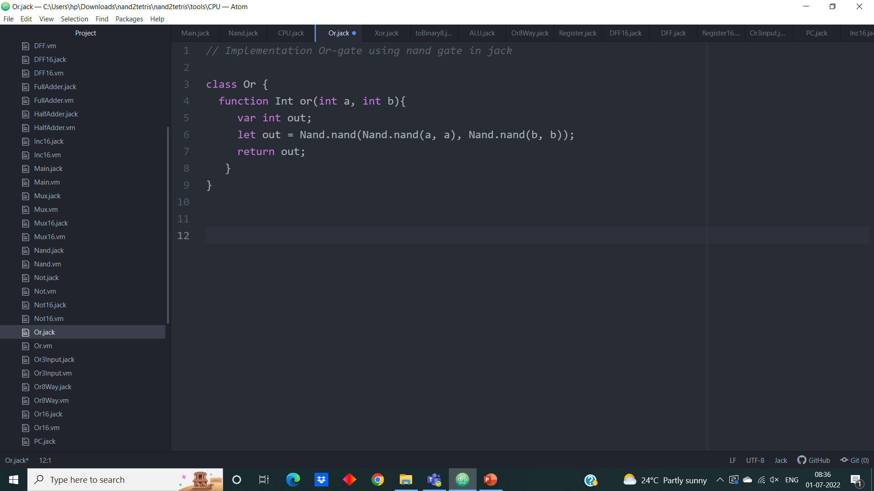

**3. And gate**

**Jack Code:**

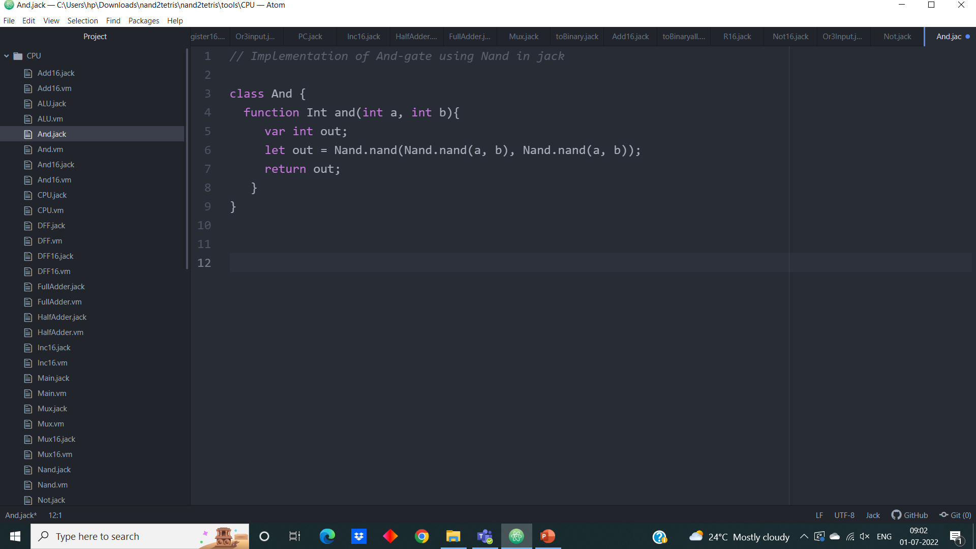

**4.Not gate**

**Jack Code:**

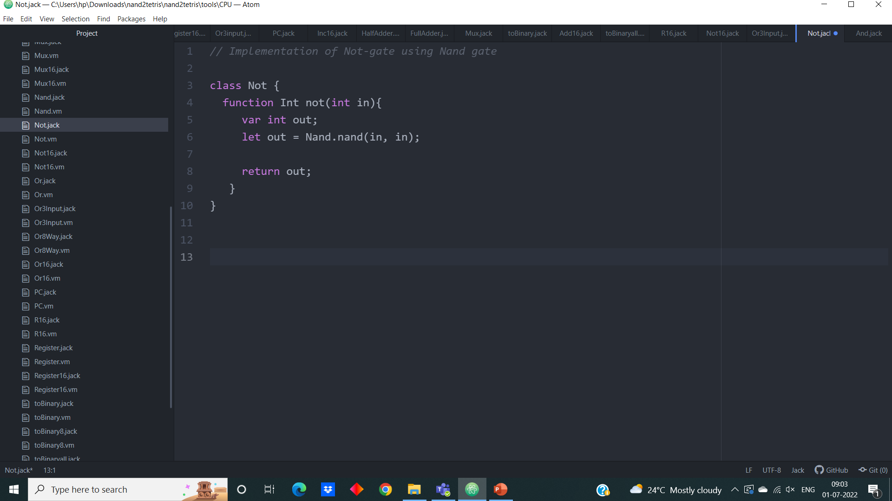

**5. Xor gate**

**Jack Code:**

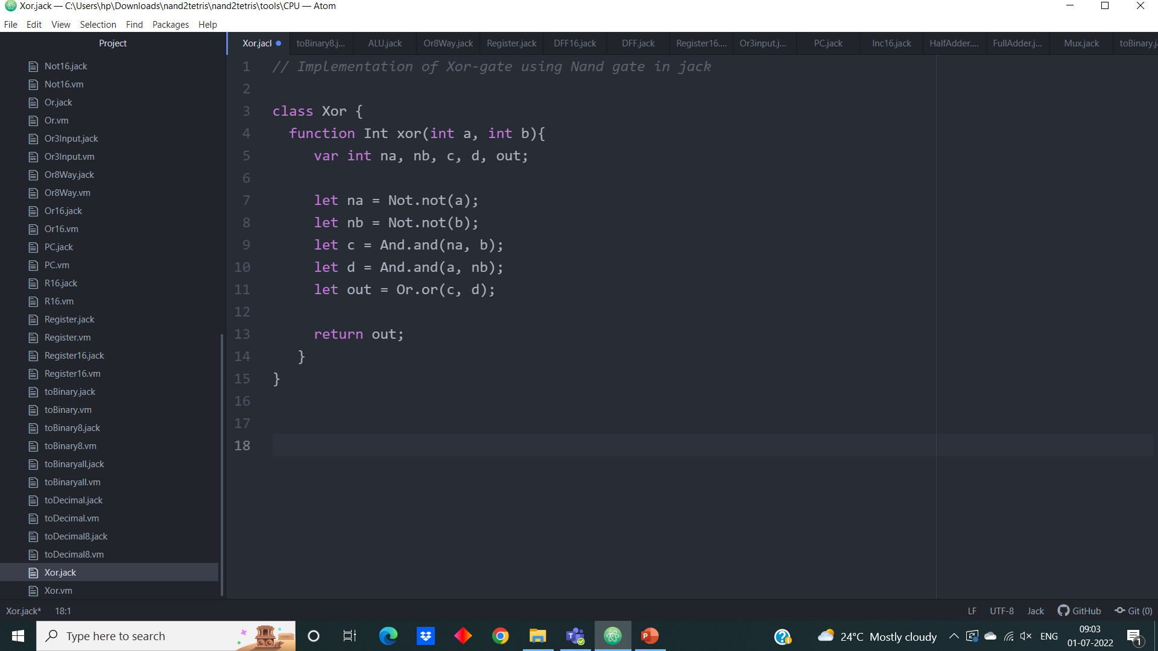

**6. Mux gate**

**Jack Code:**

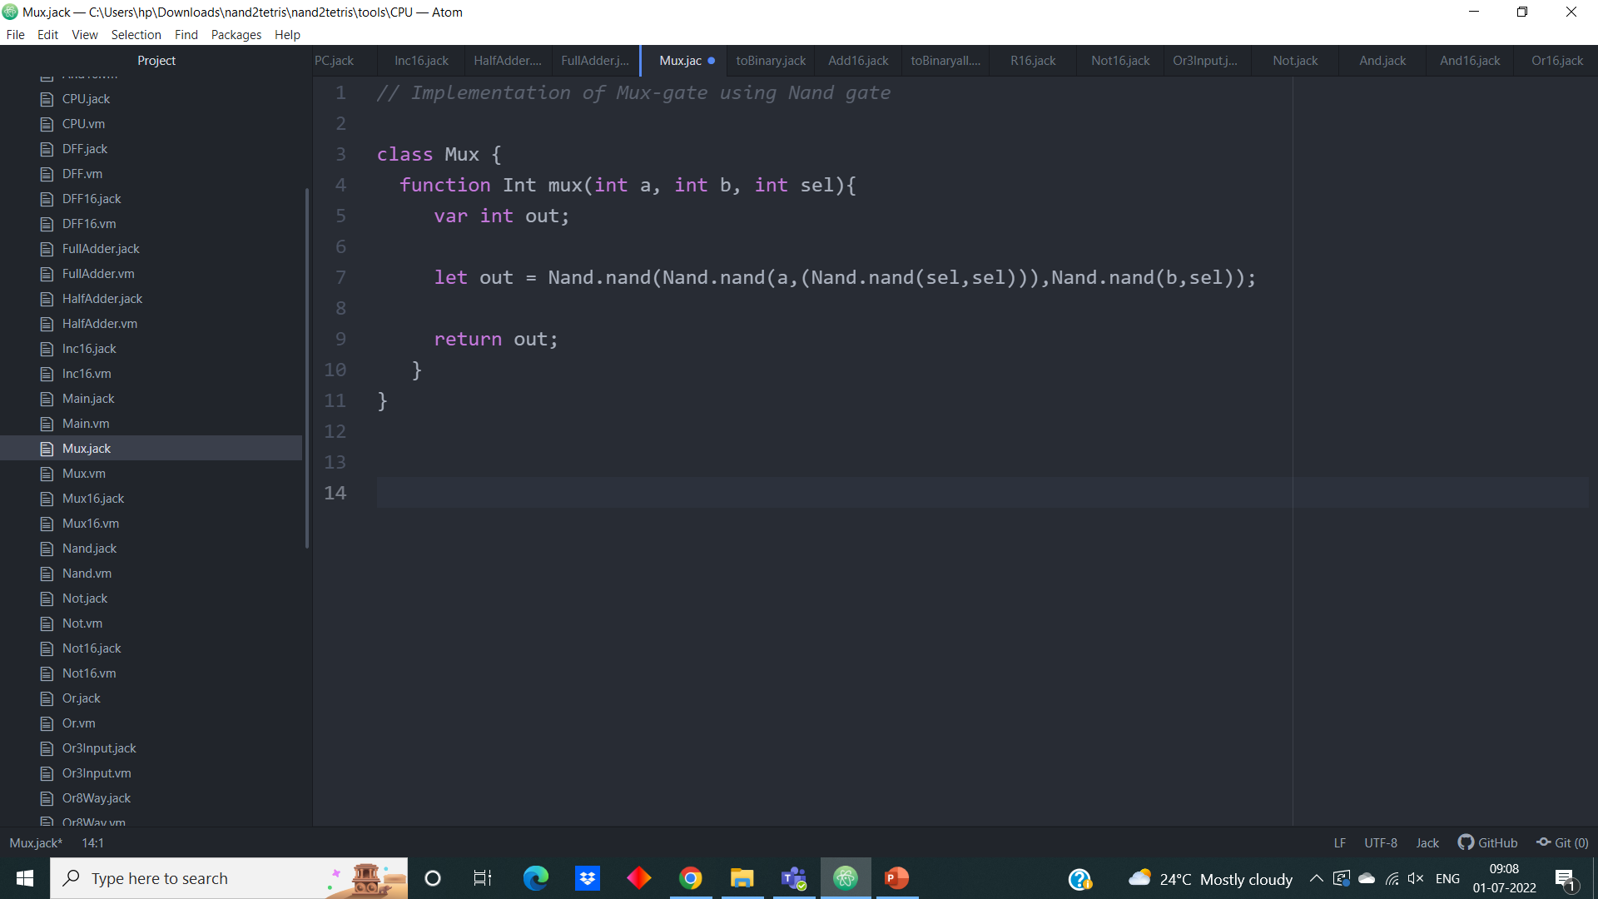

**B) Secondary Chips**

**1.Half Adder**

**Jack Code:**

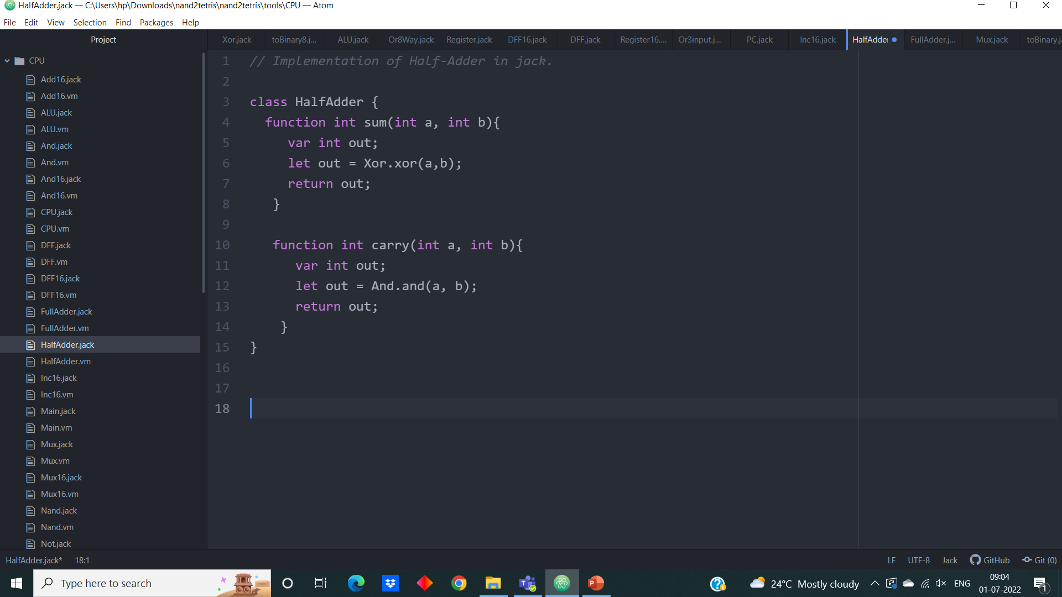

**2.FullAdder**

**Jack Code:**

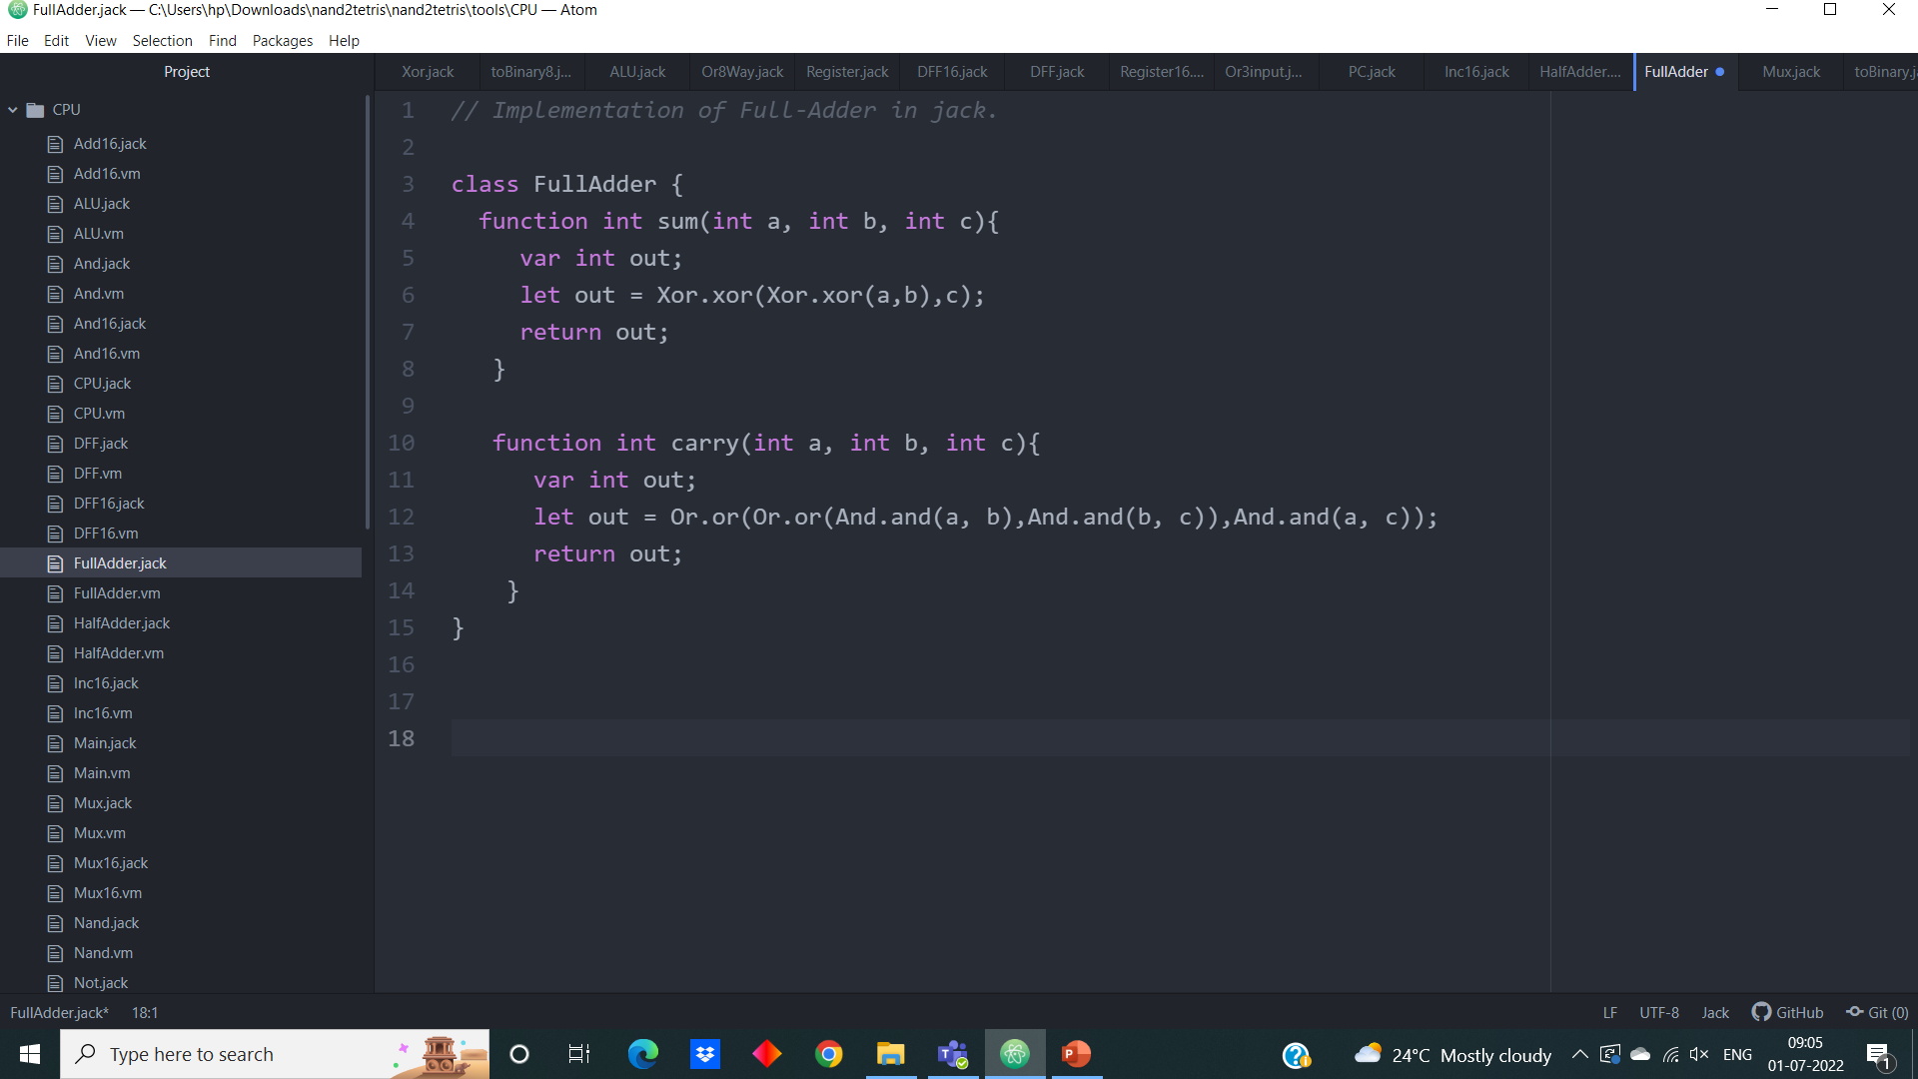

**3. 16-bit Adder**

**Jack Code:**

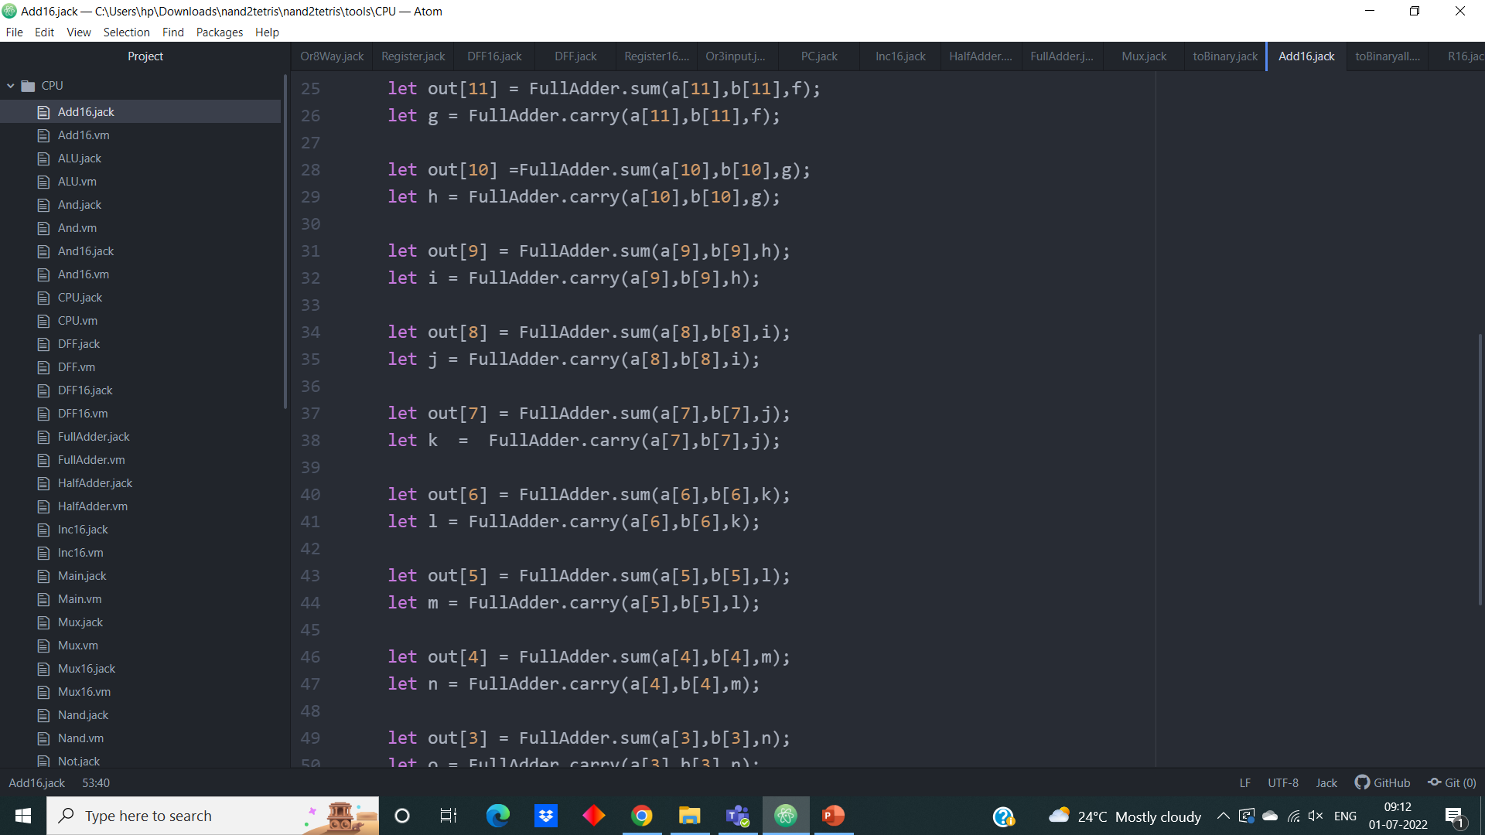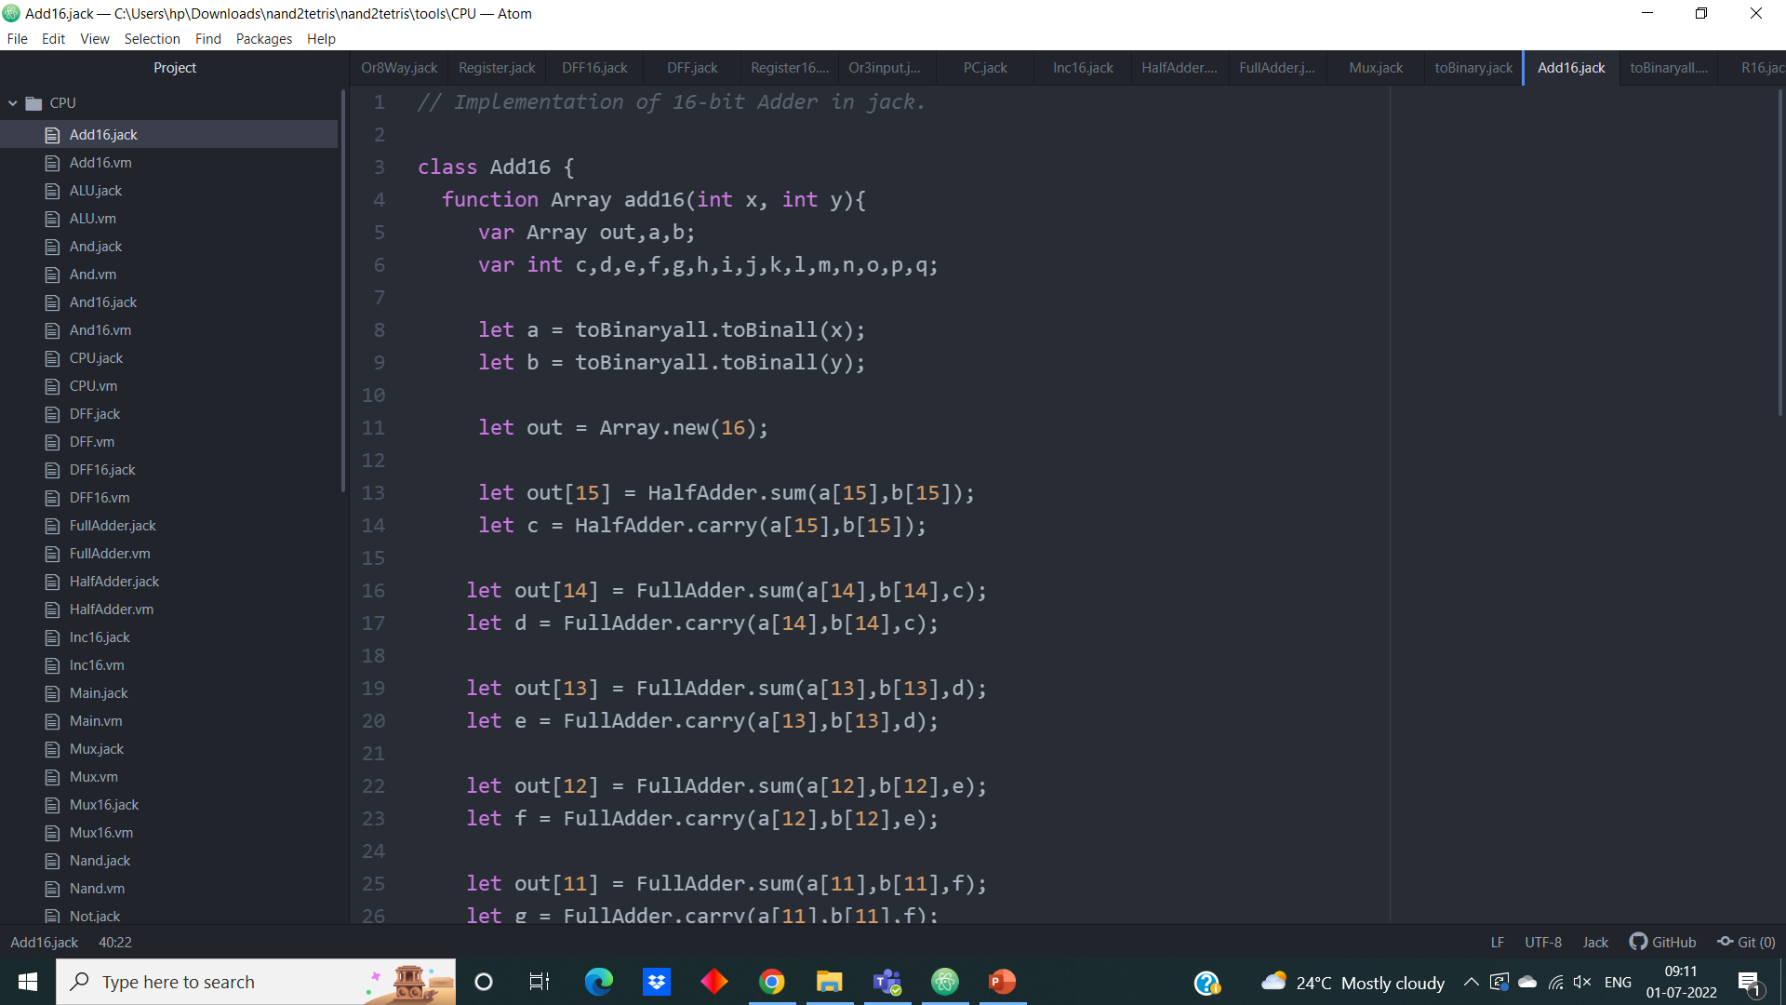

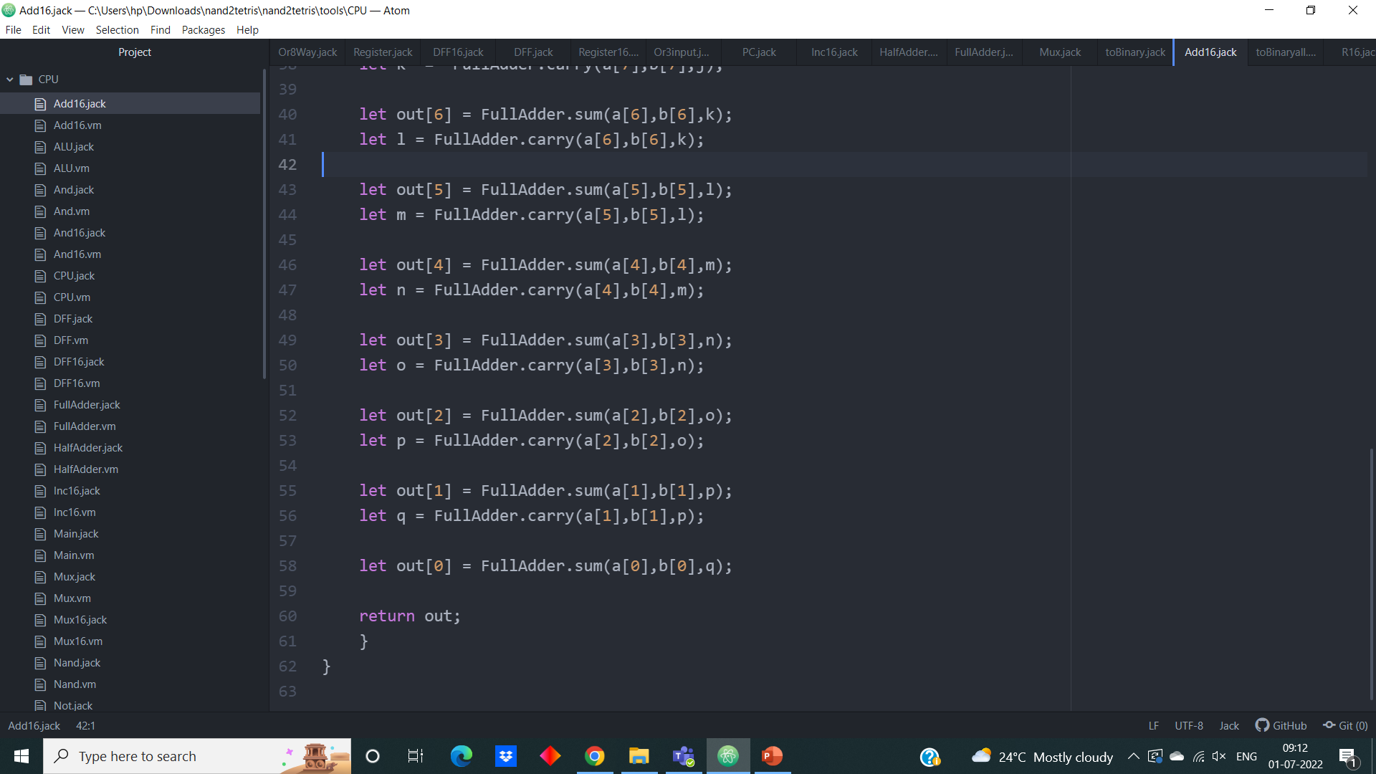

**4. 16-bit And gate**

**Jack Code:**

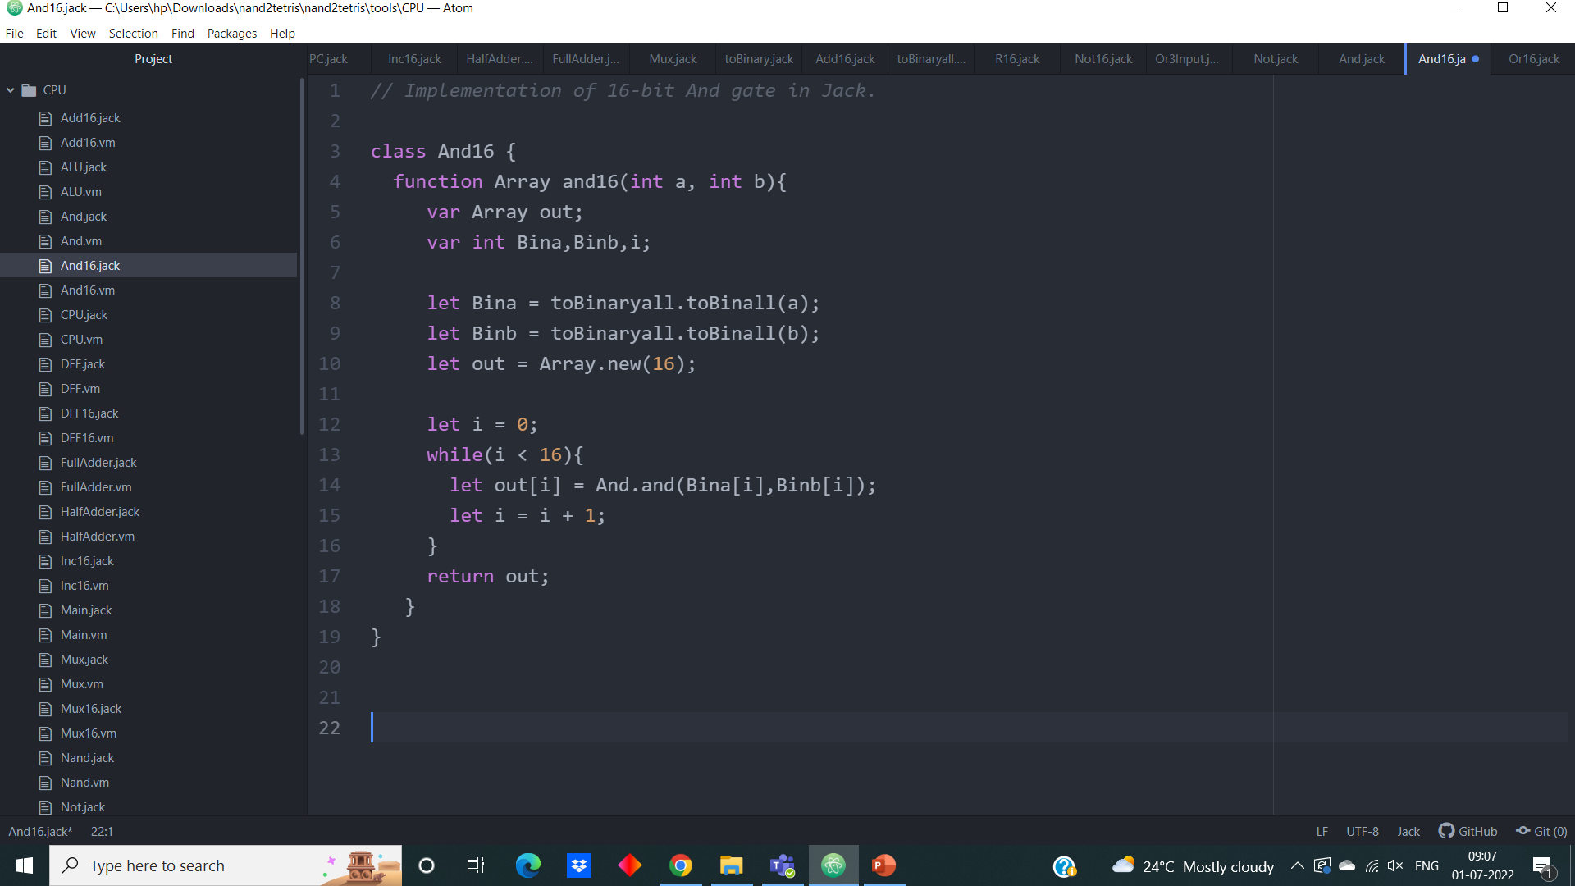

**5. 16-bit Mux gate**

**Jack Code:**

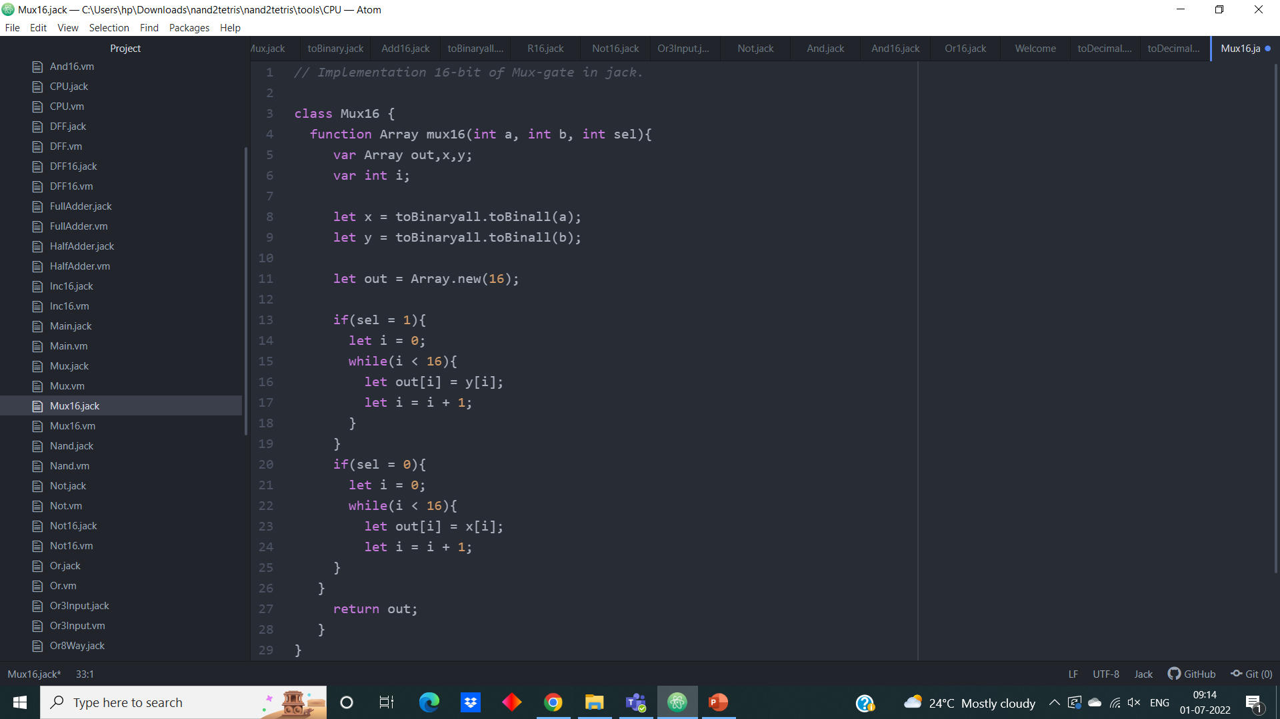

**5. 16-bit Not gate**

**Jack Code:**

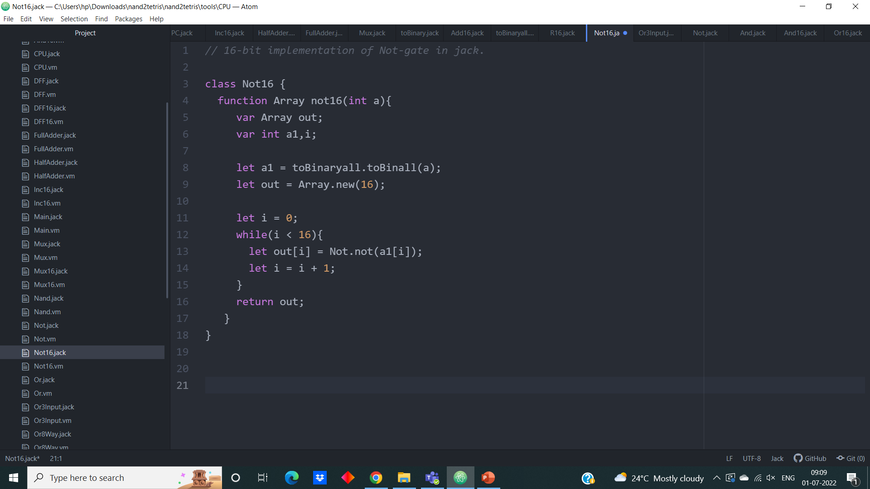

**6. 16-bit Incrementor**

**Jack Code:**

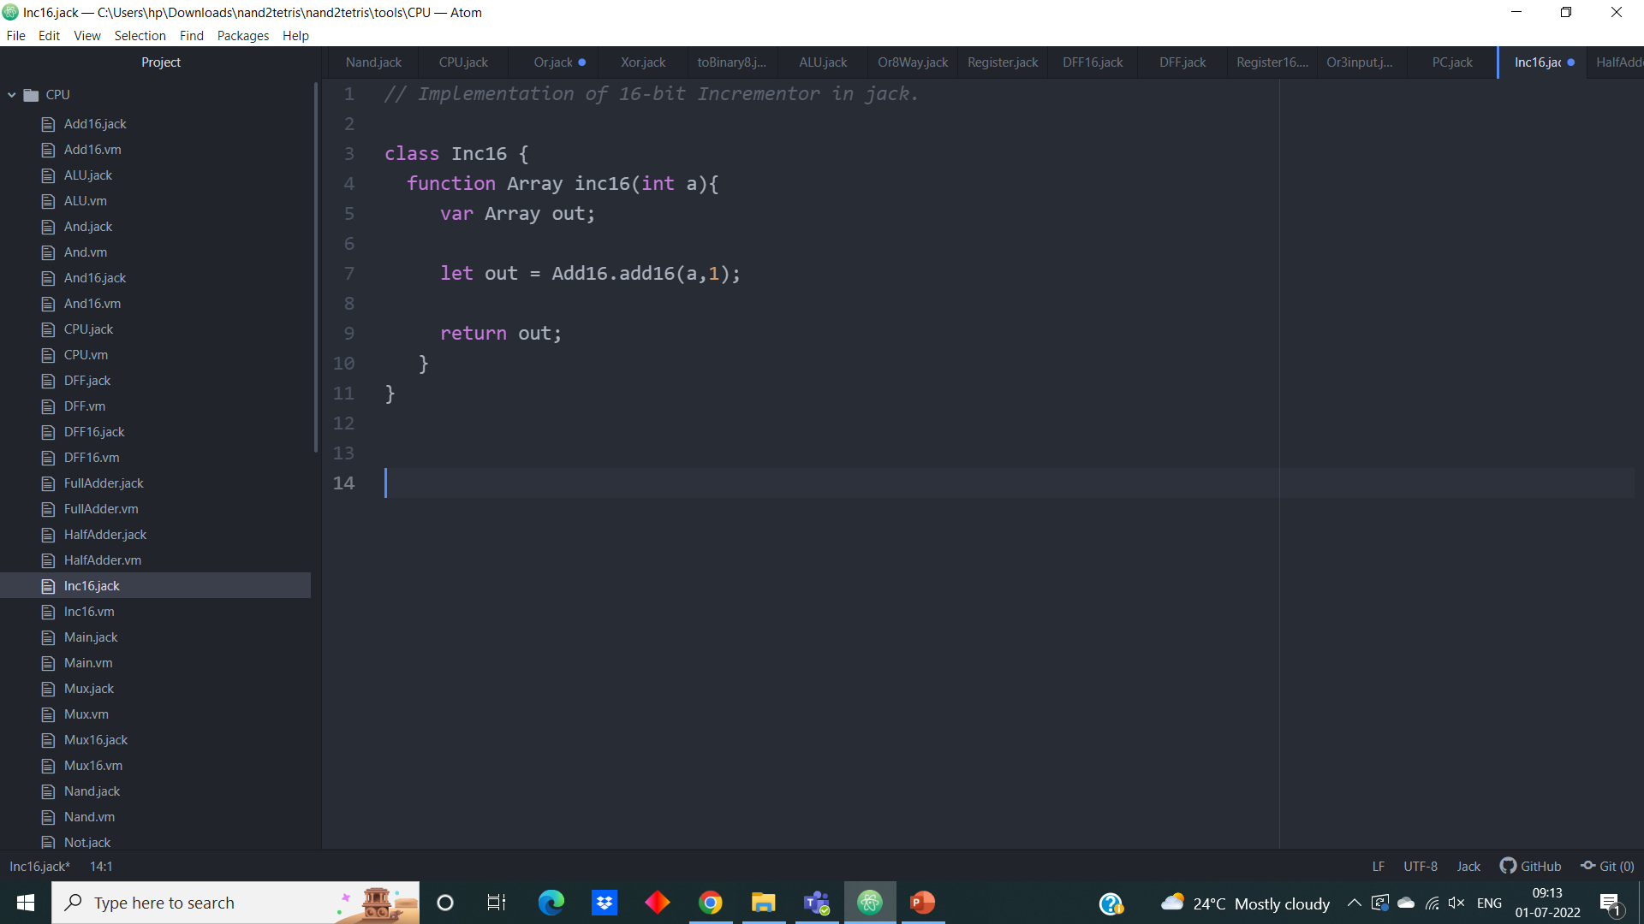

**7. Or-8-way**

**Jack Code:**

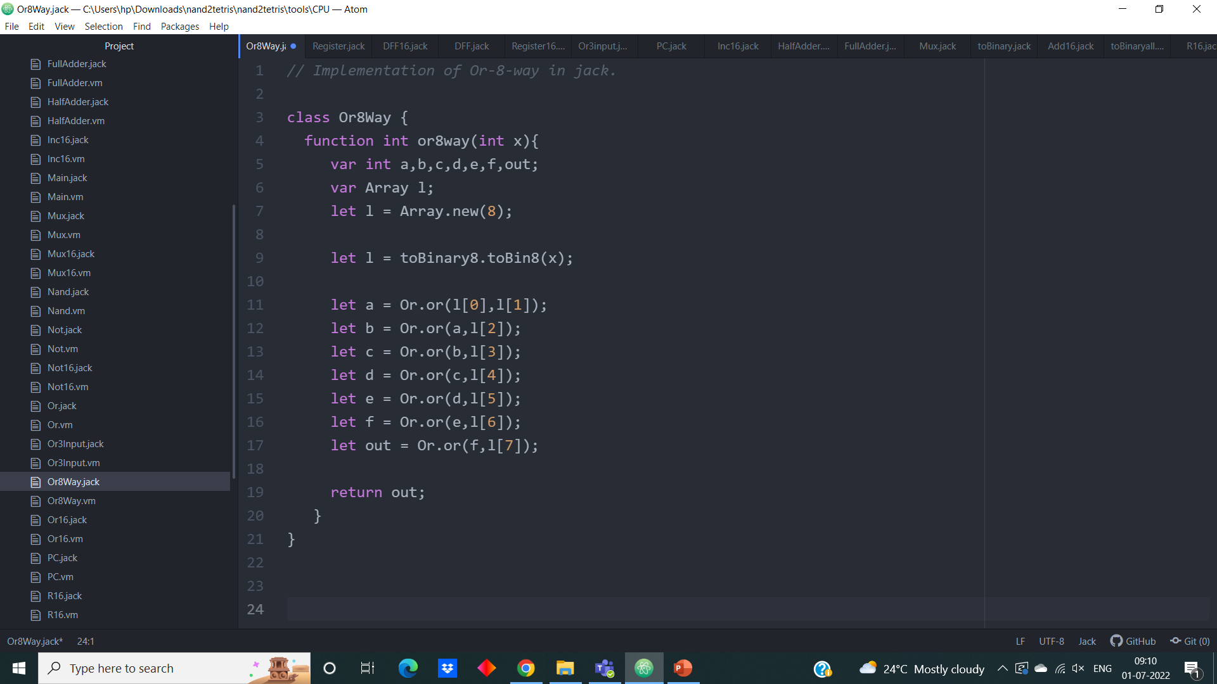

**8. Or-3-input**

**Jack Code:**

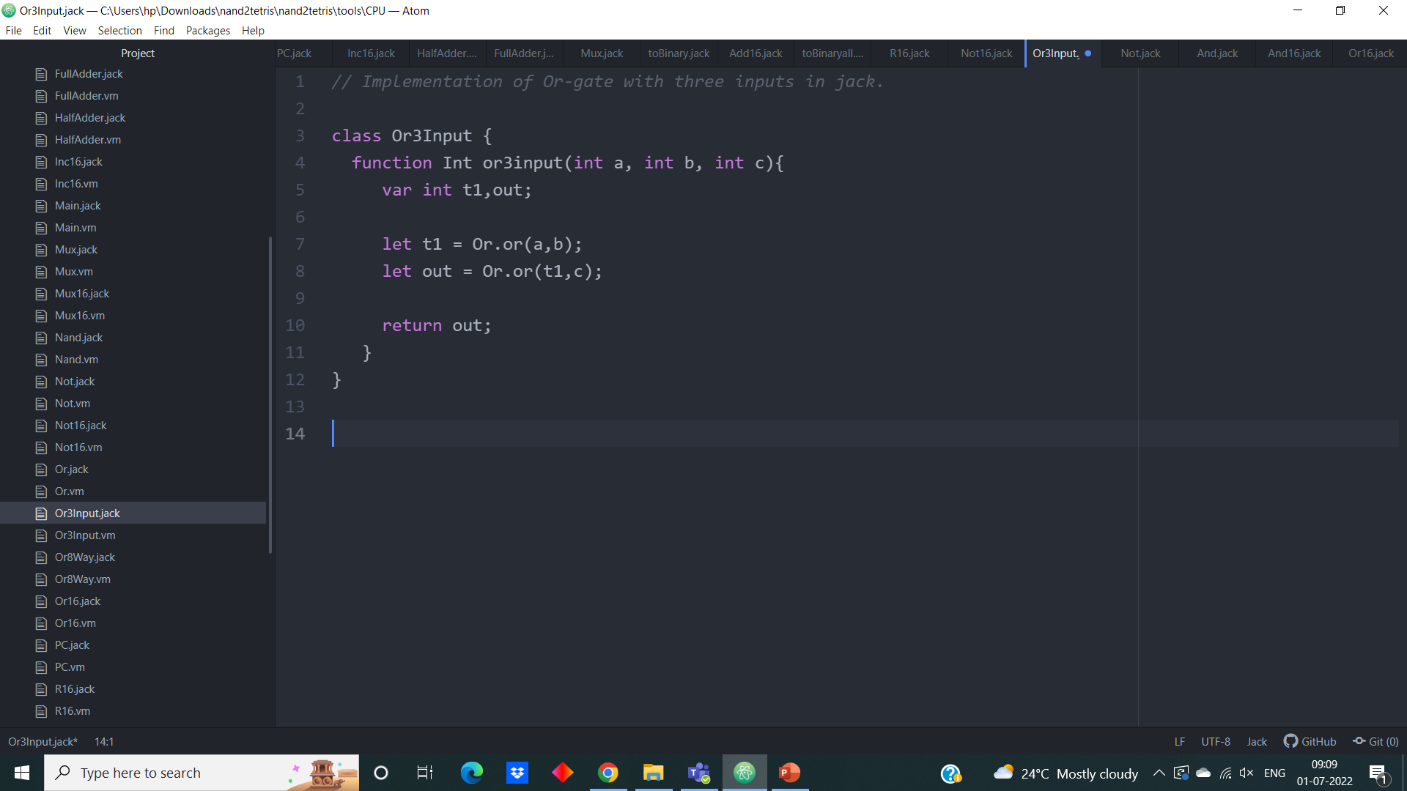

**C) Important conversions**

**1. to Binary**

This implementation of “to Binary” allows us to convert a positive number to its respective 16-bit binary representation. This conversion is done in the same way we do generally that is dividing the given number with 2 and mention its remainders until zero, by writing these remainder from down to up we get the 16-bit binary representation of the given.

**Jack Code:**

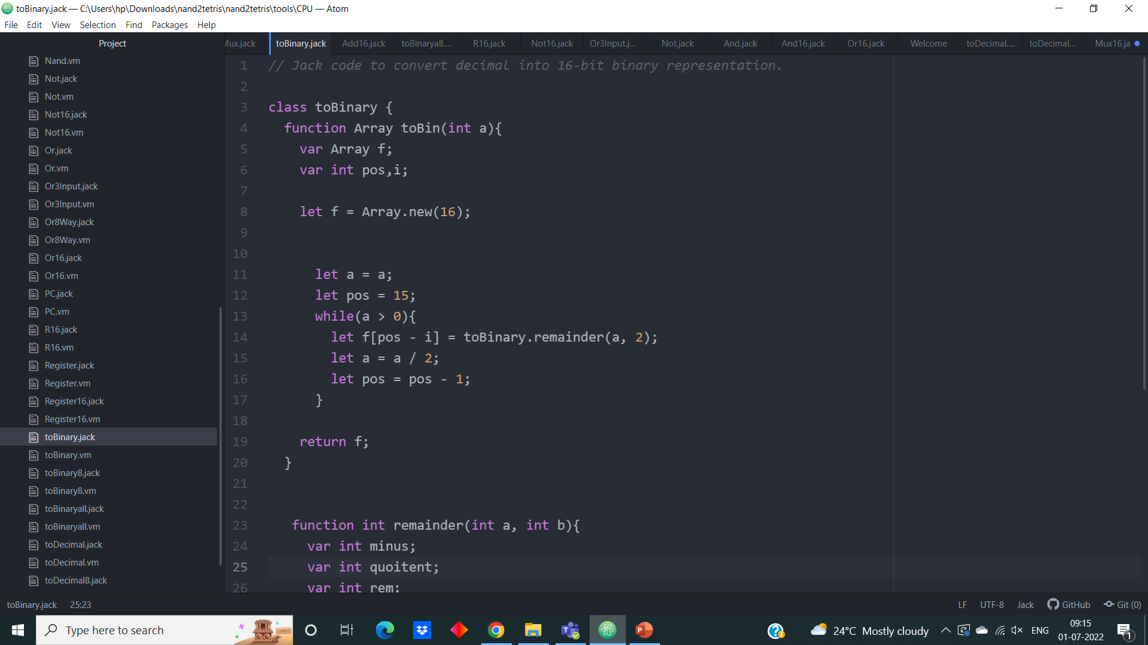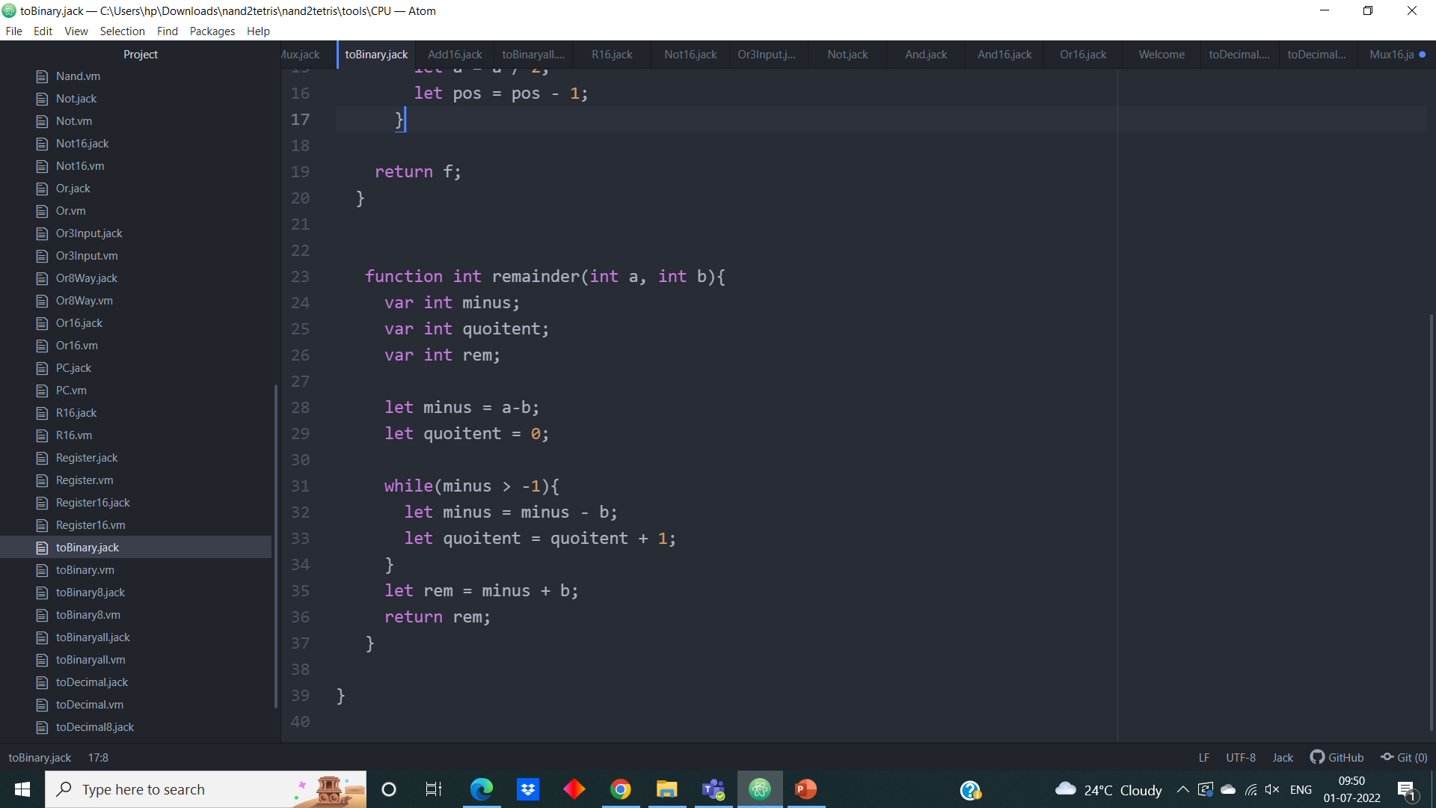

**2. toBinaryall**

This implementation of “toBinaryall” allows us to convert a both positive and negative integers to its respective 16-bit binary representation.

In the same way for positive numbers, we will use above implementation ‘toBinary. For negative numbers, 2’s complement is used to find the binary representation. For that we will take the number convert into 16-bit representation and negate all the bits and add 1 to 0th bit.

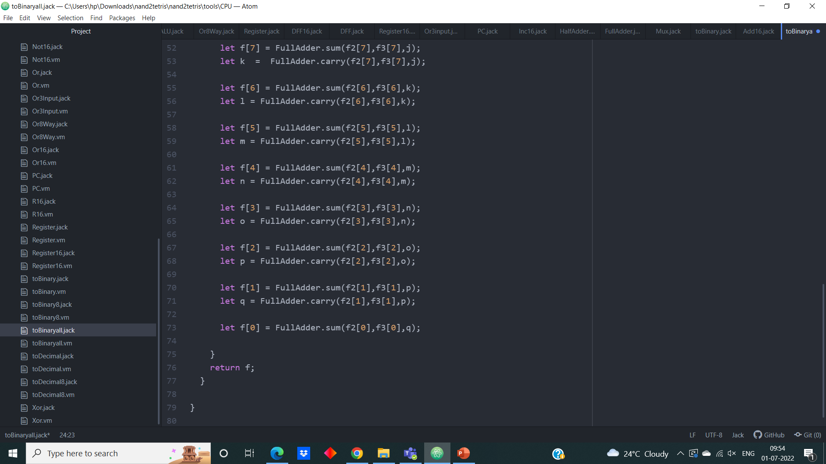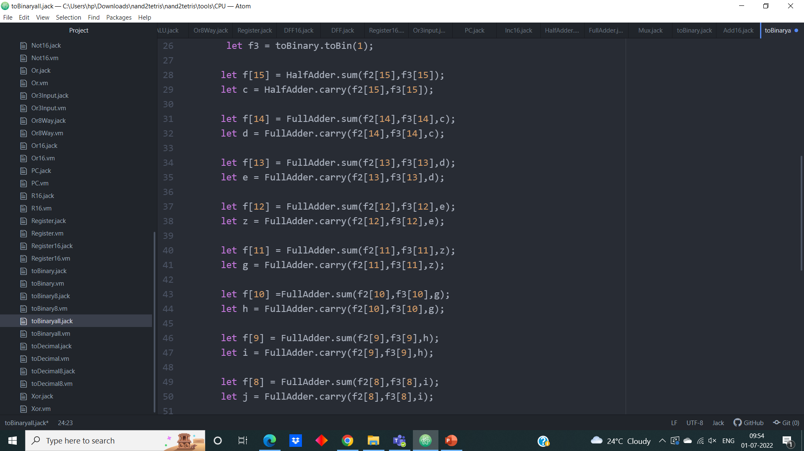**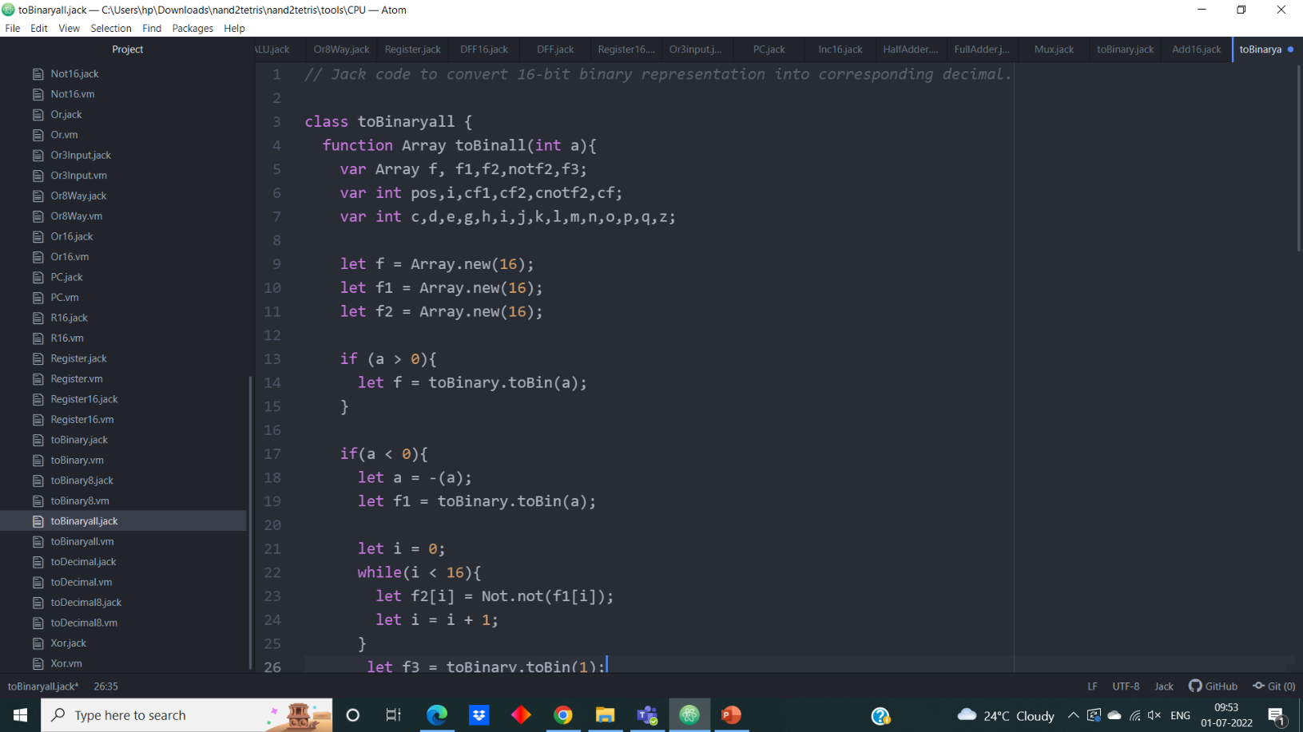 Jack Code:**

**3. toBinary8**

This implementation of “to Binary8” allows us to convert a positive integer to its respective 8-bit binary representation. This conversion is done in the same way we do generally that is dividing the given number with 2 and mention its remainders until zero, by writing these remainder from down to up we give the 8-bit binary representation of the given.

**Jack Code:**

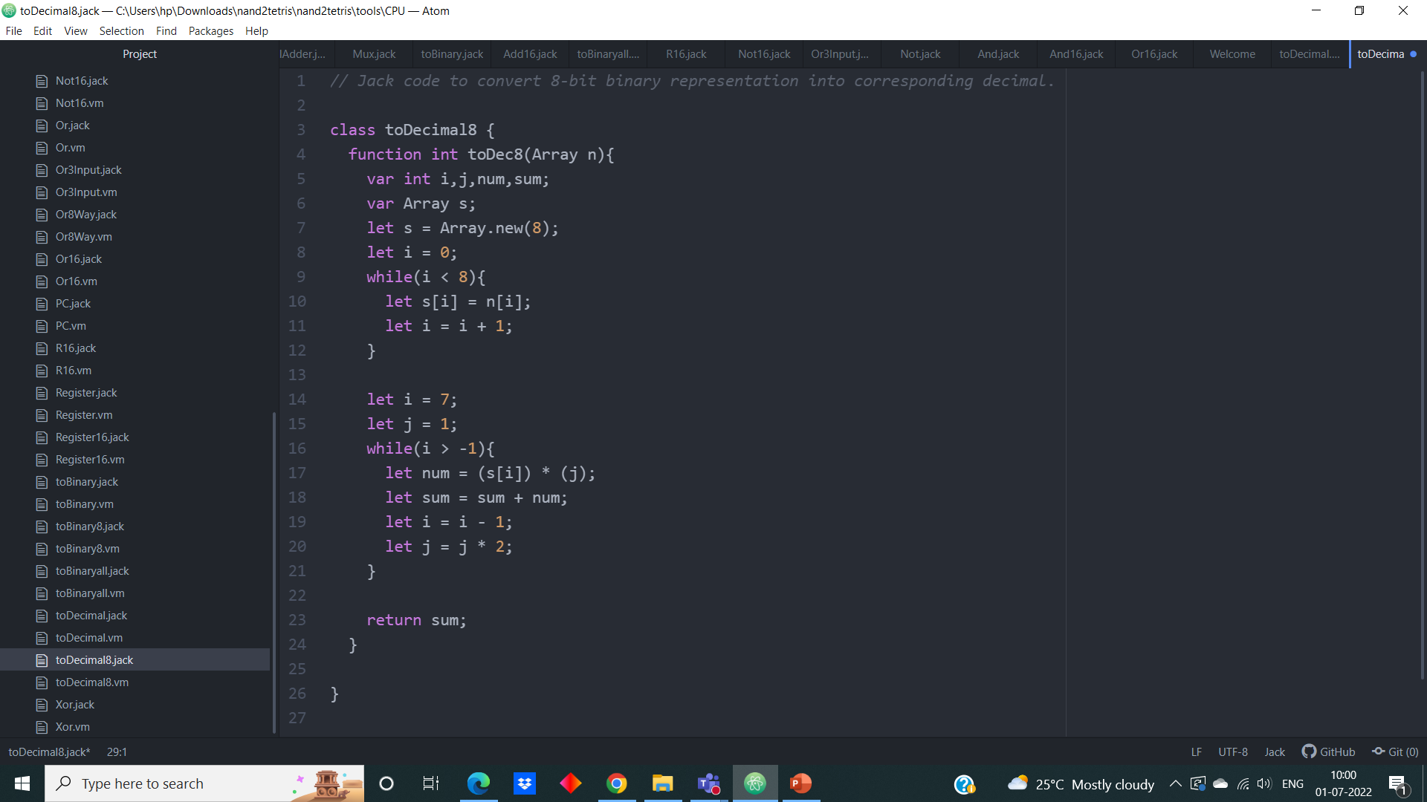

**4. toDecimal**

This implementation of “to Decimal” allows us to convert 16-bit binary representation to it corresponding decimal value.

This conversion can be done in a simple way by adding the product of each binary digit with its weight (which is of form – binary digit × 2 raised to the power of the position of the digit). Finally, the given 16-bit representation is converted into decimal.

**Jack Code:**

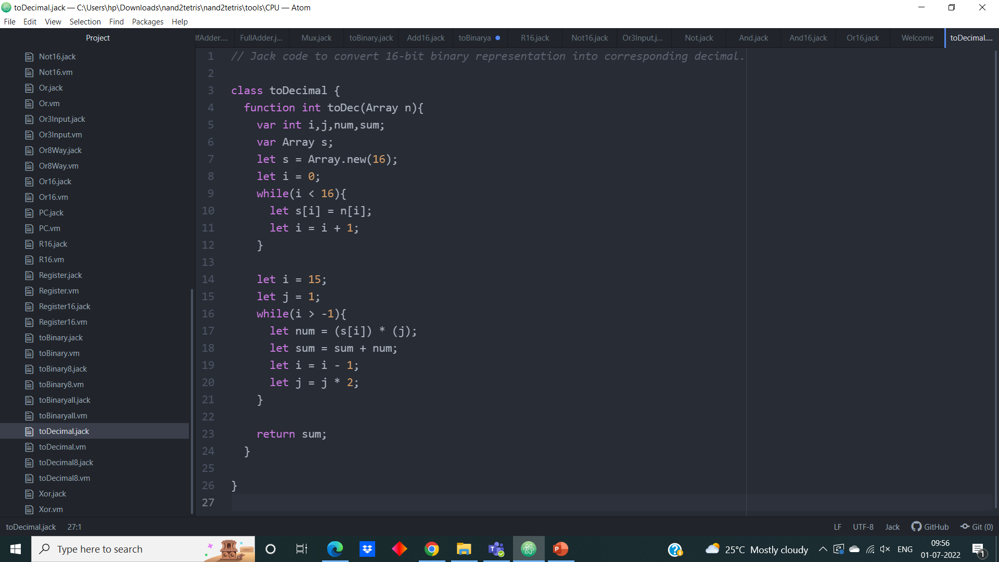

**5. toDecimal8**

This implementation of “to Decimal8” allows us to convert an integer to its respective 8-bit binary representation.

This conversion can be done in a simple way by adding the product of each binary digit with its weight (which is of form – binary digit × 2 raised to the power of the position of the digit). Finally, the given 8-bit representation is converted into decimal.

 **Jack Code:**

**C) Important chips**

**1. Data Flip-Flop**

**Jack Code:**

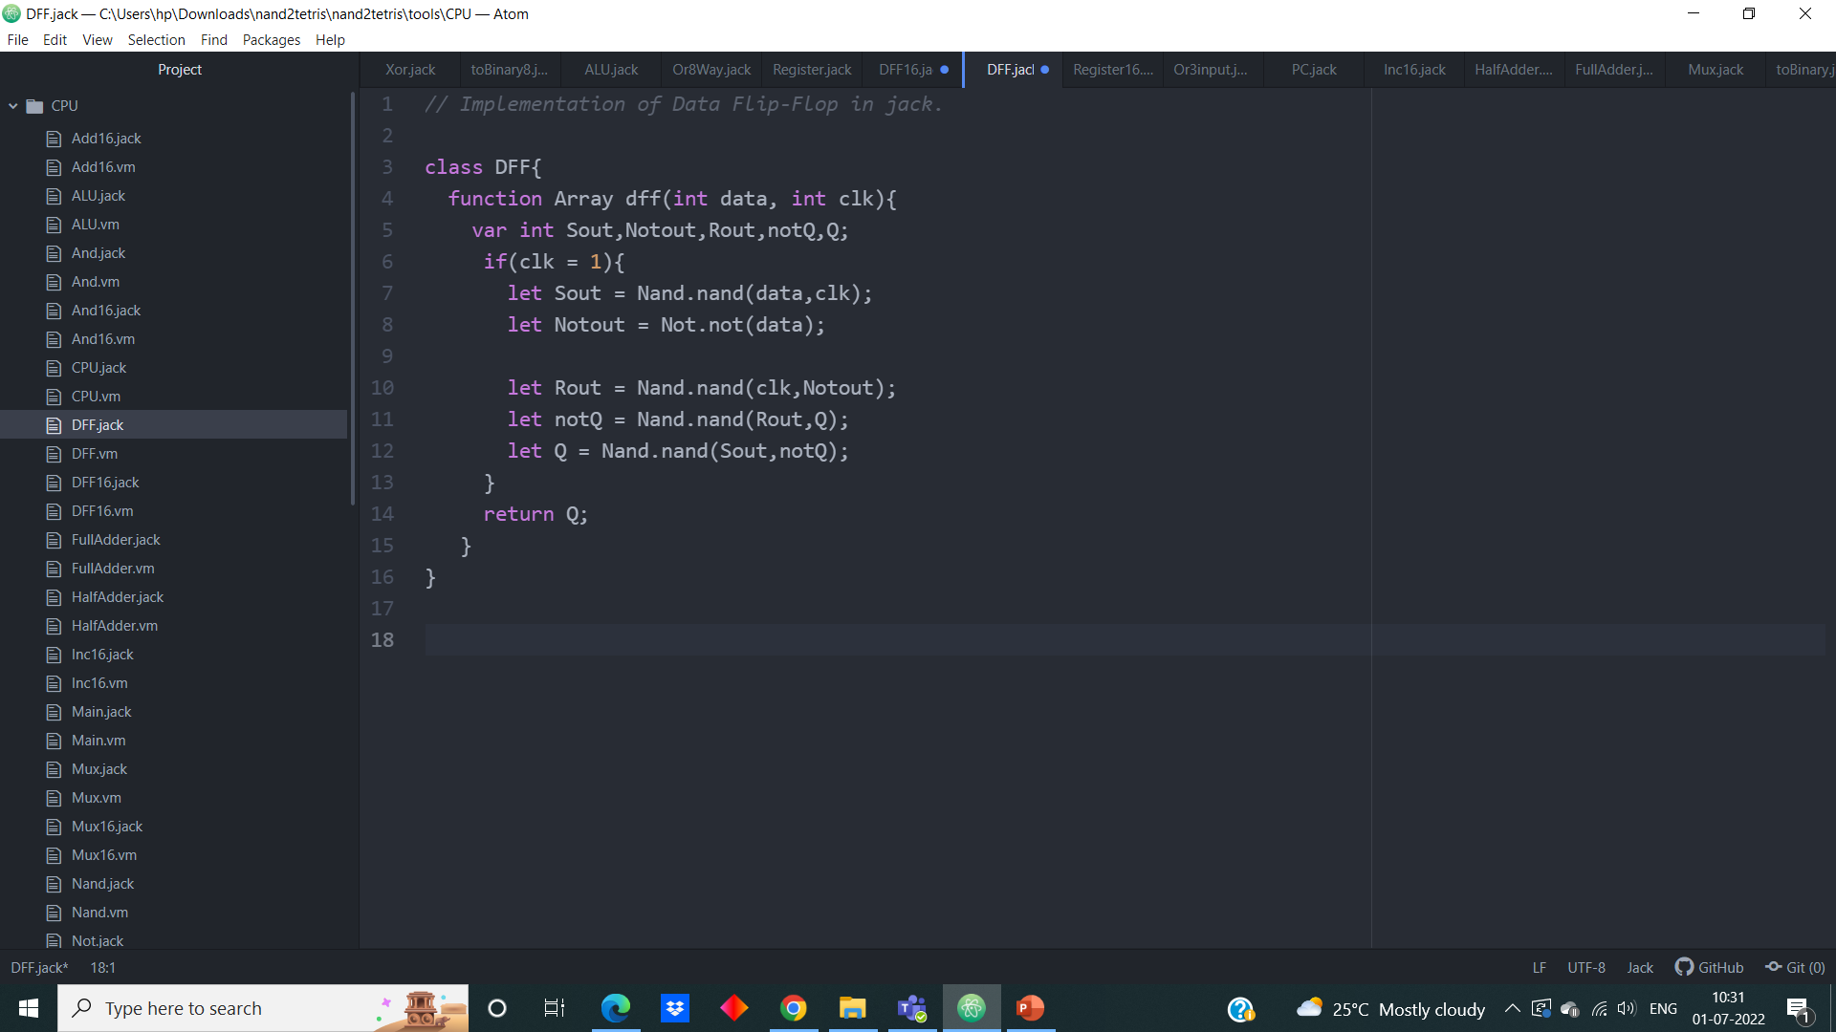

**2. 16-bit Data Flip-Flop**

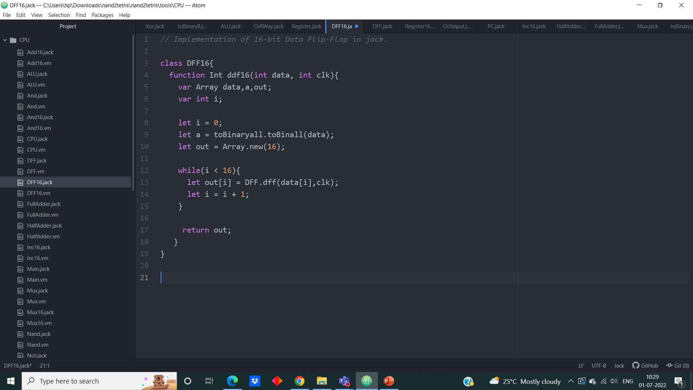 **Jack Code:**

**3. Register**

**Jack Code:**

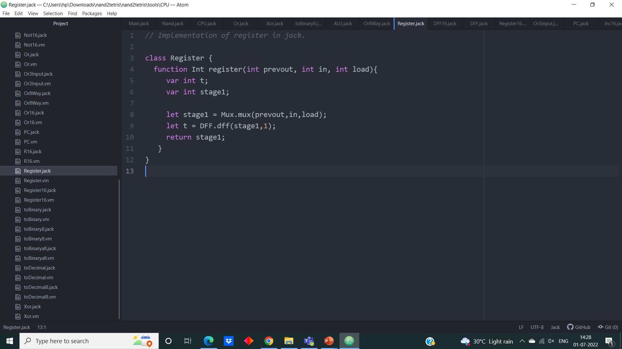

**4. 16-bit Register**

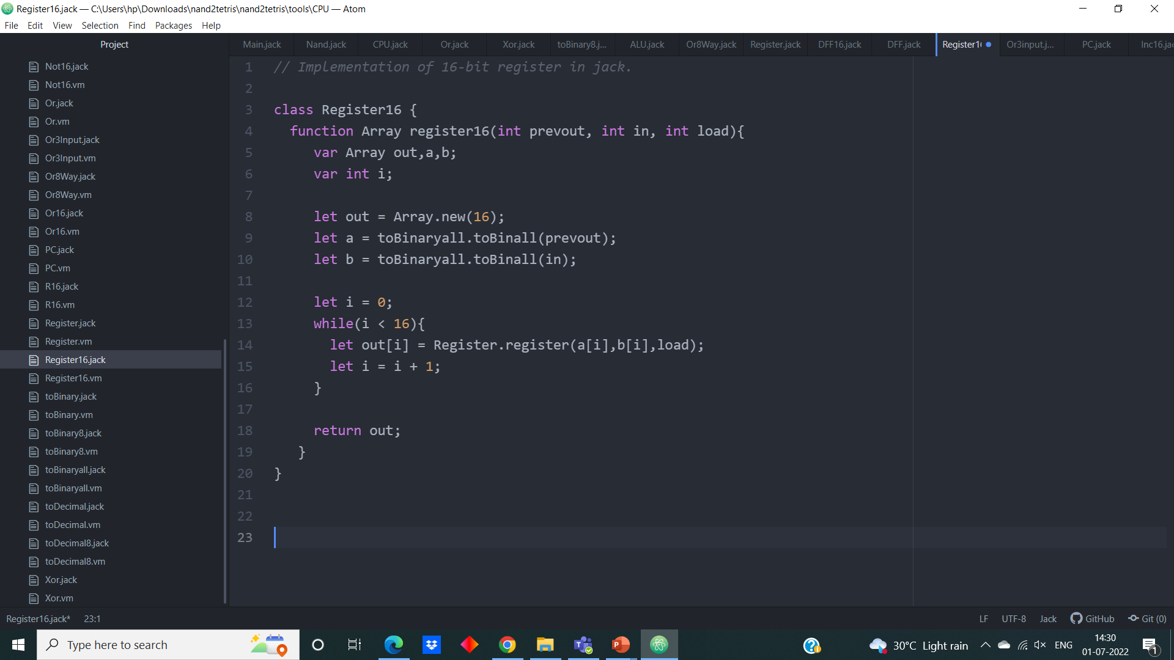 **Jack Code:**

**5. The Hack ALU**

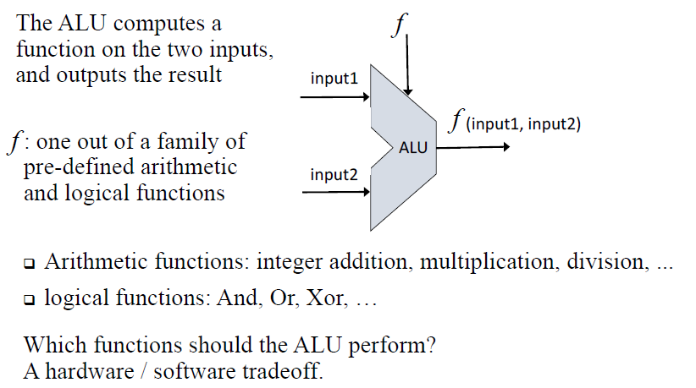

* The ALU computes a function on the two inputs, and outputs the result.
* f:one out of family of pre-defined arithmetic and logical function

Arithmetic functions: integer addition, multiplication, division…...

Logical function: And, Or, Xor

* 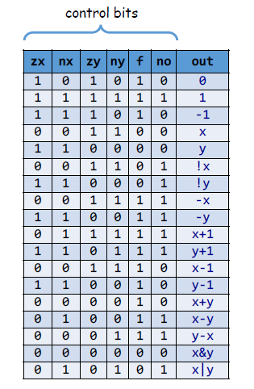To cause ALU to compute a function, set the control bits to one of the binary combinations listed below

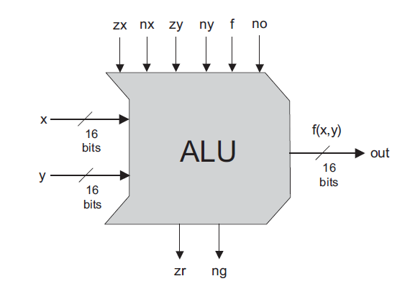

* The ALU contains two control bits (zr, ng)

if (out = 0) then zr = 1, else zr = 0

if (out < 0) then ng =1, else ng = 0

**Jack Code:**

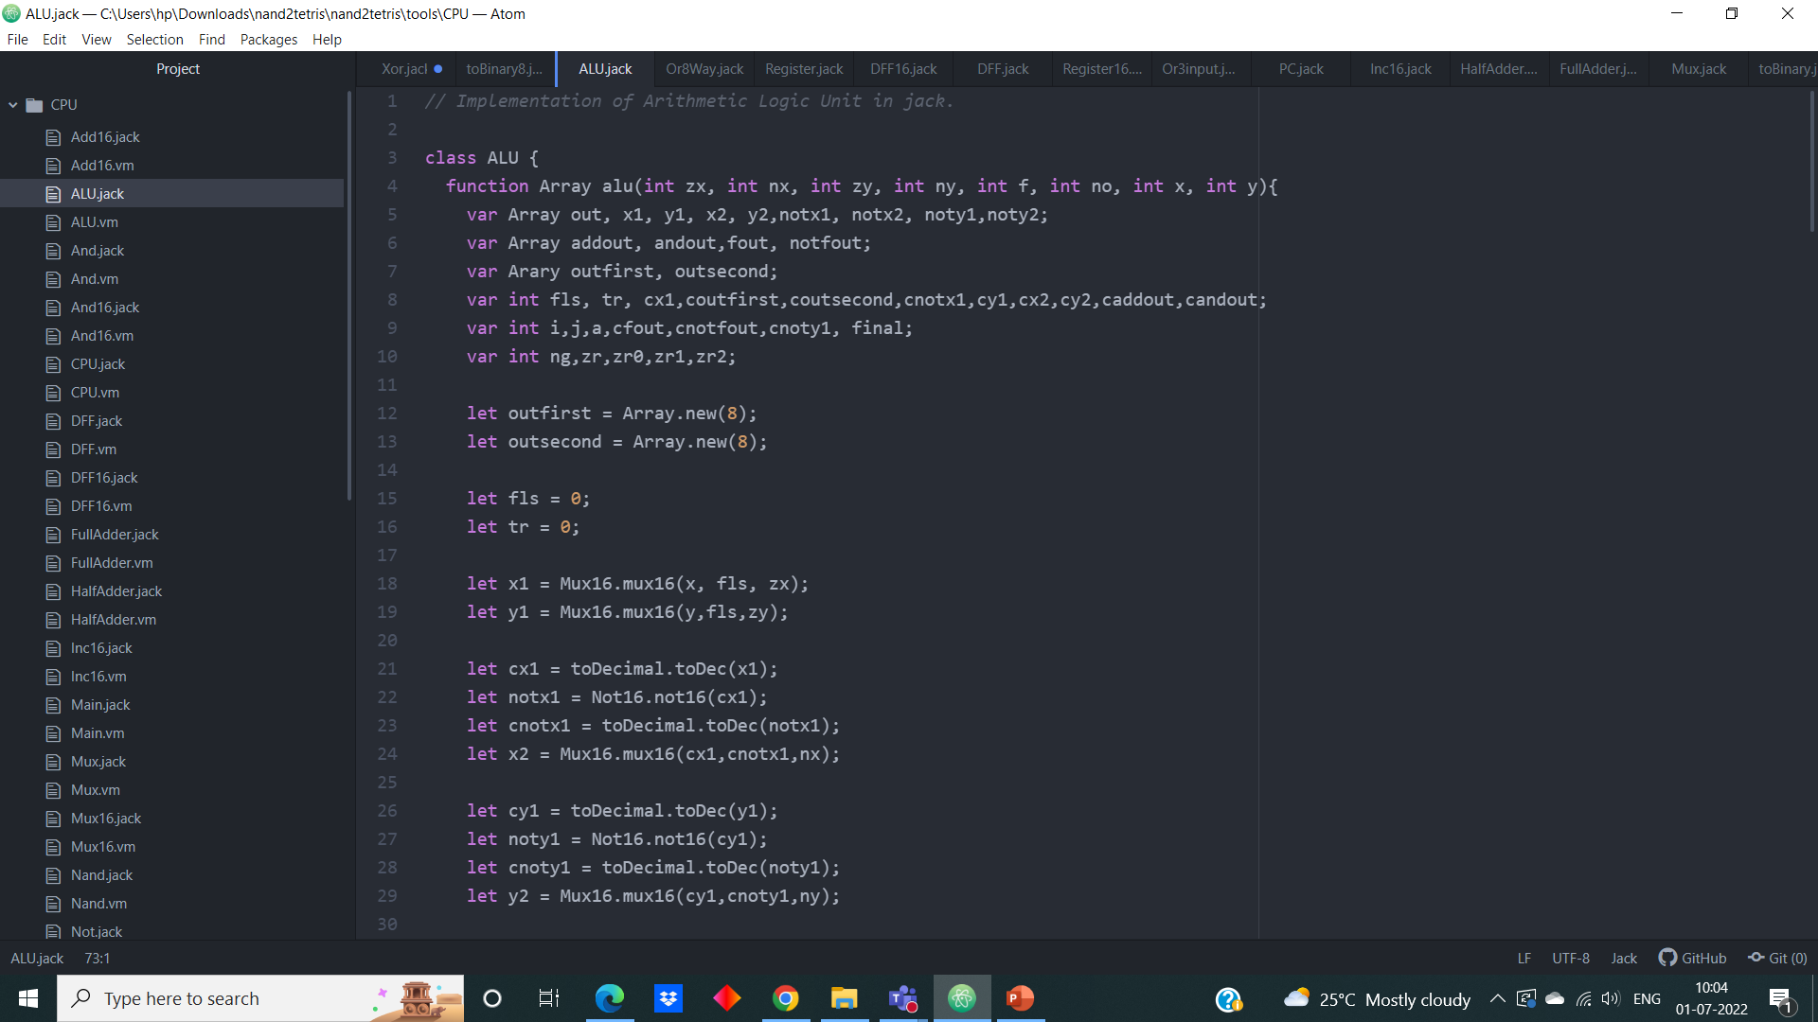



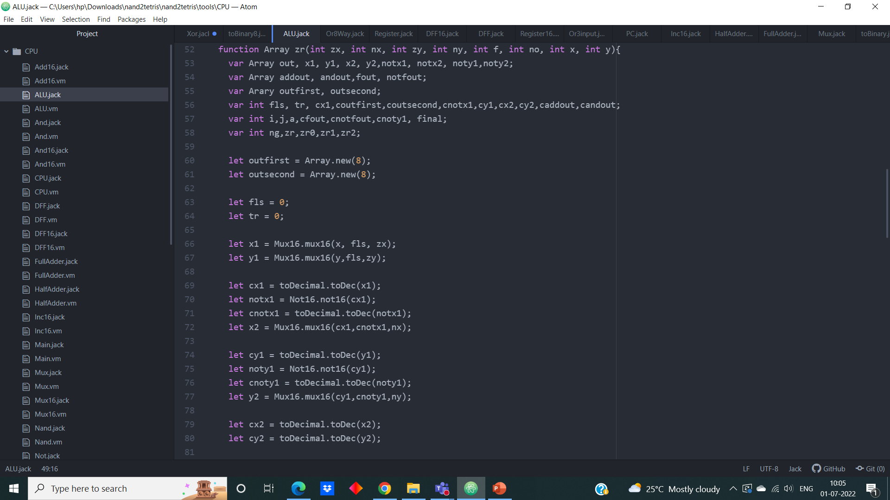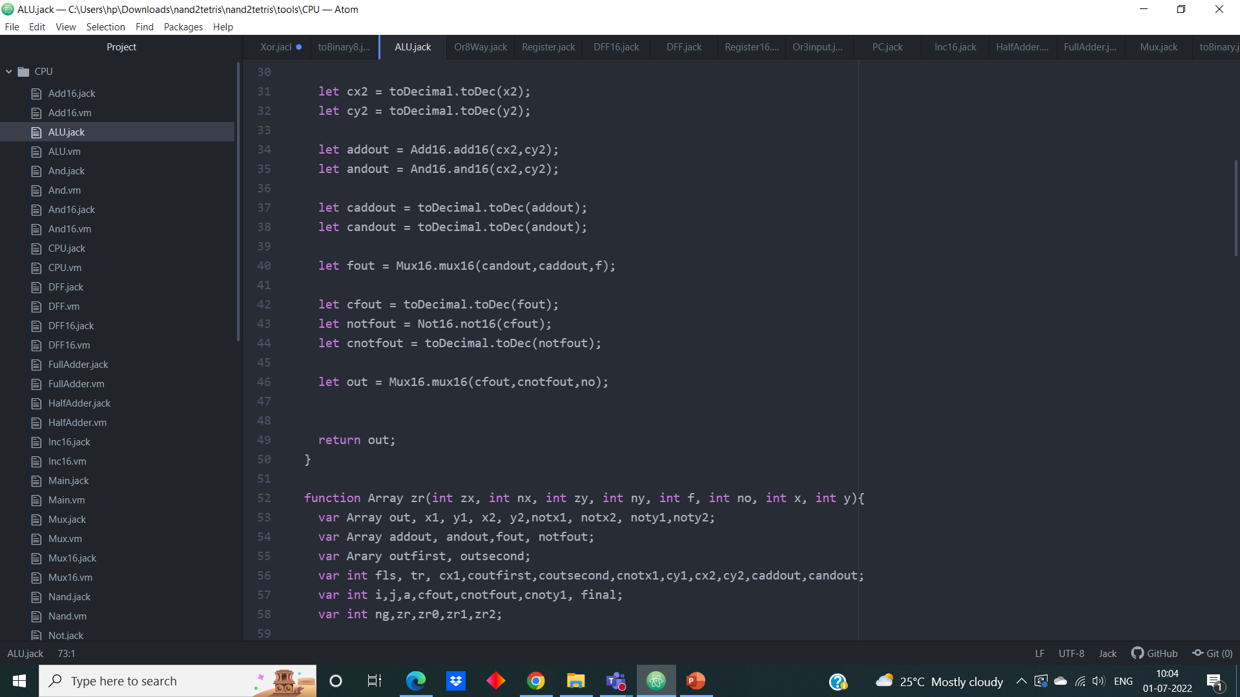



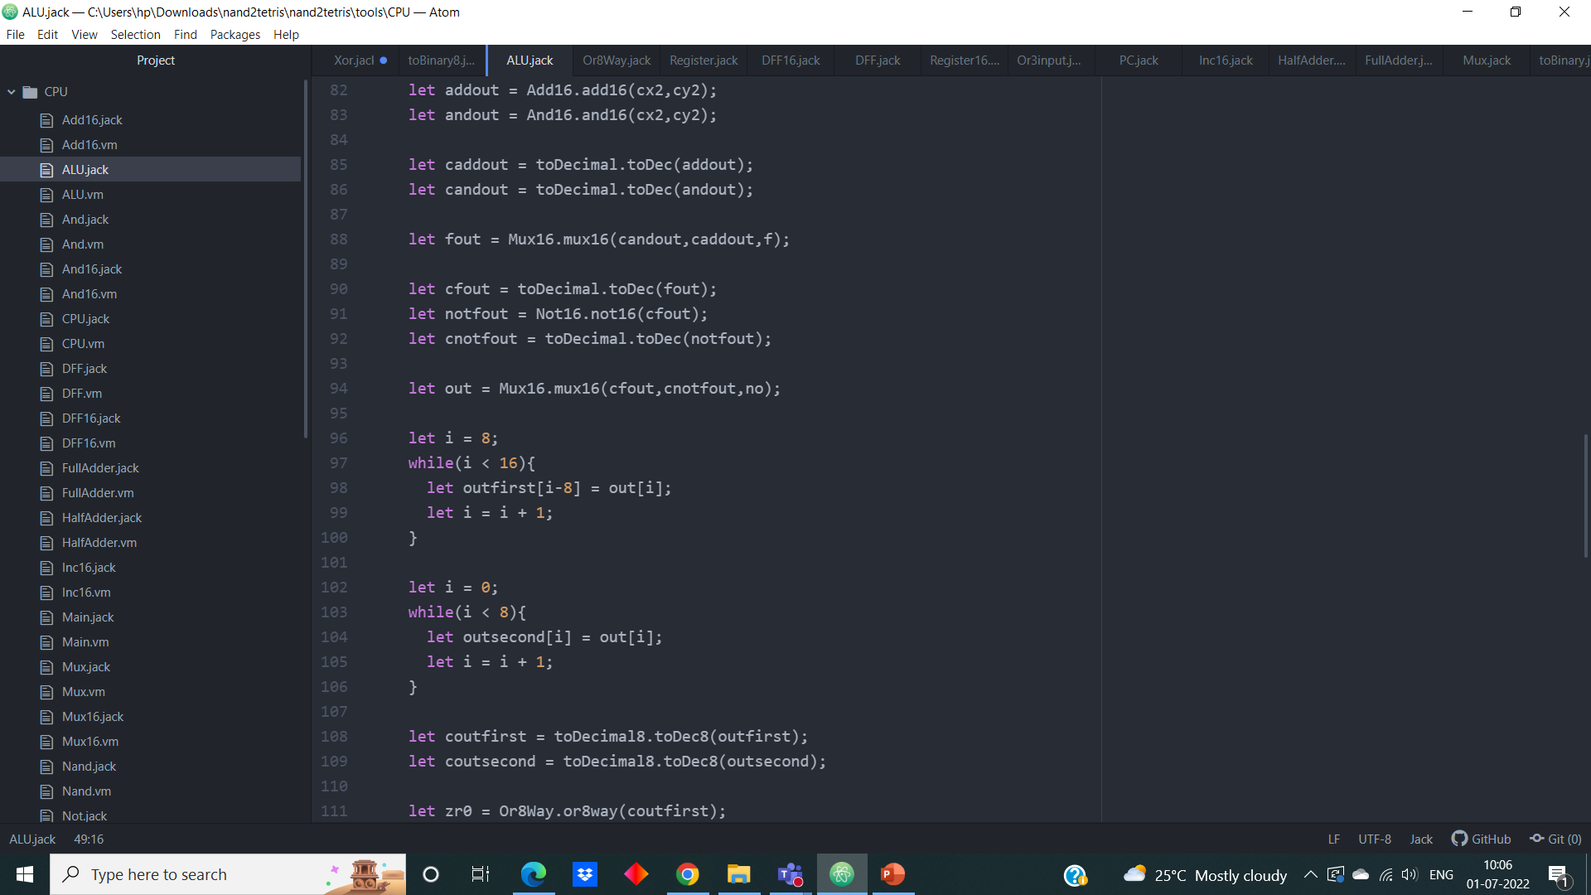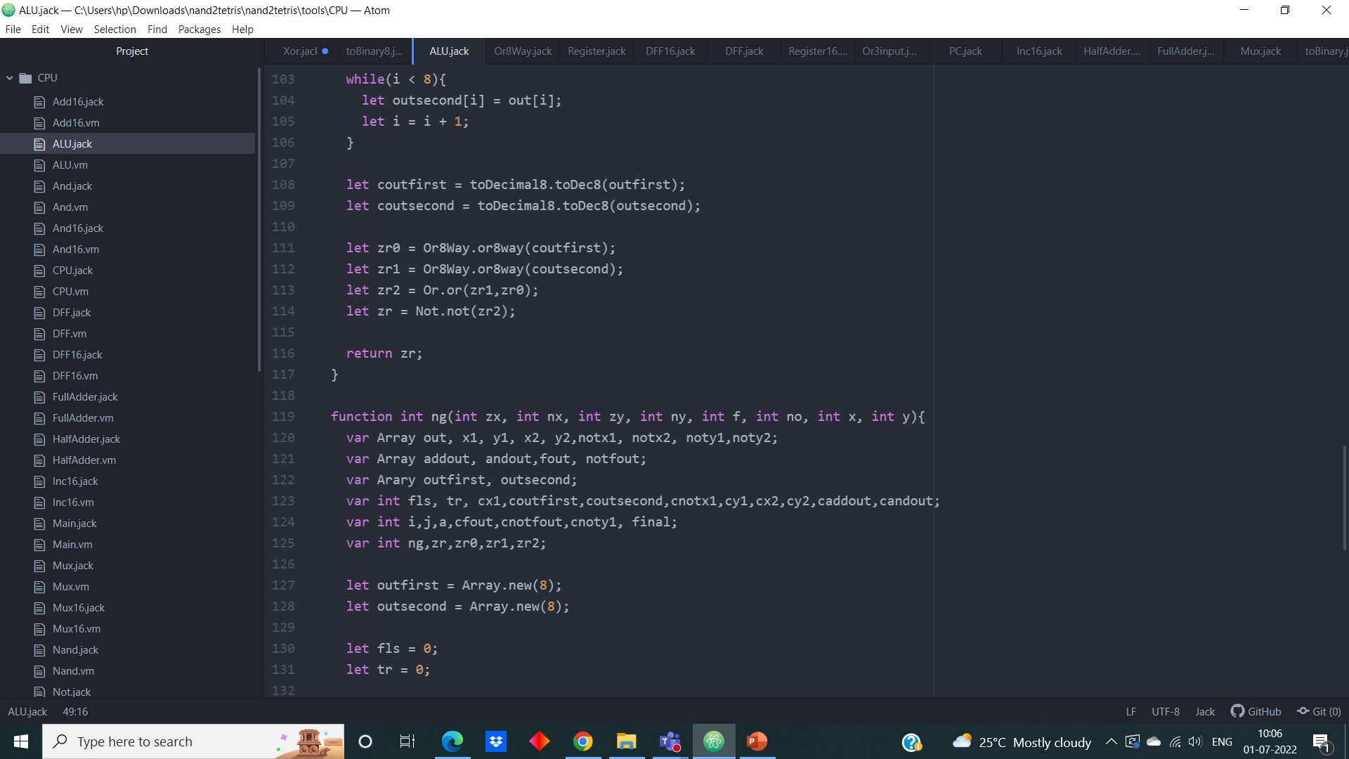

**6. Program Counter (PC)**

* 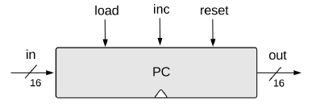The Program Counter (PC) is a register that keep track of which instruction should be fetched and executed next.
* The PC supports three control operation.

**Reset**: fetches the first instruction

**Next**: fetches the next instruction

**Goto**: fetches the instruction n

* PC contains one input, one output, and three control input pins.

Input control bits:

1. Reset

2. Load

3. Increment

* These input controls pins have a priority order associated with it. Depending

on the priority, the program counter will behave.

1. Reset

2. Load

3. Increment

* **Priority order:**
* PC perform the operations in according to the priority order. If we asked to

perform two operations at a time, it performs only the operation which has the

highest priority order.

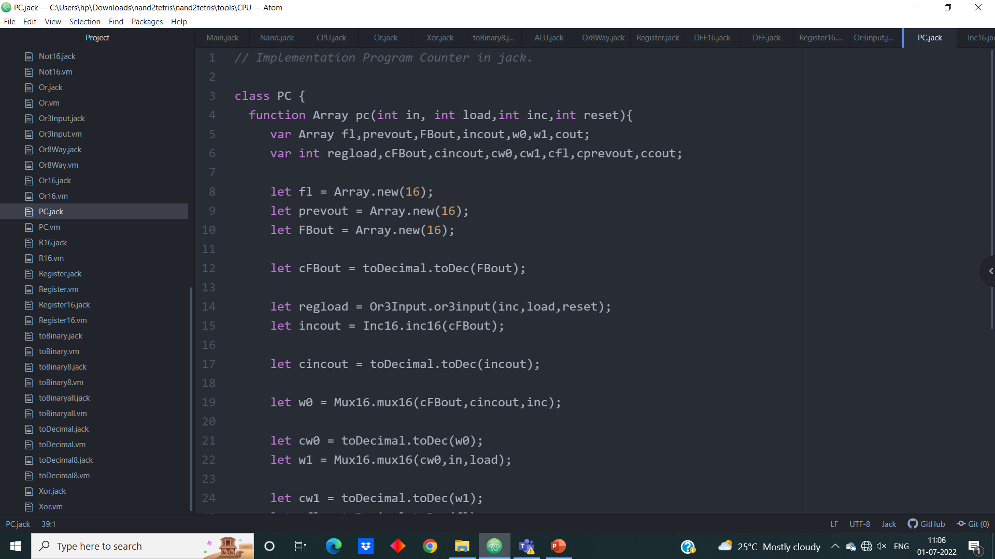**Jack Code:**

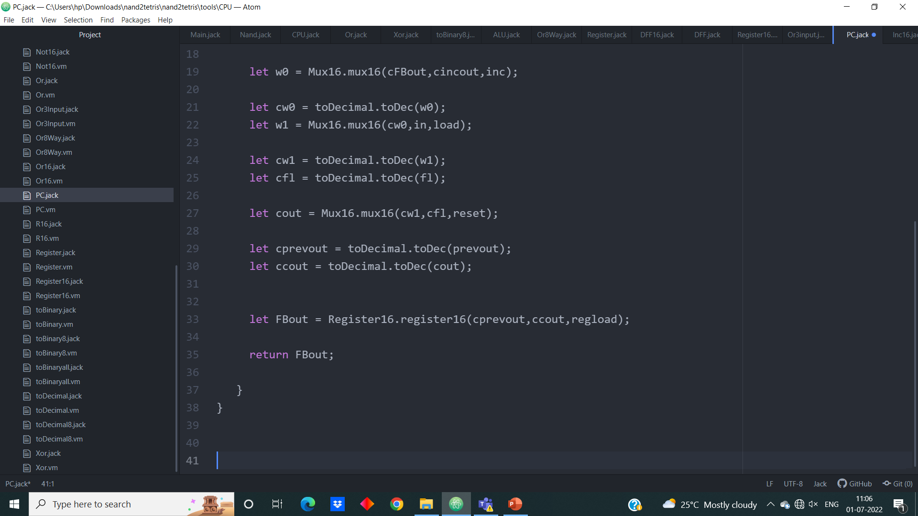

**Hack CPU**

The CPU—the centerpieces of the computer’s architecture—is in charge of executing the instructions of the currently loaded program. The CPU executes these tasks using three main hardware elements: an **Arithmetic-Logic Unit (ALU)**, a set of **registers**, and a **control unit**.

The CPU operation can be described as a repeated loop: decode the current instruction, execute it, figure out which instruction to execute next, fetch it, decode it, and so on. This process is sometimes referred to as the **fetch-execute cycle**.



**Jack Code:**

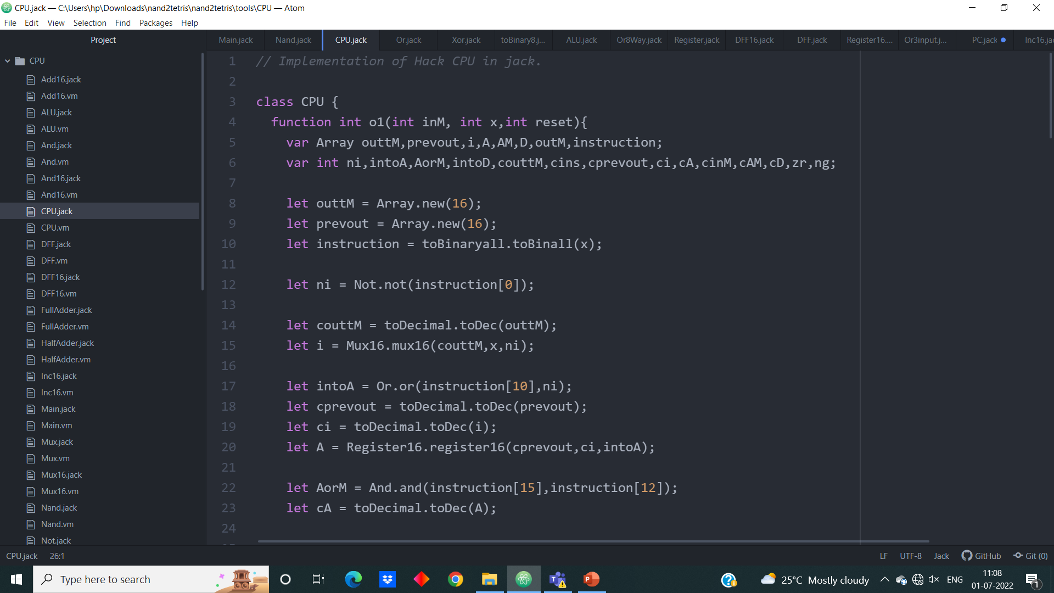

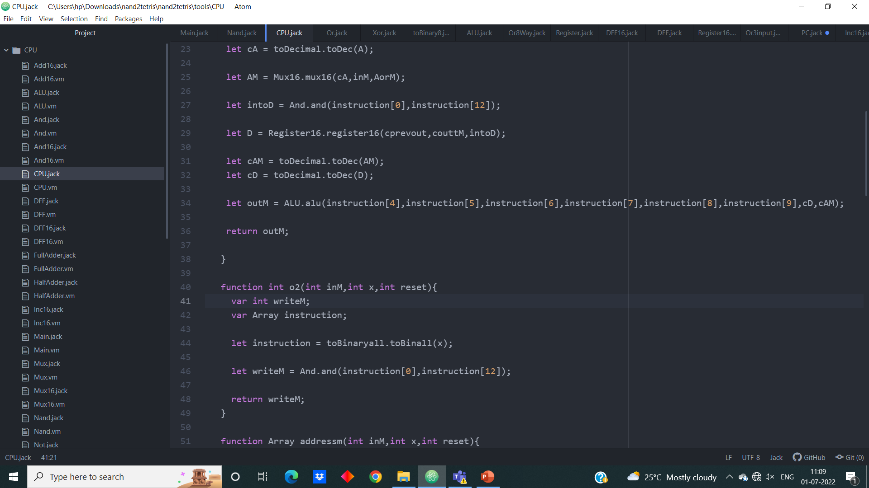

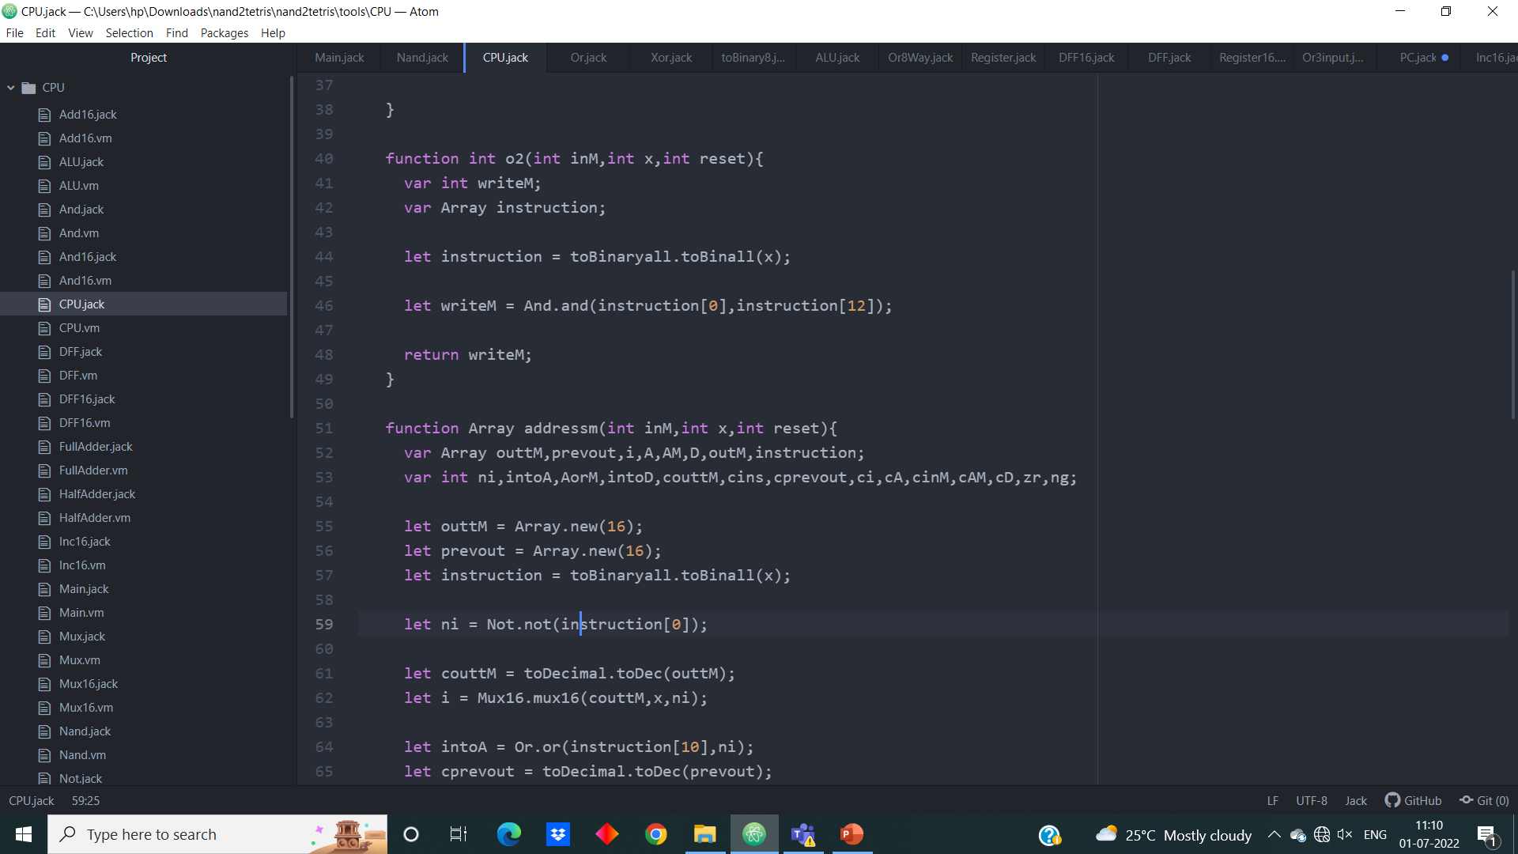

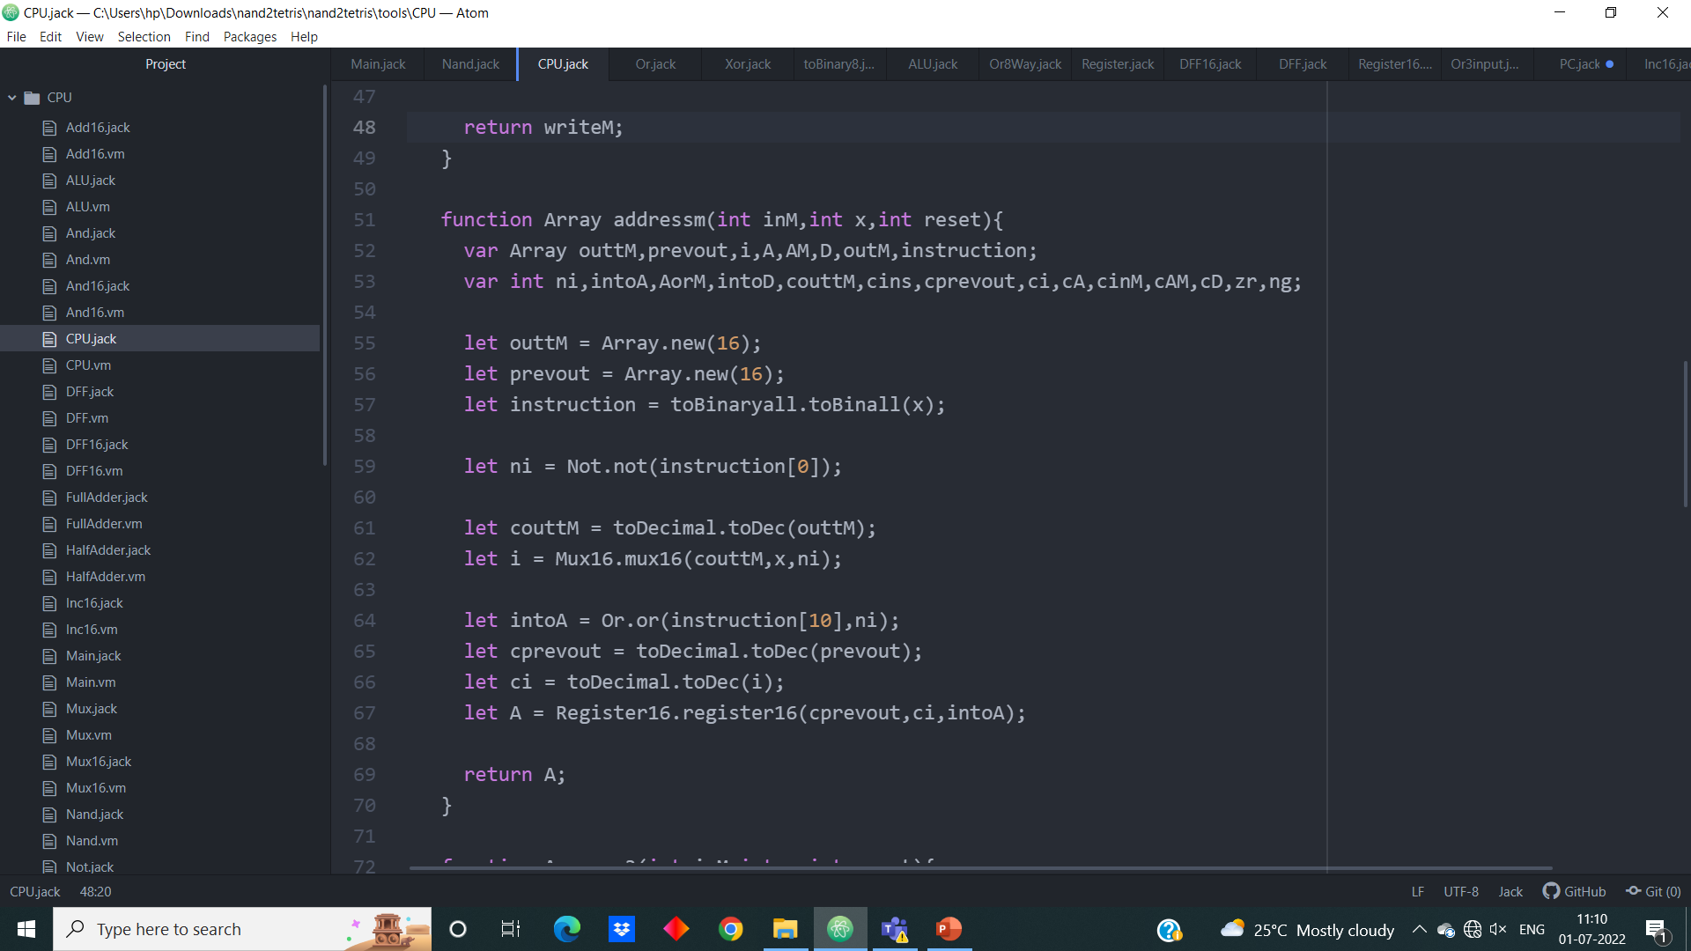

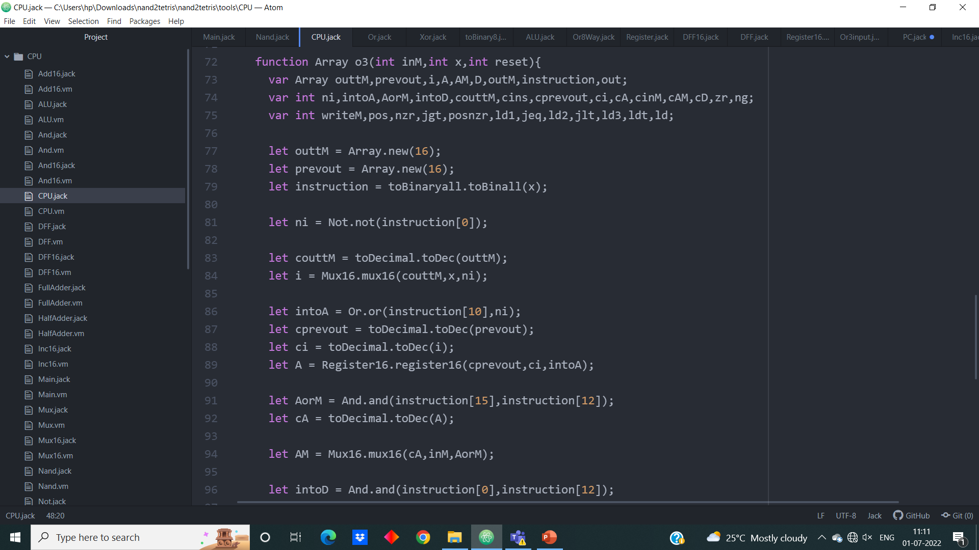

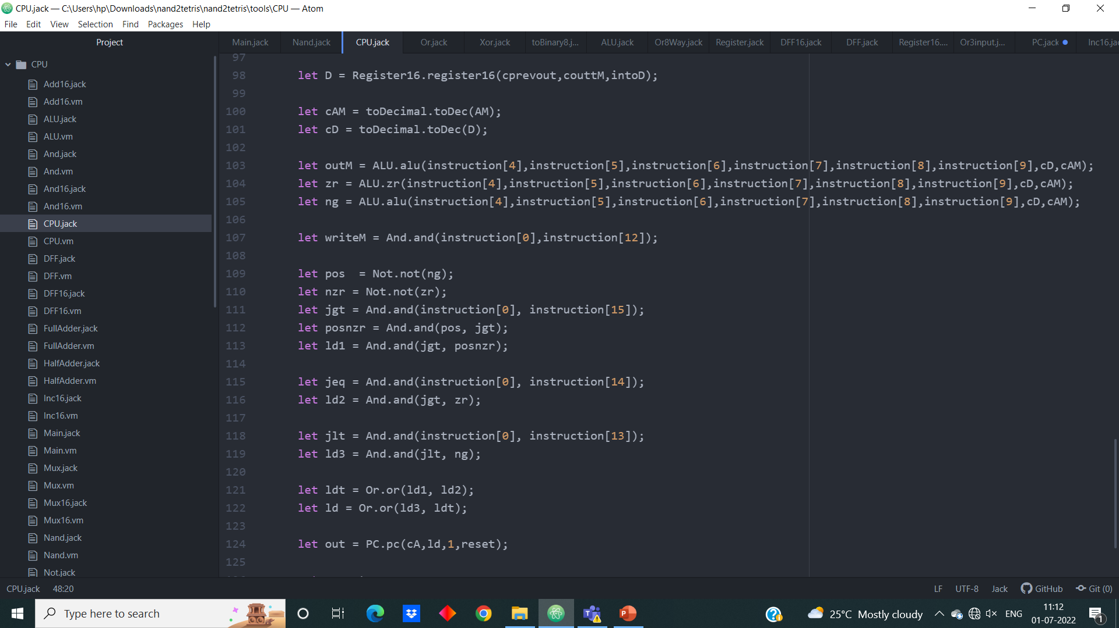

**CPU Output in VM Emulator:**

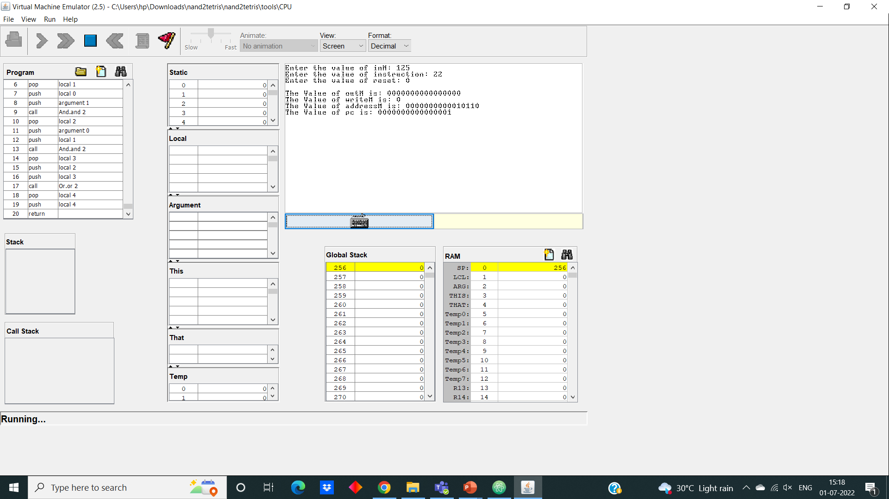

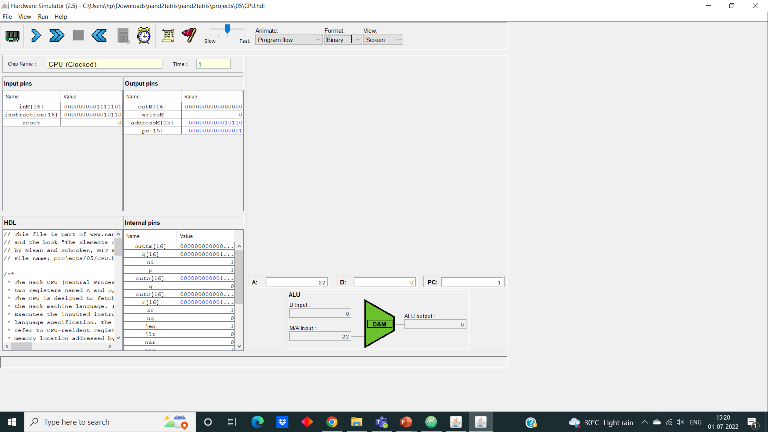**CPU Output in Hardware Simulator:**

**Chapter - 3**

**AIM:**

Our aim is to build a 9X9 Sudoku solver in Jack and required 2-D array implementation used in it.

**Steps of action of Jack:**

1. Here for creating a 9X9 sudoku solver first we have to implement a double (2D) array which makes our work easy.
2. The Sudoku solver can be implemented in jack by using its appropriate rules and the 2D array.

**3.1 Rules of Sudoku**

### **Rule 1 - Each row must contain the numbers from 1 to 9, without repetitions**

The player must focus on filling each row of the grid while ensuring there are no duplicated numbers. The placement order of the digits is irrelevant.  
   
Every puzzle, regardless of the difficulty level, begins with allocated numbers on the grid. The player should use these numbers as clues to find which digits are missing in each row.

### **Rule 2 - Each column must contain the numbers from 1 to 9, without repetitions**

The Sudoku rules for the columns on the grid are exactly the same as for the rows. The player must also fill these with the numbers from 1 to 9, making sure each digit occurs only once per column.  
   
The numbers allocated at the beginning of the puzzle work as clues to find which digits are missing in each column and their position.

### **Rule 3 -** **The digits can only occur once per block (nonet)**

A regular 9 x 9 grid is divided into 9 smaller blocks of 3 x 3, also known as nonets. The numbers from 1 to 9 can only occur once per nonet.  
   
In practice, this means that the process of filling the rows and columns without duplicated digits finds inside each block another restriction to the numbers’ positioning.

### **Rule 4 - The sum of every single row, column and nonet must equal 45**

To find out which numbers are missing from each row, column or block or if there are any duplicates, the player can simply count or flex their math skills and sum the numbers. When the digits occur only once, the total of each row, column and group must be of 45.

1+2+3+4+5+6+7+8+9= 45

**3.2 Implementation Logic**

* First, we will check if there is any number repeated in the row.
* Next, we will check if there is any number repeated in the column.
* And then we will check the 3X3 box if there is any number is repeated.
* For solving the sudoku we used Back tracking approach.
* It solves an algorithm by recursively running the loop from the initial condition. Every time an exception is found.

**3.3 Multi-Array**

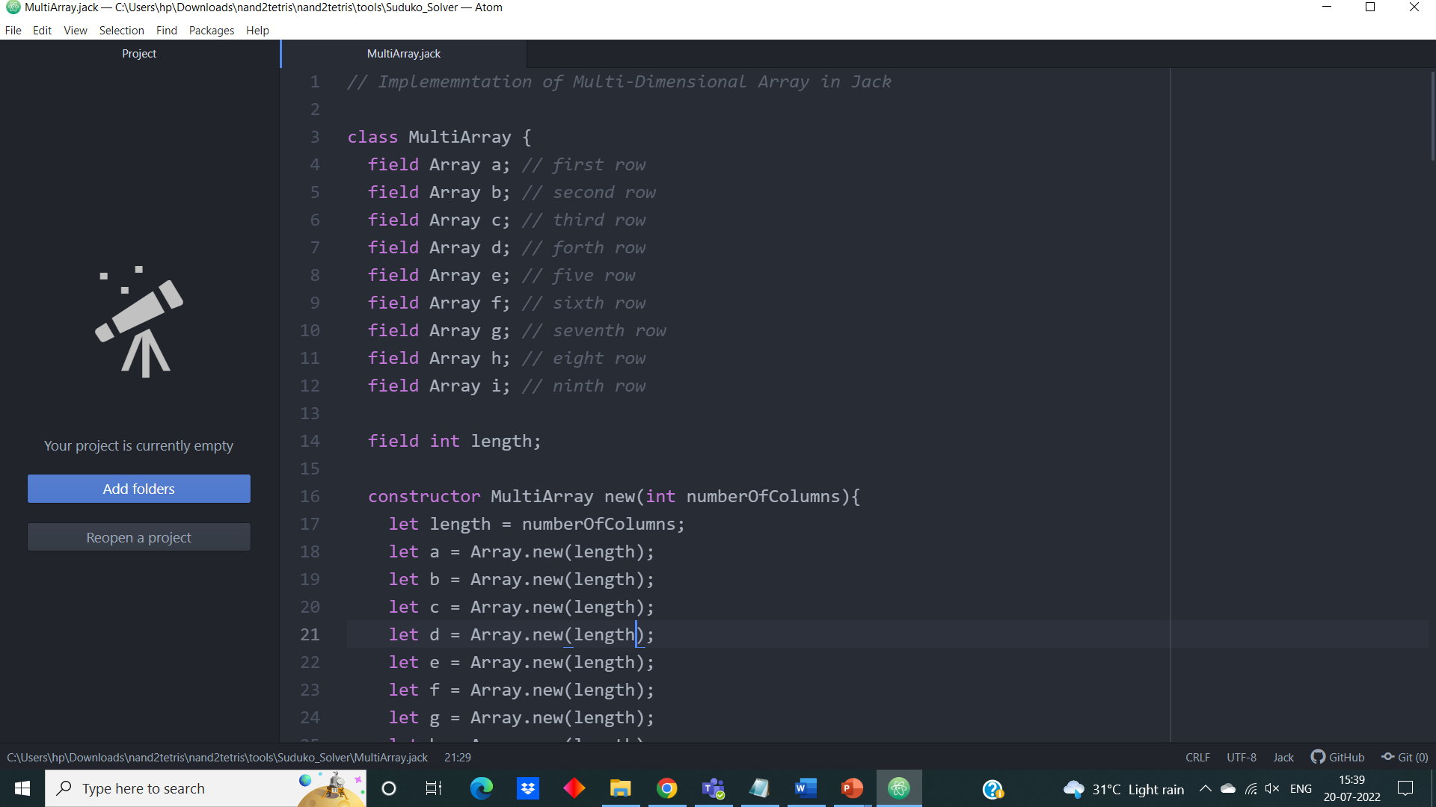

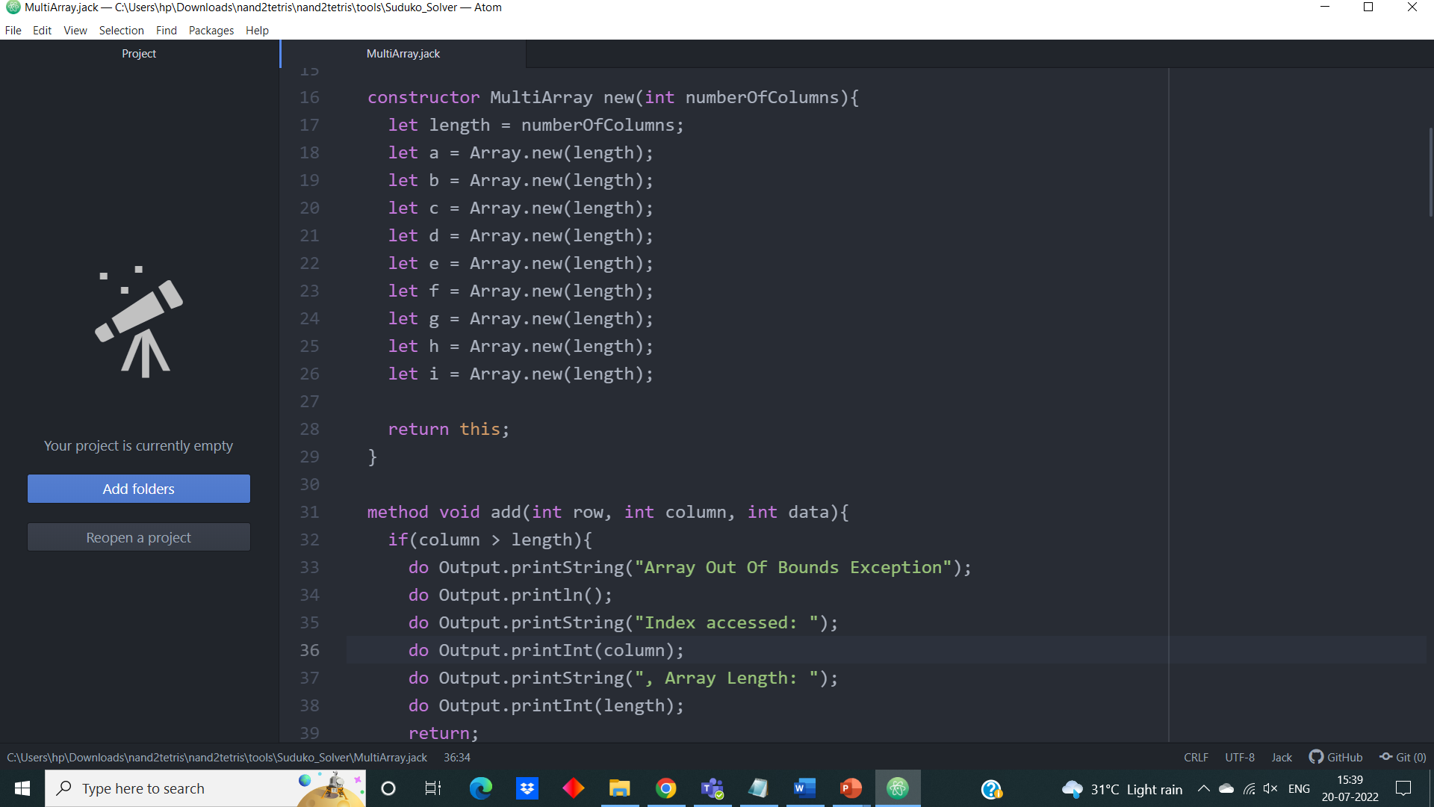

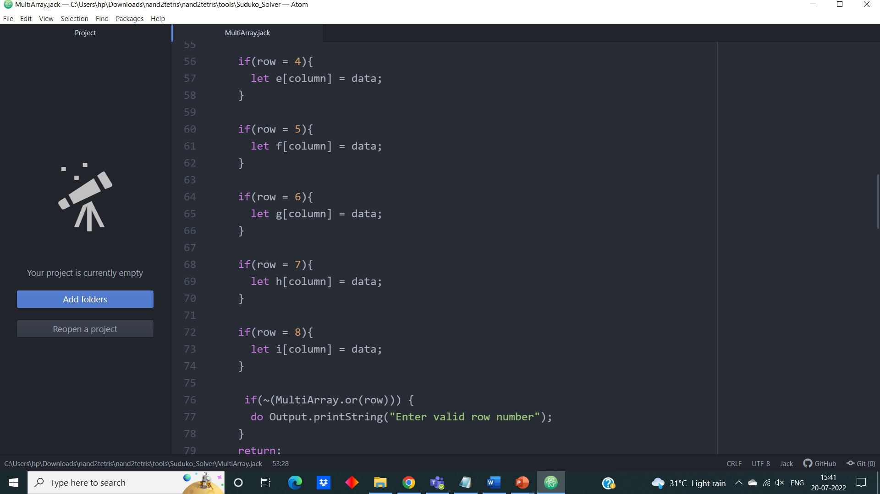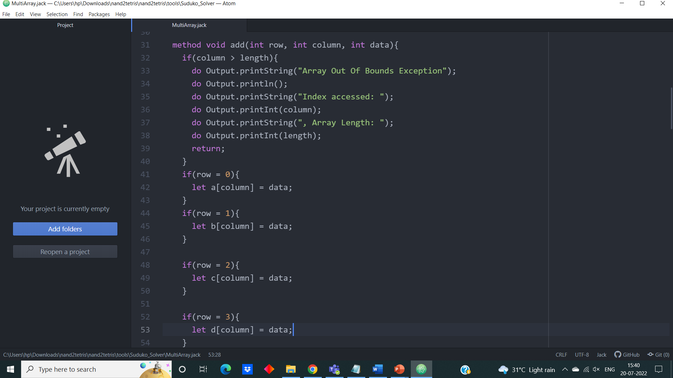

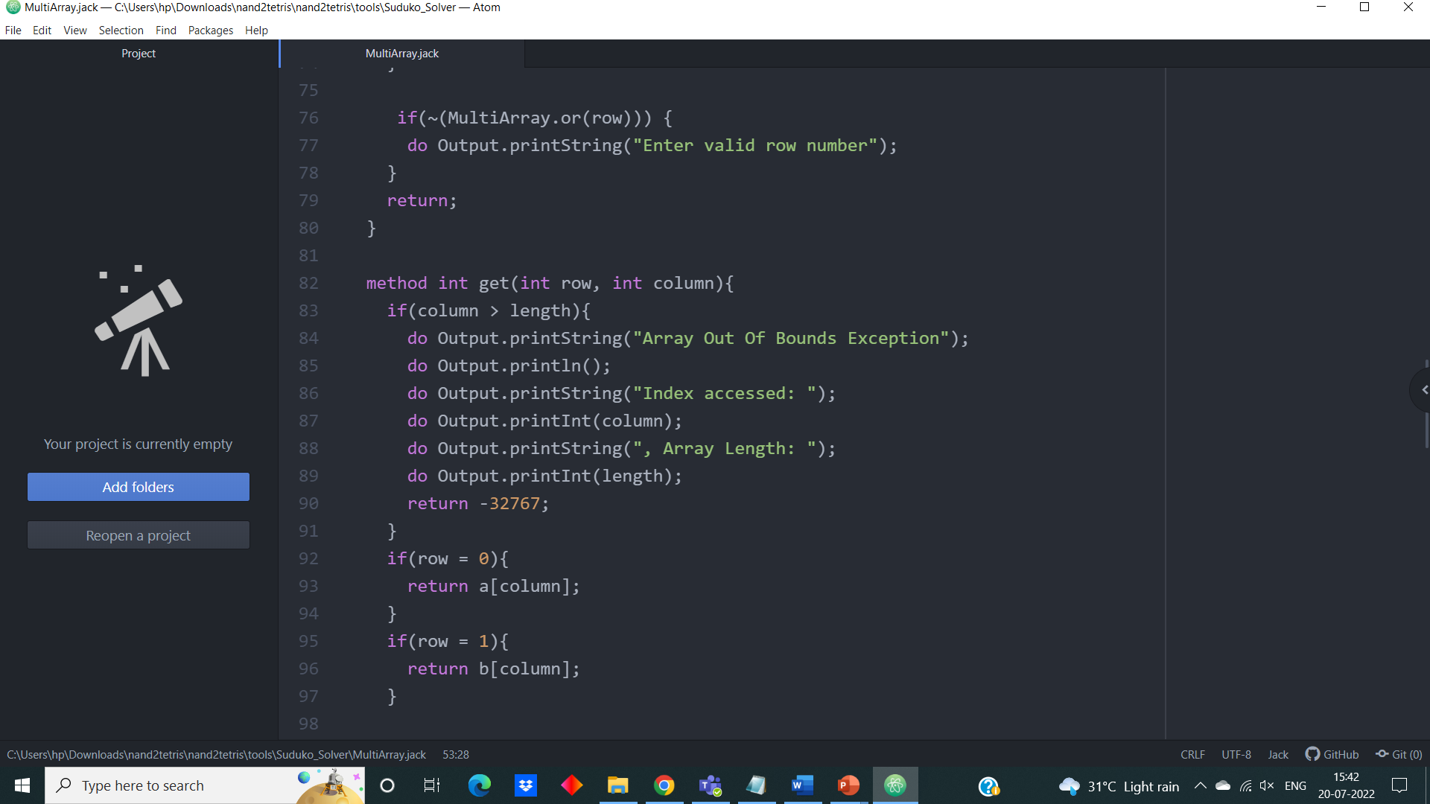

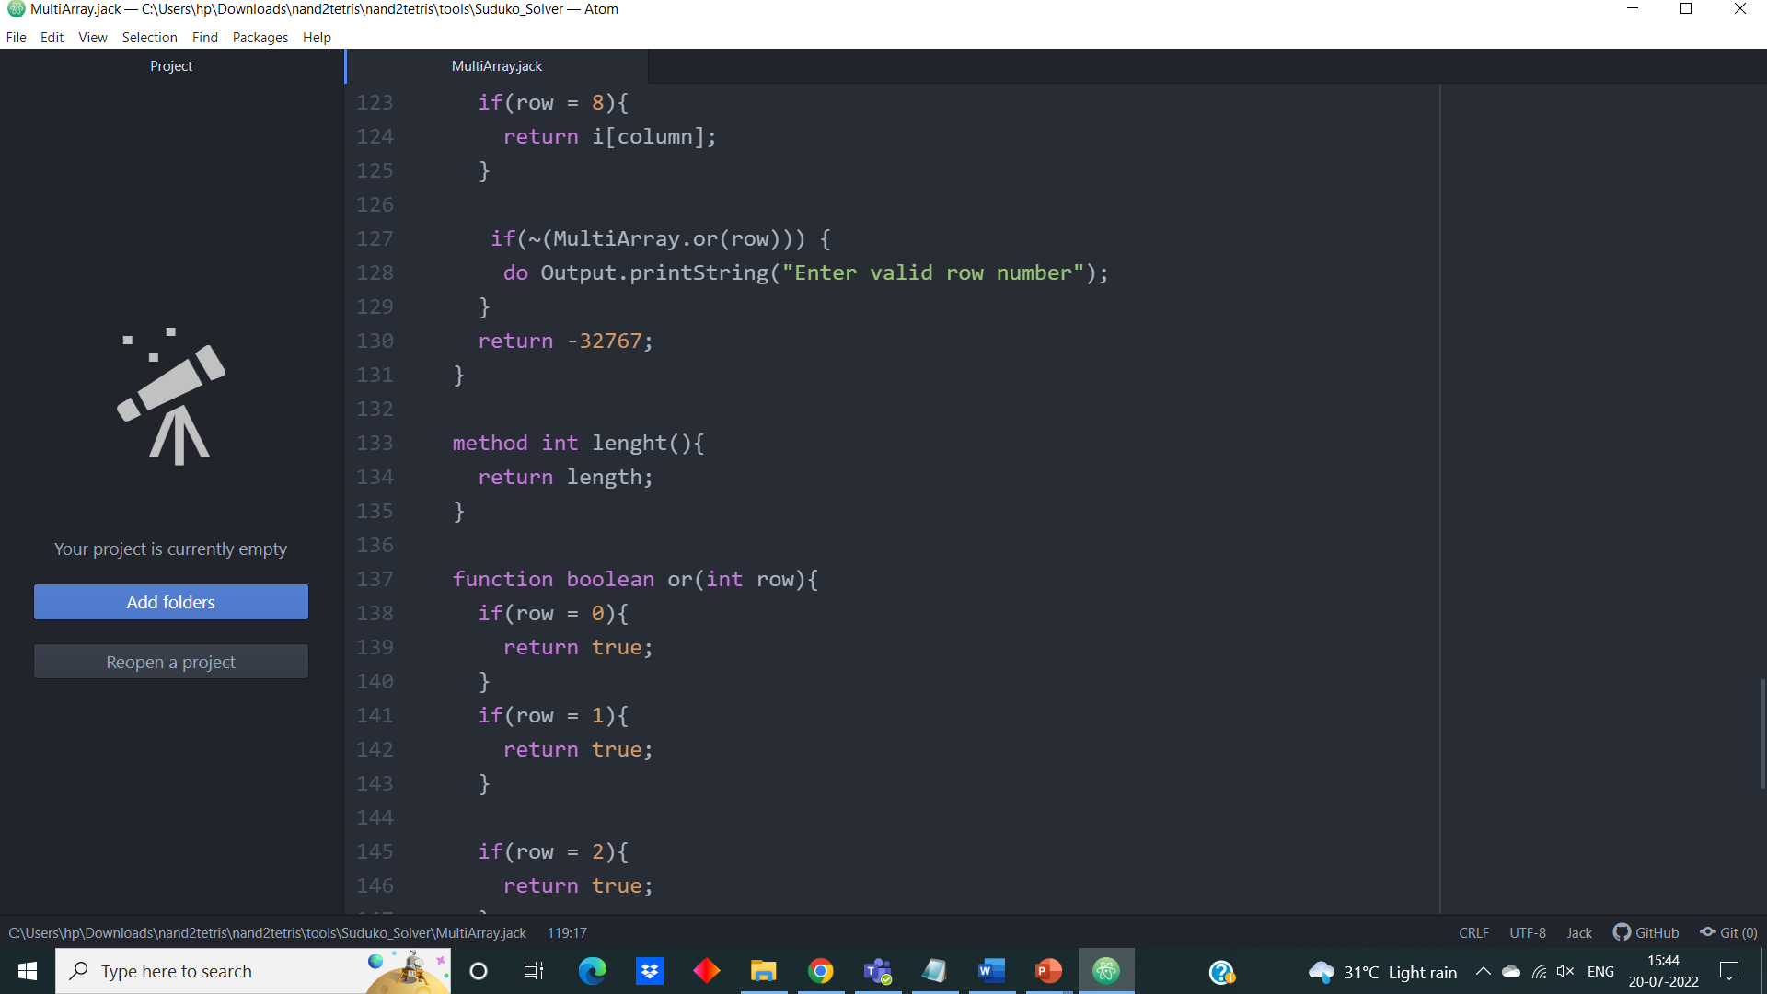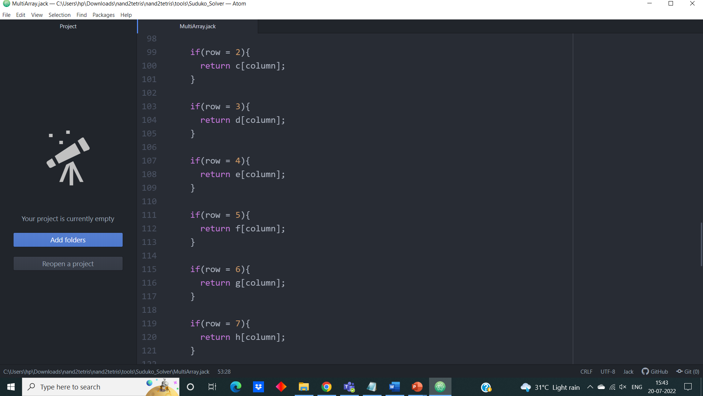

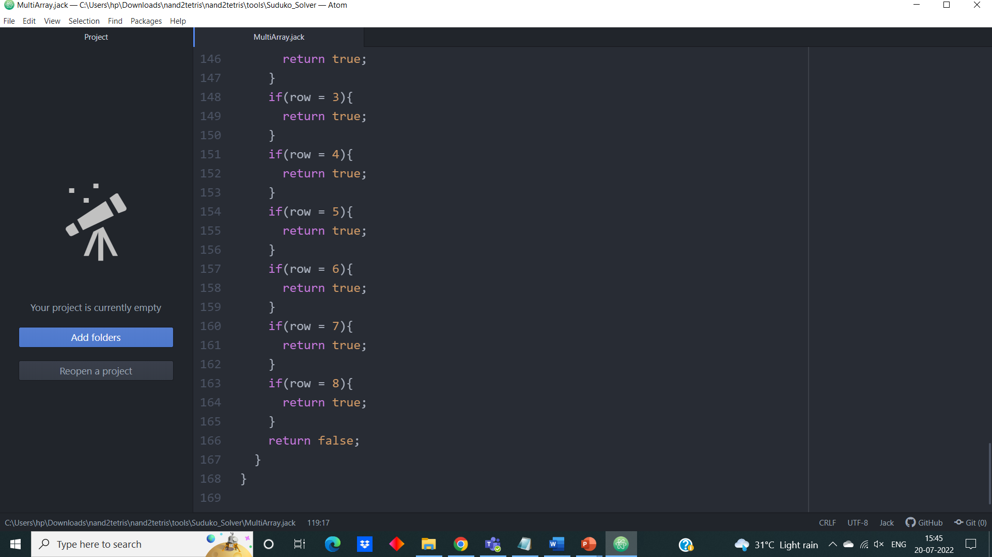

**3.4 Sudoku solver**

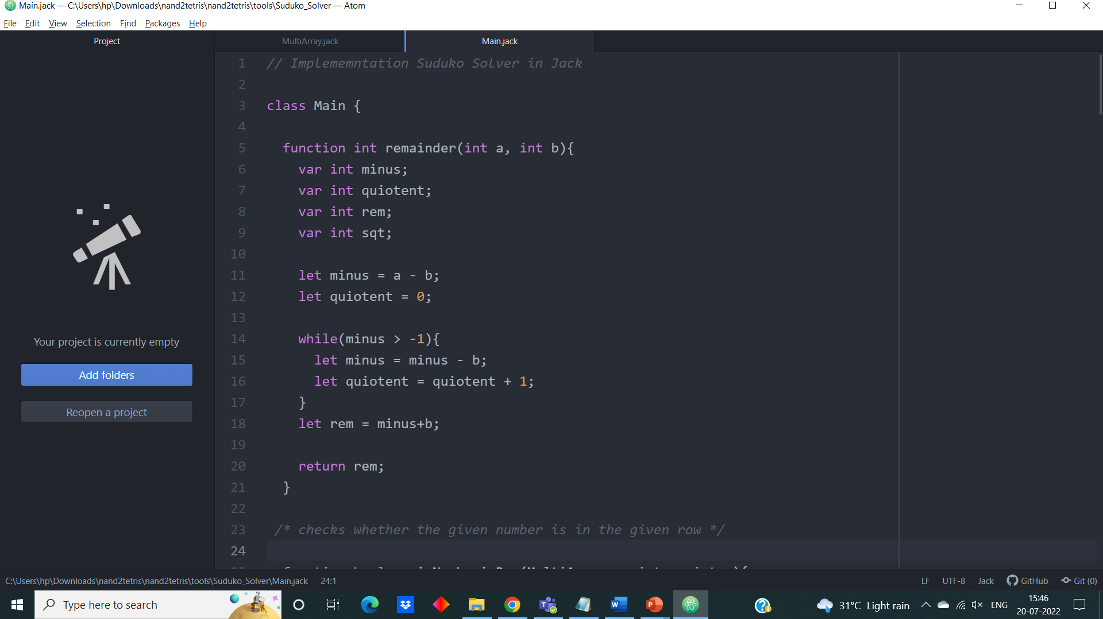

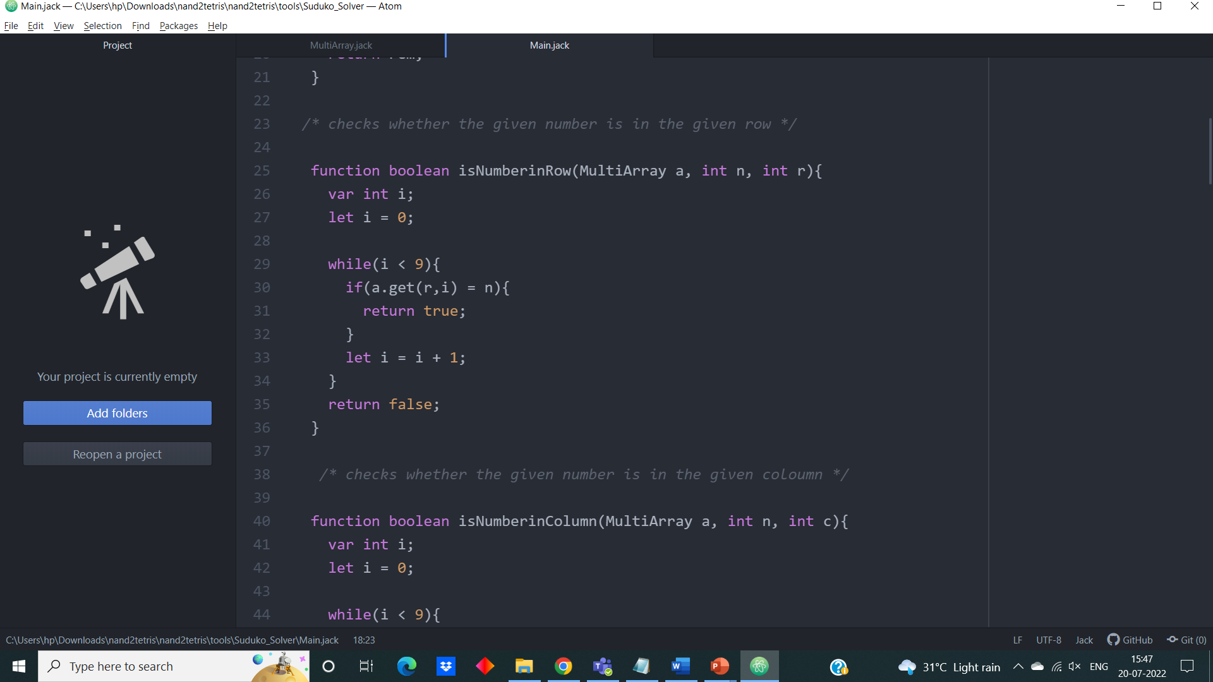

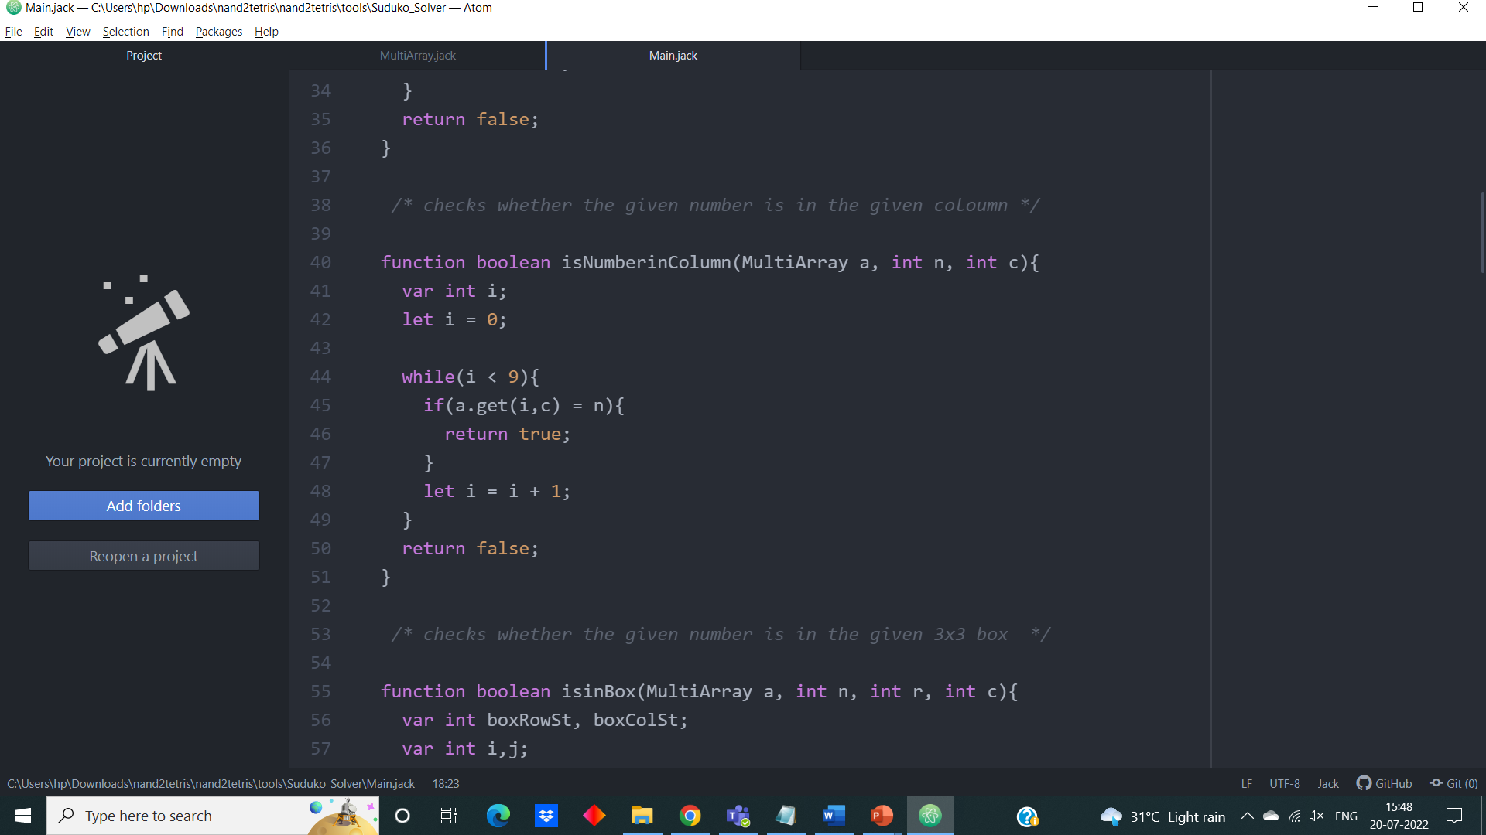

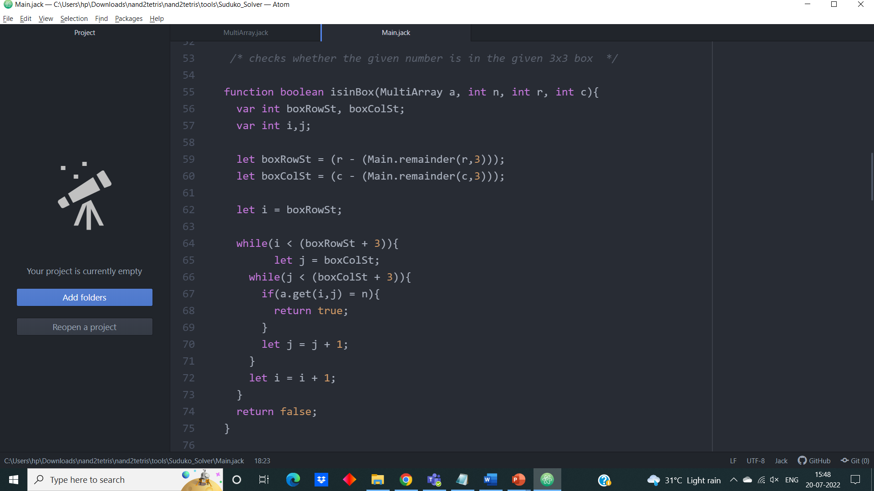

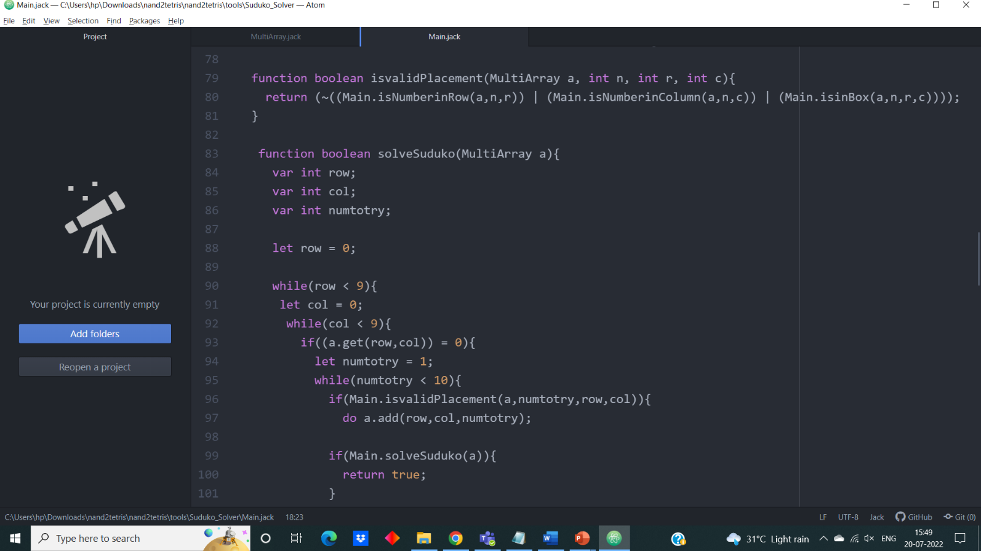

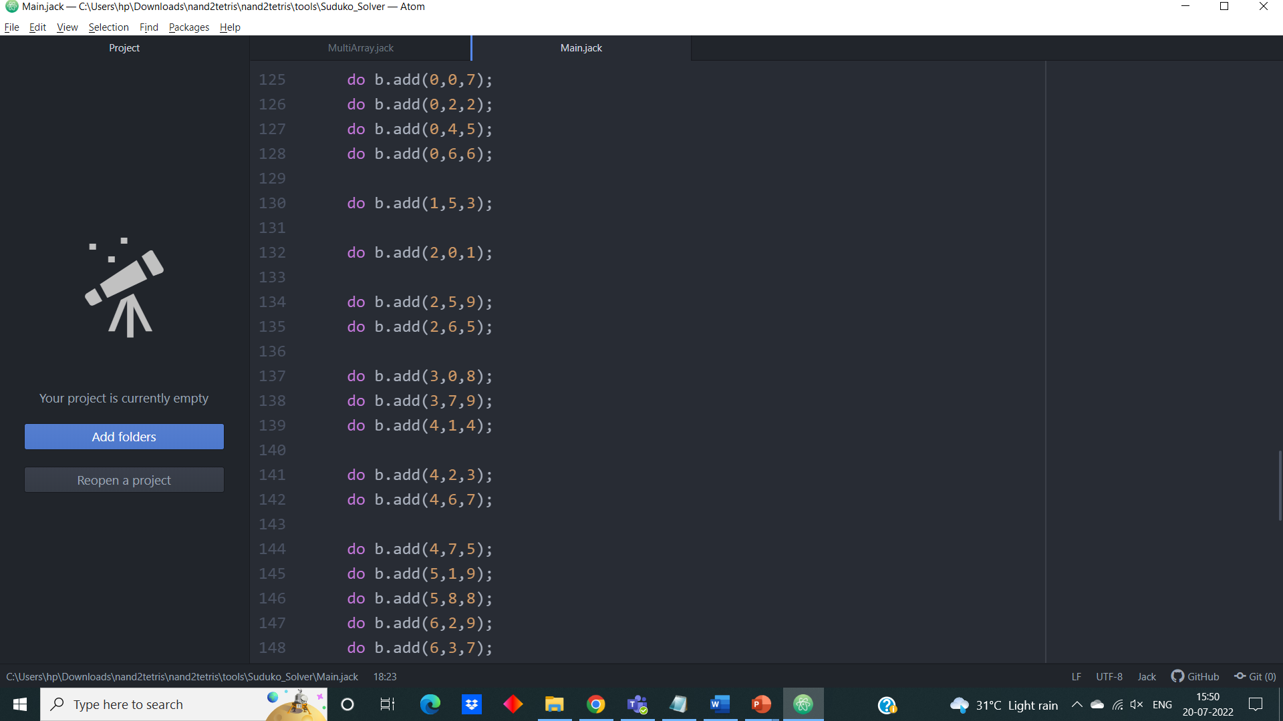

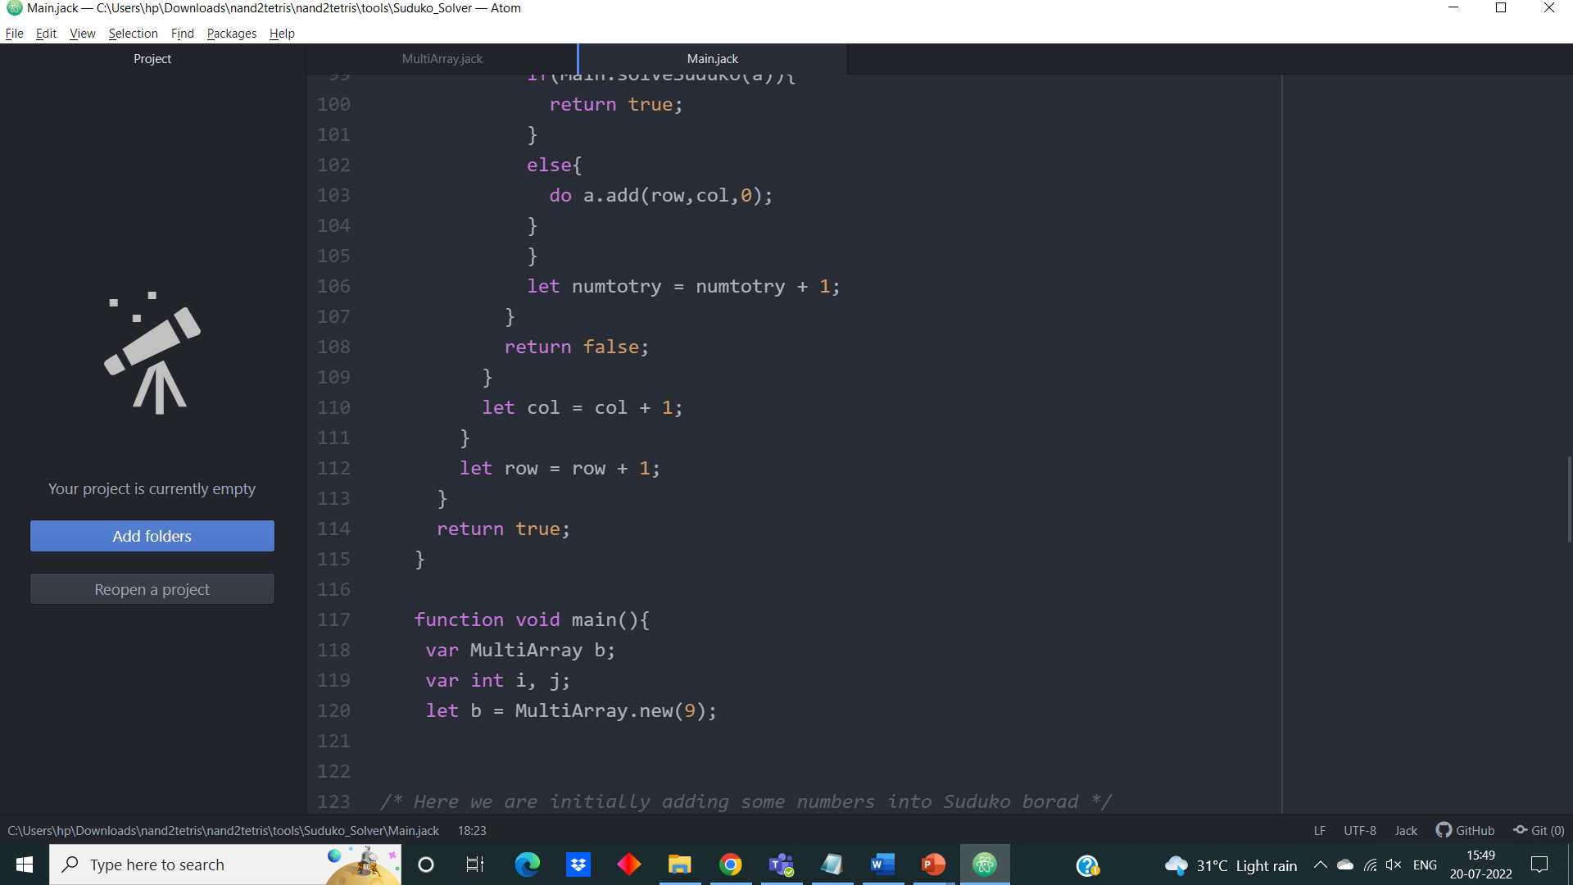

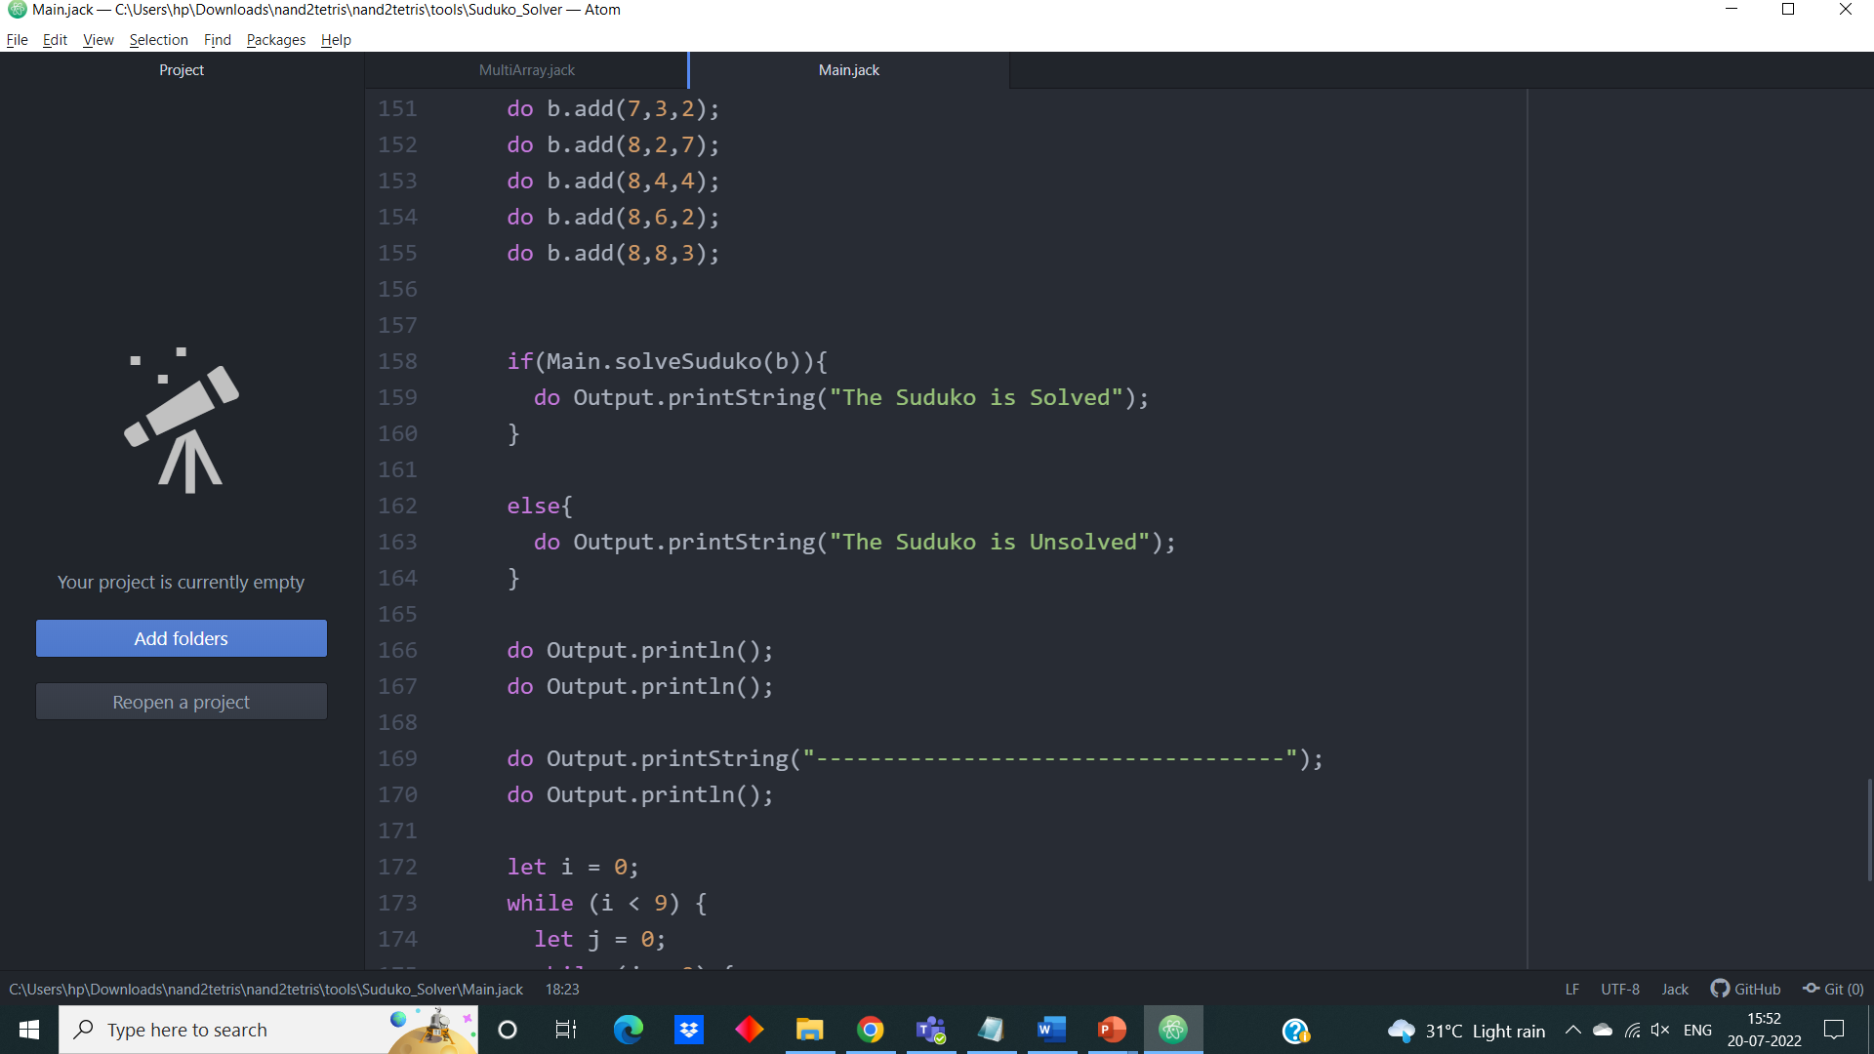

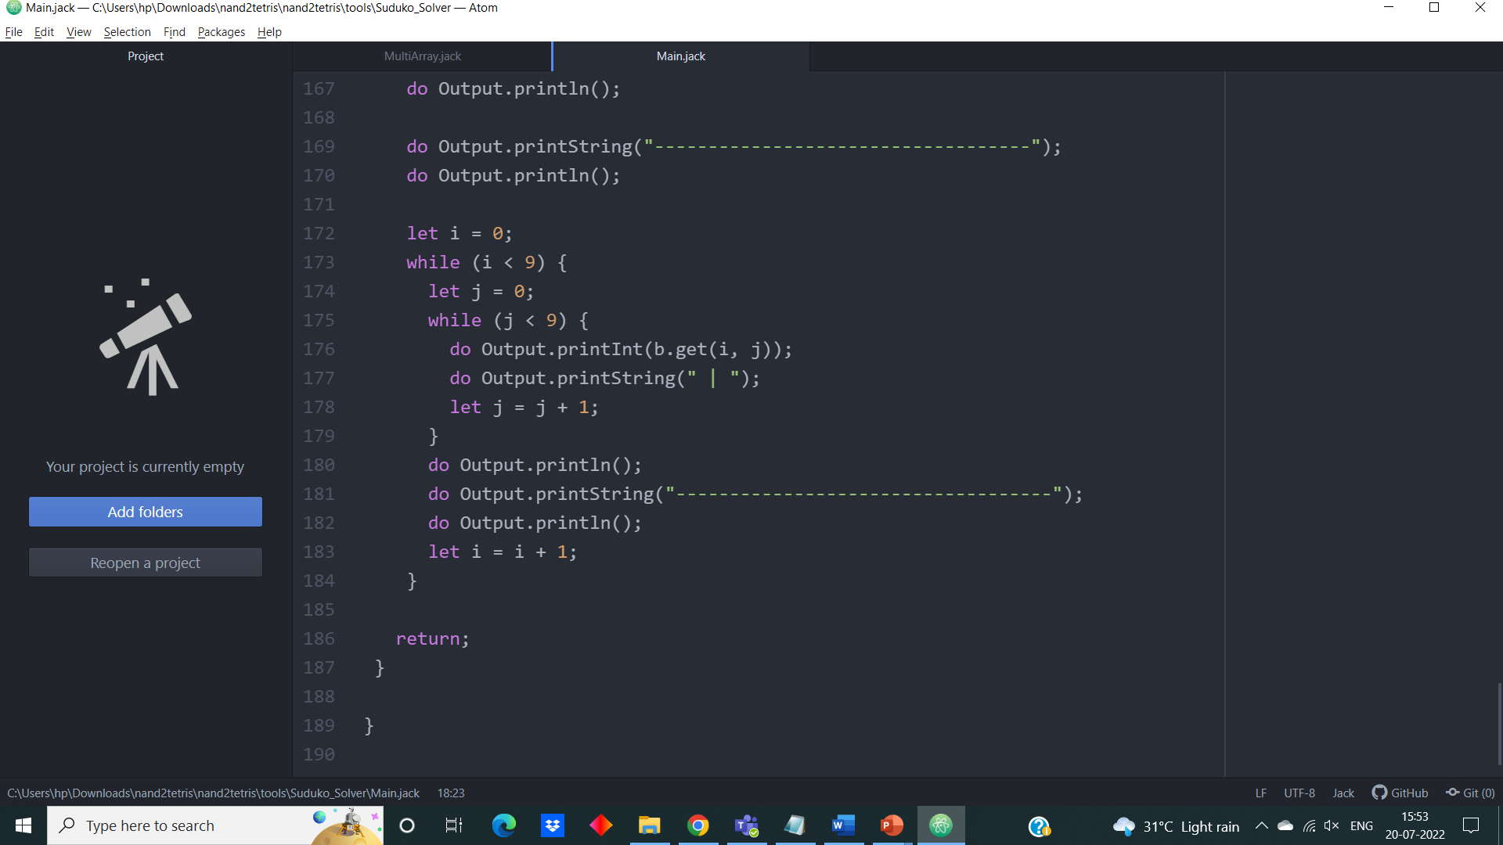

**Bibliography**

[**https://docs.oracle.com/en/java/javase/17/docs/api/java.base/java/lang/String.html**](https://docs.oracle.com/en/java/javase/17/docs/api/java.base/java/lang/String.html)

[**https://www.nand2tetris.org/**](https://www.nand2tetris.org/)